2021-31 Long-Term Plan Amendment

City Housing

# Purpose

This document outlines the key amendments to the 2021-31 Long Term Plan required as a consequence of Council taking a decision on the establishment of a Community Housing Provider to operate Council’s social housing portfolio. The document should be read as an accompanying document to the 2021-31 Long-Term Plan, outlining the sections of the plan that are amended as a consequence of decisions on the future operating model for City Housing.

Contents

Purpose 2

Overview 3

Consultation and what you said 3

Independent auditor’s report 5

Summary of financials 8

Statement of Service Provision - 5.2 Tautoko Hāpori Community Support 10

5.2 Tautoko Hāpori | Community support 10

Operating Expenditure by activity 12

Capital Expenditure by activity 12

Forecast Financial Statements 13

Funding Impact Statements 18

Disclosure statements for the period commencing 1 July 2021 20

Financial and Infrastructure Strategy 26

Financial trends and implications 26

Challenges 26

Challenge 2 – Housing and Urban Development - Growing & Changing 26

Community Infrastructure 27

Revenue and Financing Policy 29

Activity 5.2.5: Housing 29

Significant forecasting assumptions 31

# Overview

Through City Housing, the council has more than 1,900 social housing units across the city, housing 3,000 tenants on low incomes. The council has provided social housing in Wellington since the 1950s.

City Housing has a long-standing financial sustainability issue that is now critical. City Housing’s only source of income is tenant rent which is set at 70% of market rent – it does not receive any rates funding or funding from government subsidies. This limited income and growing cost pressures means City Housing runs an operating deficit ($10m and growing) and has a shortfall in funding for necessary housing upgrades. The costs of required housing upgrades will be at least $286m, significantly higher than the $180m in the Deed of Grant that the council signed with the government in 2007.

Without new sources of funding, City Housing will run down its financial reserves and will not be able to meet its operating costs and meet Deed of Grant commitments beyond 2022/23.

We have taken steps to address City Housing’s sustainability over several years, including operational changes to reduce costs and improve efficiency, establishing a programme to reinvest proceeds from targeted divestment into ongoing upgrades, and leasing properties to other providers to increase revenue – but more significant change is now needed.

This amendment seeks to provide a long-term solution to address city housing financial sustainability issues.

This amendment will see the Council establish a registered Community Housing Provider (CHP) set up as a community housing trust. A CHP is a regulated entity that is registered with the Community Housing Regulatory Authority (CHRA) and provides public housing. Establishing a CHP means the social housing service will be independent from council and run by a separate entity – in this case a Board of Trustees. The council will continue to own the housing assets and the trust would run the housing service.

A CHP will improve tenant wellbeing over time through access to the subsidy scheme (IRRS) for new eligible tenants. It will also resolve the financial sustainability challenges and will enable delivery of new social housing supply in Wellington.

### Impact of Granville Flats decommissioning

Since consultation was completed, in May 2022 the Wellington Tenths Trust, which owns the land on which the Granville Flats buildings sit, agreed with Council that it would not renew the land lease when it expires at the end of the 2022/23 year. This will result in the decommissioning and demolition of the Granville buildings and return of the land to the Trust.

We have considered the implications of this decision for the LTP amendment and consider that the impact is not significant on the amendment agreed by the Council on 1 June.

While the budget forecasts to be adopted as part of the amendment do not reflect the decision to not renew the Granville lease, given the impacts of the lease termination are immaterial and have no impact on the 2022/23 year, they will be adjusted through the 2023/24 Annual Plan process.

We will work with residents to complete a thorough needs assessment to understand what residents need and want from their future home, and all tenants will be rehoused in alternative Council homes by December 2023, with the Council covering tenants’ moving costs.

# Consultation and what you said

Consultation on this amendment was undertaken over April to May 2022 alongside consultation on the Council’s 2022/23 Annual Plan. Consultation included submissions, live webinars and oral hearings with Councillors with a particular focus on engaging with current City Housing tenants. Consultation with tenants included direct contact with all tenants on the proposals, face-to-face drop in sessions, and translations of key documents into a range of languages.

Consultation outlined a number of options to address the service’s current and forecast financial sustainability challenges. Questions in consultation were:

* Would you prefer the Council fund City Housing through increasing rates and borrowing or by setting up an independent Community Housing Provider?
* If the Council did establish a Community Housing Provider (CHP), which option do you support?
  1. Option 1: Asset-owning, fully independent CHP
  2. Option 2: Leasehold CHP with broad responsibilities (Preferred Option)
  3. Option 3: Leasehold CHP with narrow responsibilities
* If the council established a CHP, do you agree with the council’s preference for a community trust, rather than a company or limited partnership?

Over the consultation period, there were over 616 submitters responding to the City Housing issue and a quarter of all submissions came from city housing tenants. The majority of the feedback was in favour of establishing a Community Housing Provider (CHP) (49.7%). Submitters also supported the Council’s preferred CHP model (Option 2: Leasehold CHP with board responsibilities) (43.9%)) and agreed that the CHP should be a community trust (78.5%).

In addition, through consultation submitters raised a range of questions, for example about the administration of a CHP, IRRS accessibility for current tenants, rental affordability, and central Government’s responsibility of providing social housing. Council officers are able to respond to these questions through feedback to submitters on the outcome of consultation and many of these issues will be considered by the Council in the design of the Community Housing Trust as it is established.

#### Southern Landfill

At the same time as consulting on the future of City Housing, we also consulted on another potential amendment to our Long-term Plan relating to the future of the Southern Landfill. Given the current landfill is nearing capacity and the existing consent is expiring in June 2026, we needed to consider the future arrangements for disposal of residual waste. We asked the community for feedback on the following question:

* The council’s preference is for a new landfill on top of the existing landfill (piggyback option), rather than waste to energy incineration or having no residual waste facility in Wellington City. Which option do you prefer?

There were over 550 pieces of community feedback on the future of the Southern Landfill during the consultation period. The outcome highlighted the most preferred option was in favour of the piggyback option (50%). Based on this community feedback through consultation, Council agreed to the ‘piggyback’ option, building a new landfill on top of the existing.

Given the ‘piggyback’ option does not required changes to Council services or additional funding beyond that already allowed for in the 2021-31 LTP, no amendments to the LTP are required for this decision.

Work will now begin on resource consenting for the extension of the landfill in the upcoming year. Construction work will commence once all the required resource consents are obtained. The extended landfill is expected to be completed before June 2026, before the current landfill expires.

# Independent auditor’s report

*This report sits with and precedes the original opinion in the LTP*

*(in Volume 1: Independent auditor’s report pages 204 -206)*

To the reader:

Independent auditor’s report on Wellington City Council’s amended 2021–31 long-term plan

I am the Auditor-General’s appointed auditor for Wellington City Council (the Council).

The Council adopted its 2021–31 long-term plan (the plan) on 30 June 2021.

A long‑term plan must contain a report from the auditor on:

* whether the plan gives effect to the purpose set out in section 93(6) of the Local Government Act 2002; and
* the quality of the information and assumptions underlying the forecast information in the plan.

We issued a qualified opinion on the plan in our report dated 30 June 2021. The basis for the qualification is the Council does not use information about the condition of its three water assets to inform its investment in its three waters networks. Rather, the renewal of assets has been forecast based on the age of the assets, capped by what the Council considers is affordable. Given the challenges outlined above we consider this approach to be unreasonable. This could result in more asset failures during the 10-year period of the long-term plan, reduced levels of service, and greater costs than forecast.

We drew attention to the uncertainty over three waters reforms, uncertainty over the delivery of the capital programme, uncertainty over funding of wastewater treatment plant, and the Council’s debt limit is forecast to be exceeded.

The Council has since consulted on a proposed amendment to the plan. The Council will establish a registered Community Housing Provider set up as a community housing trust. This means the social housing service will be independent from the Council and run by a Board of Trustees. The Council will continue to own the housing assets and the trust would run the housing service.

Following the consultation process, the Council has decided to amend its plan. The amended plan replaces the previously adopted plan.

The amended plan must contain a report from the auditor that either confirms or amends the previous audit report issued when the plan was adopted.

My report is below.

I carried out the work for this report using the staff and resources of Audit New Zealand. This work was completed on 30 June 2022.

Report confirming our previous opinion

Our work for this report focused only on the amendment and its effect on the plan. We did not repeat the audit work we did on the plan when it was originally adopted.

As a result of this work, we do not consider it necessary to amend our previous opinion which was included in our report on the plan as originally adopted.

I confirm that our previous audit opinion on the plan as originally adopted issued on 30 June 2021, is not affected by the amendment to the plan.

As for our opinion on the plan prior to it being amended, this report does not provide assurance that the forecasts in the amended plan will be achieved, because events do not always occur as expected and variations may be material. Nor does it guarantee complete accuracy of the information in the amended plan.

Basis of this report

We carried out our work in accordance with the International Standard on Assurance Engagements (New Zealand) 3000 (Revised): Assurance Engagements Other Than Audits or Reviews of Historical Financial Information. In meeting the requirements of this standard, we took into account particular elements of the Auditor-General’s Auditing Standards and the International Standard on Assurance Engagements 3400: The Examination of Prospective Financial Informationthat were consistent with those requirements.

We did not evaluate the security and controls over the electronic publication of the amended plan.

Responsibilities of the Council and auditor

The Council is responsible for:

* meeting all legal requirements affecting its procedures, decisions, consultation, disclosures and other actions relating to amending the plan;
* presenting forecast financial information in accordance with generally accepted accounting practice in New Zealand; and
* having systems and processes in place to enable the amended plan to be free from material misstatement.

I am responsible for reporting on whether the amendment to the plan affects my previous audit report on the plan as originally adopted. I do not express an opinion on the merits of the plan’s policy content.

Independence and quality control

In carrying out our work, we complied with the Auditor-General’s:

* independence and other ethical requirements, which incorporate the independence and ethical requirements of Professional and Ethical Standard 1 (Revised); and
* quality control requirements, which incorporate the quality control requirements of Professional and Ethical Standard 3 (Amended).

In addition to this report on the Council’s consultation document and all legally required external audits, we have performed a limited assurance engagement related to the Council’s debenture trust deed, performed a review of the revenue and expenditure of the Clifton Terrace car park managed by the Council on behalf of Waka Kotahi NZ Transport Agency, and provided probity assurance for the Central Library seismic strengthening and refurbishment project, and the main contractor for the Healthy Homes project. These engagements are compatible with those independence requirements. Other than this reporting, and these engagements we have no relationship with or interests in the Council or its subsidiaries and controlled entities.

Karen Young, Audit New Zealand

On behalf of the Auditor-General, Wellington, New Zealand

*Taken from Volume 1: Summary of financials pages 24-31*

# Summary of financials

Council’s preferred option for City Housing going forward is establishing a Community Housing Provider (CHP) to operate the social housing service which would see Council retaining the ownership of the Housing assets but have a long term leasing arrangement in place with the CHP. This means Council will need to continue to fund the on-going maintenance of the existing Housing stock. In order to meet its commitment to the Deed of Grant, Council will need to fund at least $180m from borrowings plus also an additional $106m is estimated to be required to meet the requirements of the Deed of Grant. An additional $157m has been provided for major maintenance work to be done over the 10 years as well. These requirements have been included in this amendment and funded from borrowings.

This option is based on a leasehold CHP with broad responsibilities arrangement, which would require Council to provide $35m capital upfront over 5 years in the form of a Grant to the new entity to enable the CHP to grow future housing stock in line with Council’s goals and objectives set for the Trust.

*Rates*

Based on this preferred option, the forecasted total rates requirement increases from $428m in 2022/23 through to $646m in 2030/31. This growth in total rates is due to a number of factors including this proposed City Housing option as well as additional increases in costs in order to provide 400 plus services that Council provides every day. We forecast a rates requirement in relation to the preferred CHP option of $246m for the 10 years to 2030-31 (an average of roughly $24.5m per year). For 2023/24, the rates requirement will be $21m or 4.4% of the total rates.

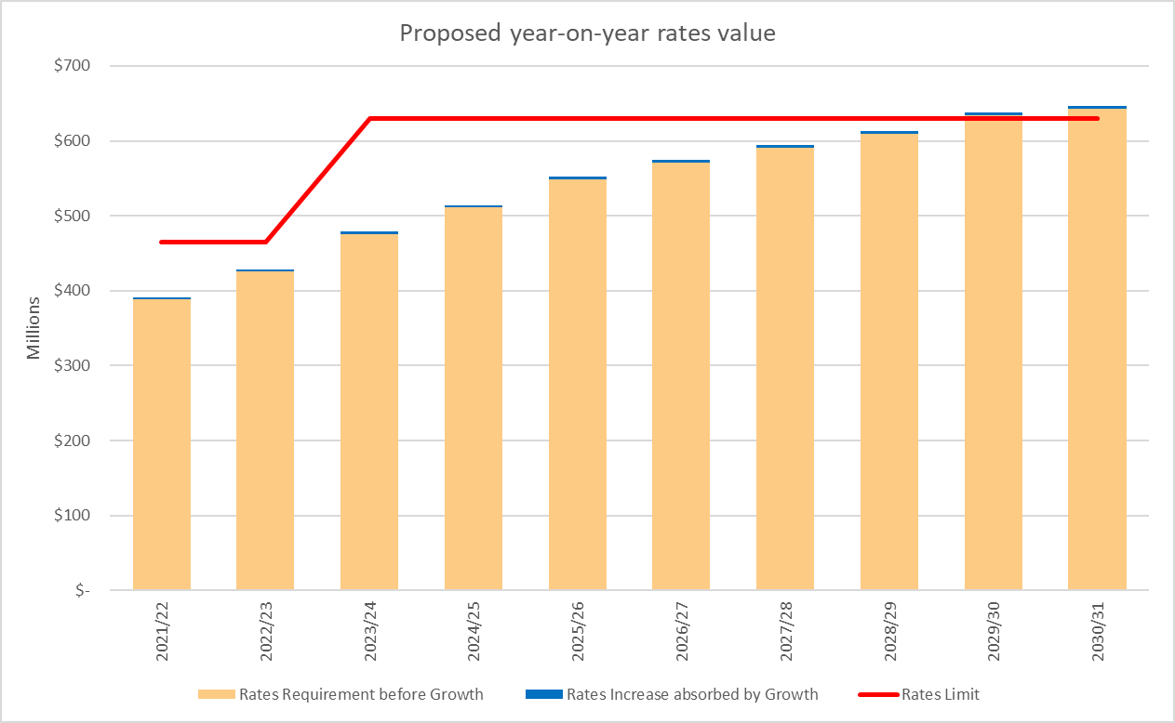

The proposed rate increases over the 10 years has been illustrated below and would have an average rates impact on ratepayers of 8.9% for the 2022/23 rating year compared to a forecasted increase of 9.1% net increase in rates as per the 2021 – 31 Long Term Plan (LTP). This option also forecasts an average rate increase (after growth in the rating based is excluded) of 6.0% over the 10 year period to 2030/31 compared to 5.5% forecasted in the LTP.

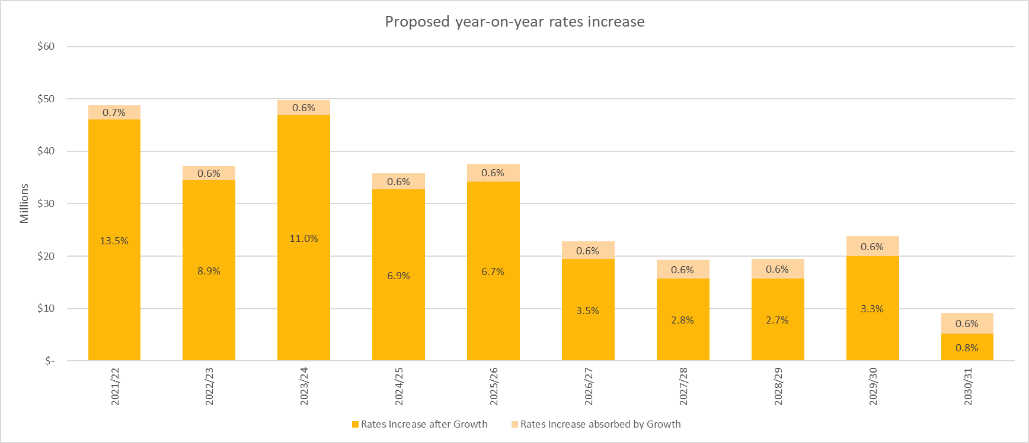

*Revenue*

Total revenue will decrease over the 10 years forecasted in the LTP due in part to the impact of this Housing proposal as Council will receive a reduced income (calculated as net income from the CHP of market rental less operating costs and a 10% margin). This will see total revenue in 2030/31 reduce from the LTP figure of $974.1m to $955.2m, a difference of $18.9m between this plan and that of the LTP. Similarly total expenditure will decrease by $31.6m from a LTP figure of $966.3m to $934.7m in the Annual Plan. This is due to certain costs of the City Housing activity moving across to the CHP.

*Debt*

As this preferred option uses debt to fund to maintain the quality of the Housing assets, this will see Council’s net borrowings in 2022/23 of $1,314m increase to $1,899m in 2026/27 before reducing to $1,732m in 2030/31. This 2030/31 figure differs from the $1,539.6m in the LTP by $193m, $23m of which relates to the preferred option for the capitalisation of Community Housing Provider. The balance of the difference is as a result of other Council decisions such as the proposed Environmental and Accessibility Performance Fund, debt funding Council’s pandemic response and changes to the capital expenditure programme. The graph below illustrates how Council is forecasting its borrowing requirements (including $270m for additional borrowing capacity to cover insurance underwriting for major events). This shows Council being outside its debt limit for 7 years until 2029/30 when it returns to Council policy limits.

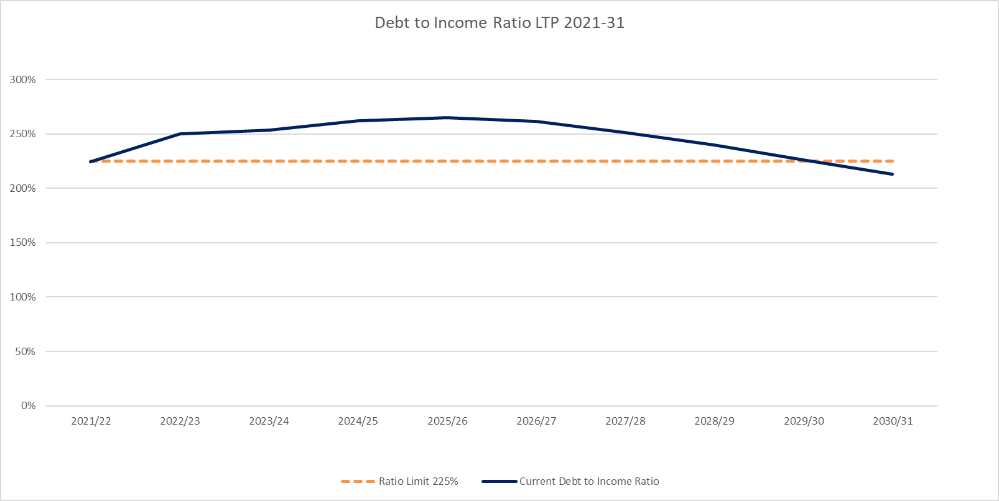

*Taken from Volume 1: Statement of service provision pages 78-81*

# Statement of Service Provision - 5.2 Tautoko Hāpori Community Support

### 5.2 Tautoko Hāpori | Community support

By providing libraries, community centres and social housing we foster diverse and inclusive communities and enable people to connect with information and each other.

We provide a wide range of facilities forming part of the city’s ‘hard’ social infrastructure that support community wellbeing. These include libraries, community spaces and social housing.

#### Activities in this group

1. Libraries
2. Access support (Leisure Card)
3. Community advocacy
4. Grants (social and recreation)
5. Social Housing
6. Community centres and halls

#### Rationale

*This activity grouping primarily contributes to the community outcome: A people friendly, compact, safe and accessible capital city*

* *To foster diverse and inclusive communities.* Our community facilities are places for groups to come together – strengthening social cohesion, celebrating diversity and making the city a more appealing and welcoming place to live.
* *To enable people to connect with information and with each other.* Our community facilities are places of discovery and learning that allow people to connect with others and exchange knowledge through events and other activities.
* *To support warmer, drier, healthier homes.*The quality of Wellington homes is improved.
* *To support communities to take climate action.* Climate actions that can be undertaken by community groups are supported and enabled.

#### Services we provide

* Council currently provides social housing for the purpose of providing rental for low-income Wellingtonians whose housing is not met by the private sector – we currently own over 1,900 units. Council has agreed upon establishing a Community Housing Provider to take over the management of our social housing portfolio. Once this CHP is established then Council’s role will shift to the leasing of housing units to the Community Housing provider

#### Key projects/programmes

* *Social Housing.* We will continue to improve the quality of our social housing to bring all Council social housing stock up to the requirements of the Healthy Homes Standards (costing $16.6m over years 1 to 3). Beyond Healthy Housing we also plan to continue to upgrade our City Housing stock in line with our Deed of Grant with the Government. The expected cost of the housing upgrade programme is $286m, based on a 2020 QS assessment. Given the escalation in construction sector costs, the costs of the upgrades are now likely to be higher than this.
* Over the long term, the level of investment required in our housing, along with the discounted rents that we are able to recover, means that our social housing portfolio is financially unsustainable. In order to address this, we will be establishing a Community Housing Provider (CHP) entity. Once established, the CHP will take over operating our social housing tenancy service. This will enable new tenants to be able to access the Government’s Income Related Rent subsidy.
* The Council will be involved in the CHP, including continuing to own the housing stock (leasing it to the CHP for social housing), and will appoint trustees to the trust’s governance board, but the council will not be in majority control. The CHP will instead be an independent community housing trust with a dedicated focus on the provision of affordable, quality and sustainable social housing in Wellington.

#### Operating and capital budgets

|  |  |
| --- | --- |
| Chart showing projected operating expenditure for the activity area. Expenditure grows from around $80m in 2021/22 to around $110m in 2030/31.  Comment  The increase in Operating expenditure is due to an increase in the Capital Programme and the associated depreciation cost. | Chart showing projected capital expenditure for the activity area. Expenditure grows from around $20m in 2021/22 to around $80m in 2027/28 before declining again to around $20m in 2030/31.  Comment  The Central Library budget is held at the organisational level rather than in this activity area and that is why it is not shown in this chart. |

#### What you can expect of us – performance measures

|  |  |  |
| --- | --- | --- |
| **Performance measure** | **Previous target (2020/21)** | **Target 2021-31** |
| **Customer focus** |  |  |
| Occupancy rate of available housing facilities* | 90% | 95% |
| Tenant satisfaction (%) with services and facilities (includes neutral)* | 90% | 90% |

*Note that these social housing performance measures will be removed once a Community Housing Provider is established. Council’s role, and performance measures, will shift from the management of social housing to the leasing of properties to the CHP for their use as the social housing provider. Once established, the CHP will have its own dedicated public accountability documents available including outlining the performance measures it will use to report performance in the management of social housing.

*Taken from Volume 1: Operating Expenditure by activity page 175*

# Operating Expenditure by activity

($000s)

|  |  |  |  |  |  |  |  |  |  |  |  |  |  |  |  |
| --- | --- | --- | --- | --- | --- | --- | --- | --- | --- | --- | --- | --- | --- | --- | --- |
| ***Strategy*** | ***Activity group*** | ***Activity*** | ***Activity description*** |  | ***2021/22 Budget*** | ***2022/23 Budget*** | ***2023/24 Budget*** | ***2024/25 Budget*** | ***2025/26 Budget*** | ***2026/27 Budget*** | ***2027/28 Budget*** | ***2028/29 Budget*** | ***2029/30 Budget*** | ***2030/31 Budget*** | ***Total*** |
| Social and Recreation | 5.2 | 1125 | Housing Operations and Maintenance | Income | (27,113) | (27,559) | (13,795) | (15,292) | (16,707) | (18,745) | (20,544) | (22,337) | (24,188) | (26,217) | (212,496) |
| Operating Costs | 37,361 | 40,061 | 29,623 | 33,341 | 42,361 | 47,160 | 48,876 | 51,463 | 56,086 | 59,866 | 446,198 |
|  |  | ***Total - 1125 Housing Operations and Maintenance*** | | | ***10,248*** | ***12,503*** | ***15,828*** | ***18,049*** | ***25,654*** | ***28,416*** | ***28,332*** | ***29,126*** | ***31,898*** | ***33,649*** | **233,703** |
| Social and Recreation | 5.2 | 1126 | Housing Upgrade Project | Operating Costs | 0 | 1 | 1 | 1 | 1 | 1 | 1 | 1 | 1 | 1 | 6 |
|  |  | ***Total - 1126 Housing Upgrade Project*** | | | ***0*** | ***1*** | ***1*** | ***1*** | ***1*** | ***1*** | ***1*** | ***1*** | ***1*** | ***1*** | ***6*** |

*Taken from Volume 1: Capital Expenditure by activity page 188*

# Capital Expenditure by activity

($000s)

|  |  |  |  |  |  |  |  |  |  |  |  |  |  |  |  |  |
| --- | --- | --- | --- | --- | --- | --- | --- | --- | --- | --- | --- | --- | --- | --- | --- | --- |
| ***Strategy*** | ***Activity group*** | ***Activity*** | ***Activity description*** | ***Project*** | ***Project description*** | ***2021/22 Budget*** | ***2022/23 Budget*** | ***2023/24 Budget*** | ***2024/25 Budget*** | ***2025/26 Budget*** | ***2026/27 Budget*** | ***2027/28 Budget*** | ***2028/29 Budget*** | ***2029/30 Budget*** | ***2030/31 Budget*** | ***Total*** |
| Social and Recreation | 5.2 | 2059 | Housing upgrades | 2009862059 | Housing upgrades - Curtains | 63 | 0 | 0 | 0 | 0 | 0 | 0 | 0 | 0 | 0 | 63 |
| 2010232059 | Healthy Homes Standard Programme | 5,305 | 5,488 | 5,635 | 2,241 | 0 | 0 | 0 | 0 | 0 | 0 | 18,669 |
|  |  | ***Total - 2059 Housing upgrades*** | | | | ***5,368*** | ***5,488*** | ***5,635*** | ***2,241*** | ***0*** | ***0*** | ***0*** | ***0*** | ***0*** | ***0*** | ***18,732*** |
| Social and Recreation | 5.2 | 2060 | Housing renewals | 2001182060 | Housing renewals - BAU Capex | 6,574 | 9,704 | 8,943 | 18,718 | 14,022 | 8,505 | 10,813 | 7,001 | 20,841 | 18,810 | 123,931 |
| 2009252060 | Housing renewals - Balconies - GRA | 63 | 2,729 | 0 | 0 | 0 | 0 | 0 | 0 | 0 | 0 | 2,792 |
| 2010242060 | Single Capital Programme | 2,148 | 8,527 | 23,148 | 32,311 | 33,054 | 51,272 | 64,029 | 65,822 | 26,379 | 0 | 306,691 |
|  |  | ***Total - 2060 Housing renewals*** | | | | ***8,785*** | ***20,961*** | ***32,091*** | ***51,028*** | ***47,076*** | ***59,777*** | ***74,842*** | ***72,824*** | ***47,219*** | ***18,810*** | ***433,414*** |

*Taken from Volume 1: Forecast financial statements pages 116-121*

# Forecast Financial Statements

Table showing Council's forecast statement of comprehensive revenue and expense

Table showing Council's forecast statement of financial position Table showing Council's forecast statement of changes in equity Table showing Council's forecast statement of cash flows Table showing Council's forecast statement of changes in restricted/reserve funds

*Taken from Volume 1: Funding impact statements pages 123 and 135*

# Funding Impact Statements

Table showing Council's Funding Impact Statement for the whole of council

Table showing Council's Funding Impact Statement for the community participation and support activity

# Disclosure statements for the period commencing 1 July 2021

*Taken from Volume 1: Funding impact statements pages 123 and 135*

**Rates (income) affordability**

The following graph compares the council's actual rates increases with a quantified dollar limit on rates increases included in the financial strategy included in the council's long-term plan. The quantified limit for the first three years of the Long-term Plan is $465,000,000 and is $630,000,000 for the years 4 – 10 of the Long-term plan.

The proposed rates income is forecast to be above the quantified limits in years 2023/24, 2029/30 and 2030/31. This is a result of updated forecasts made through the 2022/23 Annual Plan and in particular increases to the costs of borrowing beyond the assumptions in the 2021-31 Long-Term Plan. The increase in rates income do not relate to the establishment a Community Housing Trust. Council will re-examine rates and debt benchmarks as a part of the next Long-Term Plan in 2024.

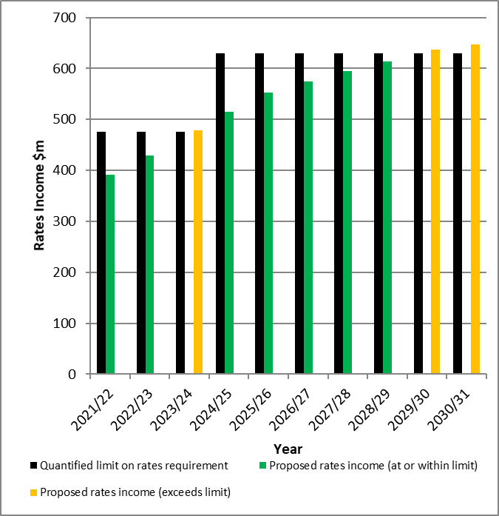

**Rates (increases) affordability**

The following graph compares the council's planned rates increases with a quantified limit on rates increases included in the financial strategy in the council Long-term Plan. The quantified limit for the annual rates increase is the difference between the rates limit for the year and the previous year’s rates income expressed as a percentage. Growth in the rating base reduces the impact of the overall rates increase on existing ratepayers. We have assumed an average growth in the ratepayer base of 0.6 percent per year over the 10 years of the plan. After accounting for growth, the annual rates increase limit is the equivalent of an average rates increase of 10.5 percent over the first 3 years of this plan and an average of 5.5 percent over 10 years.

The proposed rates increase is forecast to be above the quantified limits in years 2023/24, 2029/30 and 2030/31. This is a result of updated forecasts made through the 2022/23 Annual Plan and in particular increases to the costs of borrowing beyond the assumptions in the 2021-31 Long-Term Plan. The increase in rates income do not relate to the establishment a Community Housing Trust. Council will re-examine rates and debt benchmarks as a part of the next Long-Term Plan in 2024.

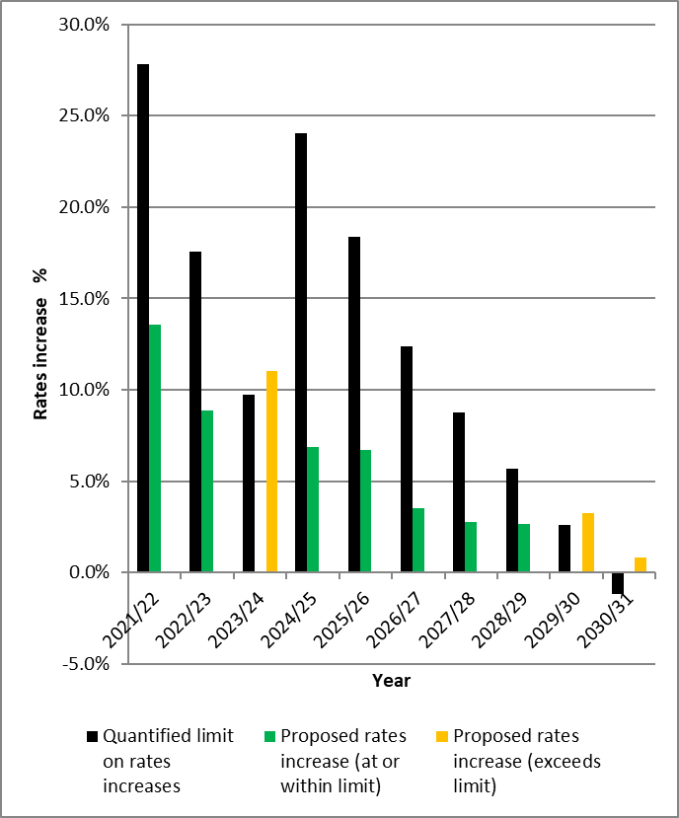

**Debt affordability benchmark**

**Net borrowing as a percentage of income**

The following graph compares the council's proposed borrowing with a quantified limit on borrowing stated in the financial strategy included in the council's long-term plan. The quantified limit is net borrowings, comprised of borrowings less cash and cash equivalents, being less than or equal to 225% of income. For this measure income is defined as total revenue less vested assets and development contribution income.

The council meets the debt affordability benchmark if its planned borrowing is within each quantified limit on borrowings.

The proposed debt to income ratio is forecast to be above the quantified limits in years 2025/26 and 2026/27. This is a result of a combination of additional borrowing forecasts and the impacts of decreased council revenue (social housing rents) related to the establishment of a Community Housing Trust. Council will re-examine rates and debt benchmarks as a part of the next Long-Term Plan in 2024.

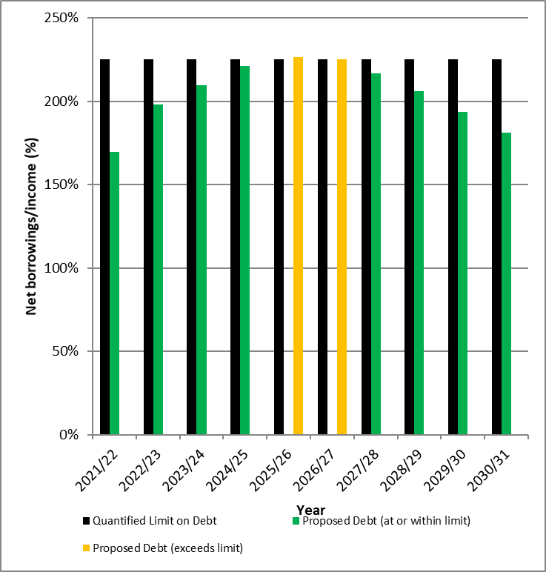

**Balanced budget benchmark**

The following graph displays the council's revenue (excluding development contributions, financial contributions, vested assets, gains on derivative financial instruments, and revaluations of property, plant, or equipment) as a proportion of operating expenses (excluding losses on derivative financial instruments and revaluations of property, plant, or equipment).

The council meets this benchmark if its planned revenue equals or is greater than its planned operating expenses. In 2022/23 the planned revenue falls below the planned operating expenditure (97%).

There are no material changes to the measure as a result of the establishment of a Community Housing Trust.

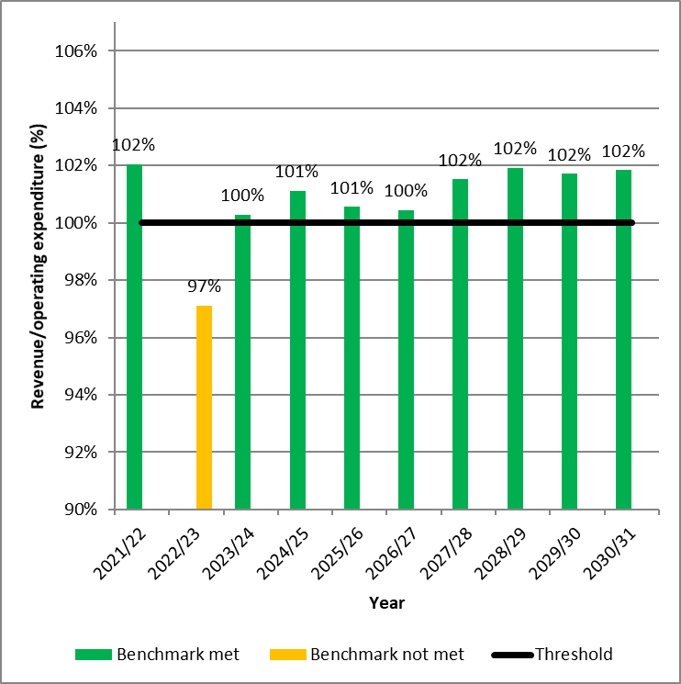

**Essential services benchmark**

The following graph displays the council's planned capital expenditure on network services as a proportion of expected depreciation on network services. Essential services comprise expenditure on the three waters and transport.

The council meets the essential services benchmark if its planned capital expenditure on network services equals or is greater than expected depreciation on network services. In years 7 to 10 of the plan the level of capital expenditure on network services falls below depreciation. This is driven by capital expenditure to improve levels of service occurring in the later years; the depreciation impact from this capital expenditure lags behind the renewal/replacement investment. The depreciation is only for the existing assets in commission and is not related to the capital expenditure of assets yet to be commissioned.

There are no material changes to the measure as a result of the establishment of a Community Housing Trust.

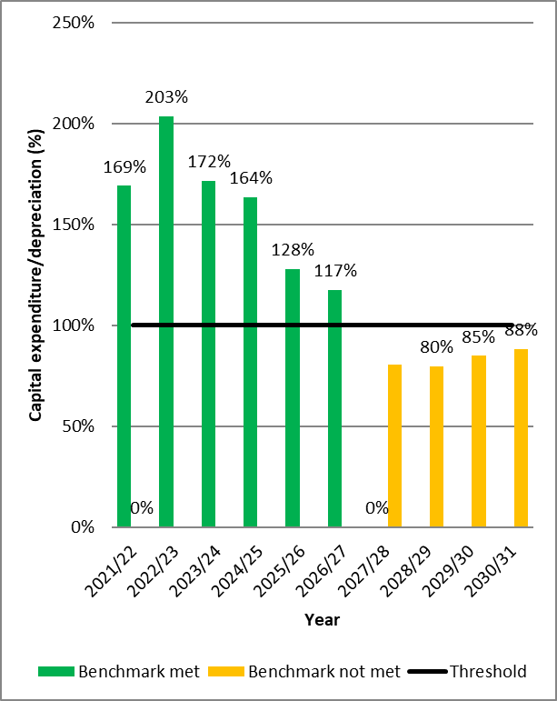

**Debt servicing benchmark**

The following graph displays the council's planned borrowing costs as a proportion of planned revenue (excluding development contributions, financial contributions, vested assets, gains on derivative financial instruments, and revaluations of property, plant, or equipment).

Because Statistics New Zealand projects the council's population will grow more slowly than the national population growth rate, it meets the debt servicing benchmark if its borrowing costs equal or are less than 10% of its revenue.

There are no material changes to the measure as a result of the establishment of a Community Housing Trust.

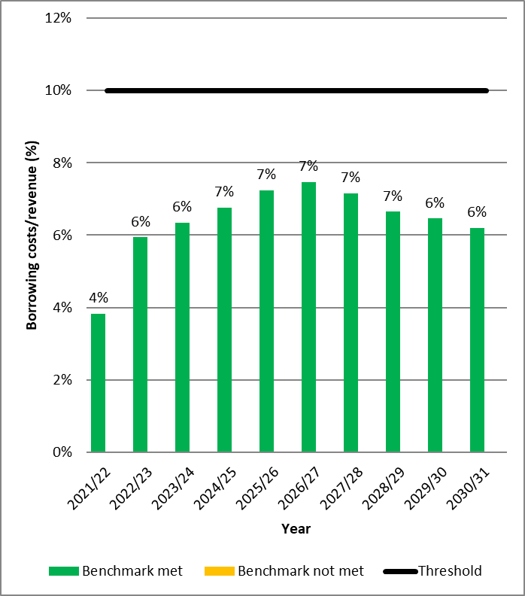

# Financial and Infrastructure Strategy

*Taken from Volume 2: Financial and Infrastructure Strategy pages 18-70*

## Financial trends and implications

*Taken from Volume 2: Financial and Infrastructure Strategy page 25*

This amendment will remove the requirement for the highlighted text below in this section of the Financial and Infrastructure Strategy given the amendment will resolve future uncertainty of a preferred operating model for city housing.

|  |
| --- |
| Text to be removed shown below:  The below graph shows the projection of the Councils net debt level against the limit of debt to income ratio of 225%.  Chart showing debt levels compared to Council limits. It is summarised in the text.  This shows the proposed capital expenditure program is causing the Council to exceed the debt limit up until 2027/28. ~~This programme includes $445m of capital expenditure on the social housing portfolio, despite this not being the preferred option. This full capital funding has been included for completeness as a default position until further certainty can be gained on a preferred operating model that will attempt to meet the ongoing financial sustainability of this service.~~ |

## Challenges

*Taken from Volume 2: Financial and Infrastructure Strategy page 29*

### Challenge 2 – Housing and Urban Development - Growing & Changing

#### Response - Providing social housing

The Council is already one of the city’s, and country’s, largest providers of social rental housing, with more than 1,900 homes across the city. WCC provides social housing to people on low-incomes and the city’s most vulnerable people.

Currently, City Housing faces both a funding challenge, with an average $26m annual operating deficit over the first 10 years, and a financing challenge, as it is unable to meet the estimated cost to complete the Housing Upgrade Programme (HUP). The rents are also becoming increasingly unaffordable for tenants. Rents are currently set at 70% of market rent (a 30% discount on rental rates necessary to make tenancies more affordable), and market rental prices are increasing in Wellington (71% increase in market rents since the Deed was signed). There is not a single, simple solution to our financing and funding challenges – a number of changes are needed. WCC is seeking to achieve several objectives through the proposed changes:

* Commit to partnering with Central Government, mana whenua and other partners to increase social housing provision in Wellington
* Providing security of tenure and affordable rents for our tenants
* Improve our financial position for the remainder of the Deed period and manage housing cost pressures alongside other Council funding issues
* Complete the full upgrade programme, including meeting new regulatory requirements that were not in effect when the Deed was signed
* Creating new revenue sources to reduce reliance on rental income from tenants.

The Council plans to establish a Community Housing Provider (CHP) to take over the management of its social housing units. Following a transition period, this will resolve the financial challenges facing the Council and stabilise housing portfolio as a CHP will be able to access the Government’s Income-Related Rent Subsidy for new tenants. Given they can access other government subsidies for housing development, a CHP will also be well set up to add to social housing supply in Wellington.

The Council has also set the Te Mahana strategy to end homelessness in Wellington. It weaves international best practice with culturally specific steps for ending homelessness, to establish short and medium-term priorities for action.

## Community Infrastructure

*Taken from Volume 2: Financial and Infrastructure Strategy pages 68-69*

#### Social Housing upgrades

The Council has more than 1,900 social housing units across the city. In 2007, we signed a Deed of Grant with Central Government. It commits us to remaining a provider of social housing until at least 2037 and to upgrading our housing portfolio to modern standards.

We have completed phase 1 of the upgrades, for which we received a $220m grant from Central Government. Phase 2 is due to begin in 2022 and be completed by 2028. By 2024, we also need to complete further upgrades to meet the new Healthy Homes standards set out in legislation.

We plan to undertake this full upgrade programme, however as outlined earlier in this Strategy, there are fundamental financial sustainability issues and City Housing operational revenue is currently unable to sustainably fund this level of investment and operate a sustainable social housing service.

In order to address this, we will be establishing a Community Housing Provider (CHP) entity. Once established, the CHP will take over operating our social housing. This will enable new tenants to be able to access the Government’s Income Related Rent subsidy.

The Council will be involved in the CHP, including continuing to own the housing stock (leasing it to the CHP for social housing) and contributing to the CHP’s governance by appointing some of the trustees to the governance board, but the Council will not be in majority control. The CHP will instead be an independent trust with a dedicated focus on the provision of affordable, quality and sustainable social housing in Wellington.

To operate, the CHP needs to be registered with the Community Housing Regulatory Authority (CHRA). This means the CHP is a regulated entity. The CHP would be required to comply with a strong regulatory framework to ensure it is well-run and that it delivered the outcomes expected by tenants, the community, and the council. CHRA requires CHPs to meet performance criteria which cover governance, management, tenancy management, financial viability, and property and asset management.

As well as regulatory requirements, the CHP would be monitored through its governing documents, particularly the trust deed and the leasehold agreement between the council and the CHP.

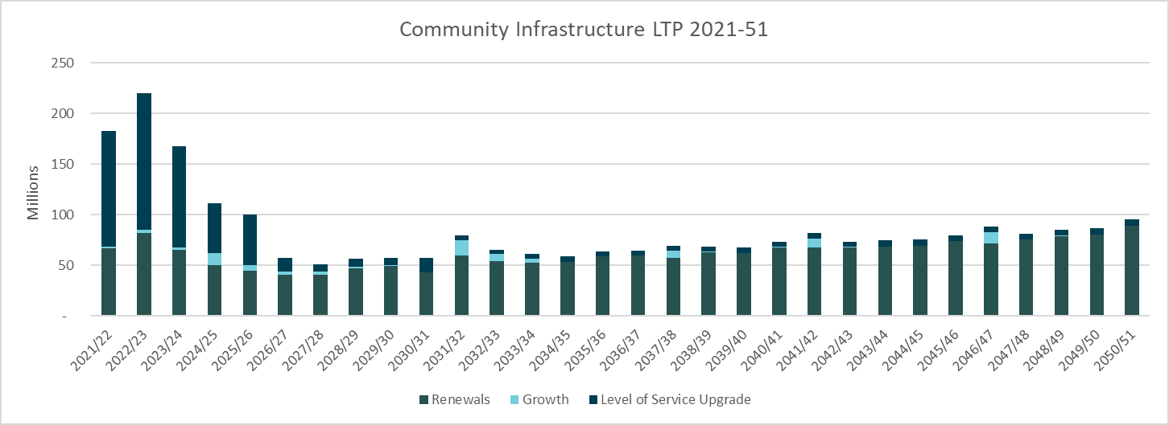

*The above graph is inflated.

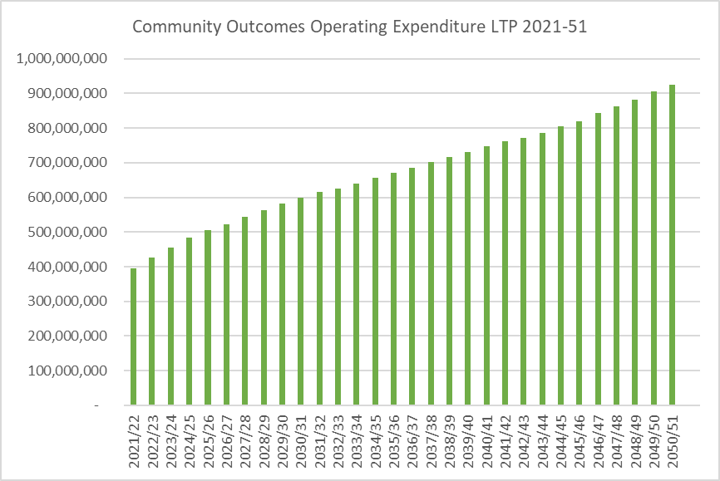

*The above graph is inflated.

# Revenue and Financing Policy

*Taken from Volume 2: Revenue and Financing Policy page 136*

## Activity 5.2.5: Housing

The Council owns over 1900 housing units, which we rent to low income people whose housing needs are not met by the private sector. We allocate these homes according to need. Tenants are charged 70 percent of the estimated market rent for their property.

**Community outcome**

This activity contributes towards the following outcome:

* *A people friendly, compact, safe and accessible capital city* -they provide an opportunity for a home and a better quality of life for those less well-off without unreasonable hardship.

|  |  |
| --- | --- |
| Who benefits? | |
| Individuals/Users | 90% |
| Whole community | 10% |

The main beneficiaries of this activity are the tenants, who receive accommodation at below market rent. Their benefits are private and exclusive. While the Council’s rental housing units are aimed at meeting needs that the market does not or cannot meet, to some extent these housing units are in competition with properties provided by private landlords.

However, there are some benefits to the community as a whole. By providing homes for people who otherwise may be unable to afford them, the Council also contributes to community cohesion and may have benefits for public health and safety.

|  |  |
| --- | --- |
| Who should pay? | |
| Individuals/Users | 100% |

As the main beneficiaries, it is appropriate for tenants to pay all of the costs involved in providing community housing. The Council’s current policy is to provide homes at 70 percent of market rent as the starting rental rate. Further subsidies and discounts are applied on top of that. The City Housing activity is ring-fenced with user charges through rent income funding 100% of operating expenses. The opportunity cost of not obtaining market rentals is not included in this funding analysis.

|  |  |
| --- | --- |
| Our funding targets: operating expenses | |
| User charges | 100% |
| Other revenue | 0% |
| Targeted rate | 0% |
| General rate | 0% |
| Total | 100% |

NOTE- following the establishment of a Community Housing Provider this activity will shift from the provision of housing units directly to tenants to the leasing of these units to the Community Housing Provider.

The policy will be updated with the 2024 Long-Term Plan following establishment of the CHP and transfer of management of social housing.

# Significant forecasting assumptions

*Taken from Volume 2: Significant forecasting assumptions page 4*

## Social housing

### Assumption

That the Community Housing Trust will be granted the necessary funding contracts by the Government in order to be able to access IRRS

### Data

Experiences of other local authorities in the establishment of their community housing trusts and discussions with the government.

### Level of certainty

**Moderate –**  funding secured for first two years through Budget 22 and moderate level of certainty over the longer-term. As well as providing funding for two years, the government has committed to continuing to work with the Council on funding arrangements beyond two years. This two years of funding is for IRRS on a turnover basis for the existing housing stock. Funding is also available, on a permanent basis, for any new supply the CHP builds.

### Key Risks

#### Risk

If the CHP does not secure the necessary funding contract

#### Effect of risk

Financial performance of the CHP could suffer, and the CHP would take longer to reach sustainable level.

If the CHP did not secure any funding contract, the CHP would be in the same financial situation as the Council currently. This would mean the council would need to re-examine financial support through council rates and debt. If the CHP received a funding contract on lesser terms that what have been assumed, the council would need to provide some level of rates support to the CHP for a longer time period.

#### Mitigation

The council continues to work actively with central government to resolve City Housing’s financial sustainability.

In Budget 22, the government provided initial funding to support the CHP’s establishment and first two years and committed to continue working with the Council on funding arrangements beyond two years.

The funding arrangements agreed to in Budget are similar to those facing other CHPs, including those put in place in the establishment of OCHT in Christchurch. All CHPs work with government on an ongoing basis to secure their ongoing funding needs.

The government was comfortable with the council considering the options in the consultation. The council is sharing information with the government on the nature of the financial support that the CHP requires to be sustainable and about the ongoing work in designing the CHP to ensure it will deliver outcomes for both Council and government.

## Social housing

### Assumption

That the level of tenant turnover will continue at historical rates resulting in projected increased revenue for the CHP over time from IRRS, and in turn the projected level of improving financial performance. Forecasting assumes the CHP would reach a sustainable position within ten years.

### Data

Experiences of other local authorities in the establishment of their community housing trusts and historical City Housing tenant turnover data.

### Level of certainty

Moderate

### Key Risks

#### Risk

That tenant turnover does not match forecast turnover

#### Effect of risk

Financial performance of the CHP could suffer and take longer to reach sustainable level than the ten years assumed in the forecasts.

#### Mitigation

If the rate at which the CHP received the IRRS was lower than assumed in the forecast assumptions, the council would need to re-examine financial support through rates and debt funding.

## Social housing

### Assumption

That any necessary changes to the City Housing Deed of Grant with the Government will be made to establish Community Housing Provider as planned.

### Data

Conversations with central government

### Level of certainty

**High**

### Key Risks

#### Risk

That any necessary changes are not made to the Deed of Grant

#### Effect of risk

The effect of the risk depends on the specific aspect of the Deed that may not be amended. But generally, the effect would be a lack of certainty for the government, council and CHP about roles and responsibilities, and/or some reduced flexibility in the CHP’s ability to operate in accordance with its other governing documents (e.g., its Trust Deed)

#### Mitigation

The council continues to work actively with central government to resolve City Housing’s financial sustainability. Both the council and government have strong shared interests and are looking for constructive and pragmatic solutions.

The government is comfortable with the council considering the options in the consultation and understands the council’s requirements to consult under the LGA. As part of these conversations, the council and government are considering any implications or necessary changes to the Deed of Grant and working on making necessary changes.

## Social housing

### Assumption

That the CHP would have its registration approved by the Community Housing Regulatory Authority so that it can operate

### Data

Conversations with central government and preliminary discussions with the Community Housing Regulatory Authority

### Level of certainty

High

### Key Risks

#### Risk

That the CHP does not achieve registration by the Community Housing Regulatory Authority

#### Effect of risk

The CHP would not be able to operate until it was registered. The council would need to continue to operate the social housing service and meet its costs through rates and borrowing until the CHP was registered.

#### Mitigation

The council has begun the process to assess the requirements for registration and work needed to submit an application and will have early conversations with the Community Housing Regulatory Authority to understand the registration process. Understanding the process well and beginning preparatory work early will help ensure a successful application.

## Social housing

### Assumption

That the CHP will be able to generate new housing supply through access to government subsidies and upfront capitalisation by the council.

### Data

Conversations with central government and experiences from other local authorities who have established their own CHPs.

### Level of certainty

Moderate

### Key Risks

#### Risk

That the CHP is not able to access necessary subsidies for new housing supply and/or that the capitalisation funding from the council is not sufficient to deliver new supply.

#### Effect of risk

The full benefits of a CHP option would not be realised. The CHP would still result in improved rental affordability for tenants and improved financial sustainability but not new social housing supply

#### Mitigation

The council has considered the approaches of other local authorities (particularly Christchurch) in determining how much upfront capital would be necessary to enable the CHP to deliver new housing supply quickly. These lessons have been built into the council’s preferred CHP option. The council is also talking to central government to understand what subsidies may be available to the CHP, and their eligibility criteria to inform the process of CHP design and establishment.