Consultation document
Our 10-Year Plan
Tō mātou mahere ngahuru tau
Wellington City Council

WELLINGTON CITY COUNCIL’S DRAFT LONG-TERM PLAN 2018–28

This document includes:
- an overview of the priority areas and proposals we need your feedback on
- our preferred options for each priority area
- a description of the impact these issues will have on rates, debt and levels of service.

This is a consultation document.
The purpose of this document is to provide information on Wellington City Council’s Draft Long-term Plan 2018-28 and encourage community feedback. It is prepared in accordance with the Local Government Act 2002.

Contents
Part one 4
Mayor’s introduction 4
CEO overview 7
The purpose of this plan 9
We want your feedback 9
How Wellington is performing 10
Our challenges as a city 10
Part two 12
Our vision 12
Priority areas 13
Resilience and environment 14
Te Manahau me te taiao 14
Housing 19
Ngā Kāinga 19
Transport 24
Ngā Waka Hare 24
Sustainable growth 28
Te Kauneke Tauwhiro 28
Arts and culture 33
Ngā Toi me te Ahurea 33
Part three 36
Where we have come from 36
Looking after our assets – our infrastructure strategy 37
Responding to growth 38
Renewing our assets 39
Responding to demands for improved service levels 39
Overall capital expenditure 41
Our financial strategy 43
Borrowing 44
Spending in activity areas 45
Paying for the proposed programme 46
Can we sustain this level of investment? 46
Fees and charges 47
Rates limits 47
How this plan will affect your rates 48
Your Mayor and Councillors 50
Auditor’s report 51
Have your say 53
What happens next? 53
To find out more: 53

Part one

Mayor’s introduction

  - This is an ambitious plan – let us know what you think
Wellington is a city of ideas, imagination and creative people. It’s a city where people want to work and live. But to maintain our high living standards, we need to prepare ourselves for the challenges ahead. Our population is growing and this, alongside other factors of change, means we need to invest in our future.
To adequately meet the challenges we face, we’ve identified five areas we believe we need to focus our spending on over the next 10 years – resilience and environment, housing, transport, sustainable growth, and arts and culture.
Up to 280,000 people are expected to call Wellington home by 2043 and we need to make sure there is enough safe and affordable housing for everyone. As part of our response, we’ve set a goal and programme of work in place to deliver 750 new social and affordable houses over the next 10 years in partnership with others, and we’re taking steps to simplify consents. In partnership with others, we’re also investing in an accommodation option for people who have experienced chronic homelessness and long-term addiction problems.
A growing population means we need to improve our transport network. We’re doing this in partnership with the NZ Transport Agency and Greater Wellington Regional Council. As part of the consultation process, thousands of submitters have already made their feelings known, with Wellingtonians indicating they want to see improved public transport, walking and cycling routes and reduced congestion.
Since the November 2016 earthquake, we’ve made resilience a priority. We’re already working in several areas, from undertaking major earthquake-strengthening work to exploring alternative sources of water supply, but we will need to continue to invest to make the city safe.
Resilience is also about making sure our growth is sustainable. Our aim is to make Wellington a place where businesses can thrive and connect with others, locally and globally.
Wellington is New Zealand’s creative capital, and we want to keep it that way. We want to invest in our arts and culture to create jobs, attract world-class acts and support local talent.
To undertake this work will require additional borrowing of $664 million to fund capital expenditure over the 10 years of this plan.
To keep our rates low has required a strong commitment from Councillors and officers. We’ve been able to keep our rates increase for 2018/19 to 3.9 percent and an average of 4.1 percent over the 10years, which compares favourably to what other cities are proposing.
These are challenging and exciting times. We’re investing in the city’s future, laying the foundations now for a better tomorrow. We have work to do, but we’re on the right track.
Justin Lester
Mayor

He whakamahere nui tēnei – he aha ōu whakaaro
Nā Justin Lester
Ko te tāone nui o Pōneke anō he pā tangata rau, he pukenga whakaaro, he puna waihanga. He tāone nui ia e paingia e te rau tangata hei wāhi noho, hei wāhi mahi. Heoi me noho takatū tātou kia mau tonu ai ngā āhuatanga ake o tō tātou noho tōnui. Ko te taupori ia kei te tipu haere tonu, nā tēnei āhua me ētahi atu panonitanga, me anga te titiro ki ngā rā kei tua.
Kua tautuhia ngā wāhi e rima e pono nei mātou koirā ngā wāhi hei whakapaunga pūtea mā mātou mō ngā tau 10 kei te tū mai, hei whakautu ki ngā wero kei mua i te aroaro, arā, ko te whai whare, ko ngā waka, ko te manawaroa, ko te tipu toitū, ko ngā toi me te ahurea.
Taka rawa ki te tau 2043, tata ki te 280,000 ngā tāngata ka noho kāinga ki Pōneke nei, ā, me mātua whakarite mātou kia whiwhi whare pai, whare haumaru ngā tāngata katoa. I tēnei wā, ko te whāinga kia noho rangapū I te taha o ētahi atu kia hangā e 750 whare pāpori hōu I roto I ngā tau tekau kei te tū mai. Me te aha, e whai ana mātou kia māmā ake te tukanga whakaae hanga whare. I runga hoki i te whakahoatanga ki ētahi atu, kei te whakapau pūtea ki te whakarite wāhi noho mō te hunga rawakore me ērā kua roa e raru ana i te kai pūroi.
Nā te tipu haere o te taupori me whai mātou ki te whakapai ake i ngā ara mō ngā waka. Hei whakatutuki i tēnei kaupapa, kei te mahitahi mātou ko Waka Kotahi me te Greater Wellington Regional Council. I runga i te tukanga kimi whakaaro i whakaritea, e hia mano tāngata kua tuku whakaaro mai me te kī mai, ko tō rātou hiahia kia pai ake ngā waka tūmatanui, ngā ara hīkoi, ara paihikara hoki me te whai kia iti ake te maha o ngā waka i ngā huarahi.
Mai i te wā o te rūwhenua i Whiringa-ā-rangi 2016, ko te te manawaroa tētahi o ō mātou kaupapa mātāmua. Kei te mahi kē mātou i ētahi wāhi, pērā i te whakakaha i ngā whare ki ngā whiu o te rū me te tūhura kia whai punawai rua mō tātou, engari tonu kei te whakapau rawa mātou kia haumaru ai tō tātou tāone nui.
Ko tētahi āhua o te manawaroa ko te whai kia toitū ai te tipu o te tāone nui nei. Ko tō mātou whāinga ia kia toitū a Poneke e tipu ai te pakihi me te hono, tētahi ki tētahi; ā-taiwhenua, ā-ao whanui hoki.
Ko Pōneke te tino pārekereke o te auahatanga ki Aotearoa, ā, me whai mātou kia pērā tonu tōna āhua mō ake tonu atu. Me whakapau rawa mātou ki ngā kaupapa toi, ahurea hoki kia tipu ai he tūranga mahi, kia tō mai ai i ngā kaiwhakatūtū rangatira rawa o te ao me te tautoko tonu i ō konei hoki.
Kia taea ai tēnei kaupapa nui te whakarite, e $664 miriona te nama kia whakaae ngā mahi kia mahia I roto I ngā tekau tau kei te haramai.
Kua kotahi te whakaaro o ngā kaikaunihera me ngā āpiha kia iti ngā reiti, nā reira kua mau ki te 3.9% te pikinga reiti mō te tau 2018-19 me te 4.1% te pikinga reiti mō nga tau 2018 - 2028, ā, he mea pai tēnei ina whakatairitea ki tā ētahi atu tāone nui ki Aotearoa.
He wā whakataratara, he wā whakaongaonga hoki ēnei wā. Kei te whakapau rawa mātou ki te āpōpō o te tāone nui nei, arā, he whakarite i te tūāpapa iāianei, kia pai ake ai te āpōpō. He nui te mahi mā mātou, heoi kei te aratika mātou e haere ana.
Nā Justin Lester
Koromatua o Pōneke

CEO overview
  - We’re up for the challenge
When I started as Chief Executive in 2013, the Council’s focus was on stimulating economic growth. Wellington is now a high growth city with a strong economy and continues to be recognised as one of the world’s most liveable cities.
While there is an upside to growth, there are also challenges. Growth needs to be sustainable and managed well to ensure Wellington is a successful city for all. We need to make our city more resilient as the earth moves, climate changes and sea levels rise.
The Mayor and Councillors have set an ambitious plan for the next 10 years. The capital investment programme alone totals $2.31 billion. The plan is focused on improving the city’s resilience, developing our transport network, enhancing our cultural facilities, helping to increase the number of homes and securing growth by continuing with our economic development agenda. It also aims to maintain and renew our existing assets, such as libraries and playgrounds.
This plan will result in an increase in the Council’s debt from $507 million to $1.17 billion over 10 years. We will borrow to fund the initial investment, and then spread the cost across the years the asset is in use through rates. The Council has the balance sheet capacity to undertake this investment (reflected in our AA credit rating) while remaining within prudent debt levels.
We are also delivering improved service levels in a number of operational areas without any service level cuts elsewhere.
This plan is not without risk, both in our ability to deliver the capital programme and to meet the service level expectations of Councillors and the public.
The impact of asking officers to deliver more for less is going to be a huge challenge and the task set by our Councillors is daunting. But we wouldn’t have it any other way. Our Councillors have been clear on the outcomes they want us to achieve, and this plan helps set those priorities. We need to be even more agile and innovative in how we deliver those outcomes. We’re up for the challenge. Let’s do this… together!
Kevin Lavery
Chief Executive

  - Kua rite mātou
Kevin Lavery, Tumuaki
Nōku i tīmata hei Kaiwhakahaere Matua i te tau 2013, ko te whakatipu ōhanga te aronga matua a Kaunihera. I āianei kua tipu kaha a Pōneke me tōna ōhanga kaha anō me te aha kua mōhiotia tonutia ko ia tētahi o ngā tāone nui tino pai rawa hei wāhi noho.
Haere ana te pikinga me ōna painga me ngā wero hoki i te taha. Me mātua whai kia tuwhiro te tipu, kia tika hoki te whakahaere kia nui ngā painga o Pōneke mo te katoa. Me whai tonu tātou kia manahau ake tā tātou tāone nui i ēnei wā e oreore nei a Tuanuku, e huri nei a Huarangi, e piki nei ngā tai o Tangaroa.
Kua whakaritea e te Koromatua me ngā Kaikaunihera tētahi mahere hao nui mō ngā tau 10 kei te tū mai. E $2.31 piriona te nui o te kuapapa whakangao rawa. Ko te aronga o te mahere nei ko te whai kia pai ake te manahau o te tāone nui, te whakawhanake i te pūnaha waka, te whakarei i ā tātou rauhanga ahurea, te whai kia piki ake te maha o ngā whare me te whakapūmau i te tipu mā whai tonu i tā mātou kaupapa whakatipu ōhanga. Ko tētahi whāinga anō ko te pupuri me te whakahou i ō nāianei rawa pērā i ngā whare pukapuka me ngā papa tākaro.
Ko tētahi hua o tēnei mahere ko te piki kia nui atu te nama a te Kaunihera, mai i $507 miriona ki $1.17 piriona i roto i ngā tau 10 kei te tū mai. Tuatahi, ka minono pūtea mātou hei moni punga, ā, ka whakarite kia hora ai te utu mō ngā tau e whakamahia ana te rawa, mā ngā reiti. E ai ki te ripanga kaute a te Kaunihera (me te AA whakataunga moni taurewa) ka taea e ia tēnei kaupapa whakangao te kawe me te whai kia matawhāiti tonu te penapena i tōna pūtea.
Kei te tuku ratonga pai ake mātou i ētahi wāhanga whakahaere me te aha e kore e poroa ētahi o ngā ratonga o wāhanga kē.
Kei tēnei mahere ōna anō āhuatanga mōrea, mō tō mātou kaha ki te whakatutuki i te kaupapa whakangao, ki te whakarite i ngā hiahia o ngā Kaikaunihera me te iwi whānui.
He tino wero tēnei arā, te whakahau i ngā āpiha kia kaha ake te hāpai i ngā mahi, ahakoa ka noho pērā tonu te nui o te pūtea, he mea wehi tēnei whakatau a ngā Kaikaunihera. Heoi, koia tonu te whakatau me te wero. Me mātua whakamārama ngā Kaikaunihera i ngā whāinga mō tātou, ā, kei te mahere nei ngā whāinga mātāmua. Kia kakama tātou, kia tuwhera te ngākau me te hinengaro kia tutuki ai ngā whāinga nei. Kia takatū, kia rite! Mā tātou katoa . . . mō tātou katoa!
Kevin Lavery
Tumuaki

The purpose of this plan
  - We’re investing in Wellington’s future.

This document explains what we propose to invest in over the next 10 years to make our city more resilient, vibrant and competitive, and to make sure our residents continue to live well. It gives Wellingtonians the opportunity to join the conversation by telling us what matters to them.
The feedback we get during this consultation will help us shape Our 10-Year Plan.

Supporting information
This consultation document outlines the major matters that we are asking for feedback on. More detail that supports this consultation document is available on our website http:// www.Wellington.govt.nz. This includes:

- Significance and Engagement Policy  - Housing Strategy  - Revenue and Financing Policy  - Financial and Infrastructure Strategy  - Rates Remission Policy  - Rates Postponement Policy  - Investment and Liabilities Policy  - Summary of Significant Accounting Policies | - Statements of Service Provision (includes information on outcomes, performance measures and CCOs, development of Māori capacity to contribute toward decision-making)  - Funding Impact Statements  - Three-Year Draft Waterfront Plan  - Fees and Charges  - Significant Forecasting Assumptions

We want your feedback

Some of the challenges we face are significant, and how we deal with them through this plan will affect the city for generations to come.
As you read on, think about the choices we’re proposing. Have we got the balance right? Should we be doing more, or less, in each of these areas?
While we won’t be able to please everyone and improve everything, our aim is to do our very best by Wellington – while keeping rates manageable.

How Wellington is performing

Three years ago, our city’s economy was underperforming and we invested in a range of economic stimulus projects as part of the Long-term Plan 2015-25.
The situation has evolved since 2015. While our economic growth is still behind that of other major cities, it has significantly improved.
While a strongly performing economy continues to be a priority, we also now need to manage the impact of growth.
What does a well-performing city look like? A healthy, thriving city is one that does the basics well, is clear about its future and how to get there, brings the Council and its stakeholders together to deliver on that future, and has strong commitments to better environmental, economic and social outcomes.
By many standards, our city is doing well. Wellingtonians enjoy a quality of life that’s among the highest in New Zealand, and the capital consistently places among the world’s top 30 cities in international surveys that measure liveability and quality of life. In 2017, a Deutsche Bank study rated Wellington number one in the world for liveability.
We have low deprivation levels compared to other cities in New Zealand. Nationally, we also have the highest percentage of people with a tertiary education, and the highest average household incomes.
The Council’s overall financial position is healthy. This is reflected in our AA credit rating with Standard & Poor's, the highest for a public sector entity in New Zealand. Our services are also value for money. In 2018/19 it will cost about $6.46 per resident per day to deliver all Council services.
While there is much to celebrate, as with all cities, there are also challenges.

Our challenges as a city

While Wellington is performing strongly, it does have challenges ahead. We can – and should – use resources more efficiently and effectively, and continue to reduce harmful impacts on the environment.
We can do more to inform and engage with residents. While according to many indicators the city is doing very well, we recognise that not everyone in Wellington enjoys high living standards.
Homelessness and street begging are on the rise – and while we provide support and play a role through a variety of outreach programmes, there is more work to do.
These are challenges we share with other cities throughout New Zealand, and indeed globally. Throughout Our 10-Year Plan you will see projects that seek to address these challenges.
There are also some very specific challenges that we face as a city that we have decided to make a priority in this plan.
These include:
  - Managing the demands of growth
More people want to live here, and our population is growing rapidly. Up to 280,000 people are expected to call Wellington home by 2043. This will put pressure on transport, infrastructure, and housing – particularly in the inner city. This will require up to 30,000 more housing units, investment in transport infrastructure, and higher capacity in water and wastewater infrastructure.
  - Making the city more resilient
In November 2016, we experienced a significant earthquake that tested our city. It responded well, but there is more work to do. The climate is also changing and we need to find ways of living with more severe and frequent extreme weather events. We also need to factor in rising sea levels. In this plan, one of the key challenges will be to improve core infrastructure and invest in the city’s resilience. We’re proposing increased investment in Council buildings and core infrastructure to make the city more resilient.
  - Developing areas where we have a competitive advantage
We’ve invested extensively in the arts over many decades and our city has an enviable reputation as a centre of culture. That didn’t happen by accident: we, along with the government and others, have been supporting and investing in the sector for years. But other cities are also investing in these areas, and we need to make sure investment levels are high enough to support a thriving arts and culture sector in the city. A key area of investment for this plan is in earthquake strengthening key cultural facilities such as the Town Hall and the St James Theatre and increasing funding support for the city’s arts and cultural activities.
  - Maintaining economic growth
Wellington offers a very high quality of life, provides a good range of quality services and facilities, and looks after its people and the environment.
This requires a healthy economy as a foundation. Without a strong economy, the Council cannot sustain the services that are provided.
Our economy generally performs very well, but in terms of GDP growth it still lags behind the New Zealand average and other major cities in New Zealand. Our challenge is to maintain the current growth and support the diversification of the economy so it is sustainable. As a result, this plan includes investment in an indoor arena and a Movie Museum and Convention Centre.
As outlined above, meeting these challenges will involve a significant programme of work in the next 10 years and beyond. Many of our infrastructure assets for example, have useful lives beyond 60 years.
In planning the proposed investment programme in this plan we have also considered:
- the Mayor’s and Councillors’ Triennium Plan (3-year work programme)
- the delivery of a number of large and complex priority-area projects in the next 10 years
- our infrastructure asset management plans that look at the next 30 years and beyond.

Do you agree these are the key challenges facing the city?

Part two

Our vision

  - Our long-term vision
Our 10-Year Plan continues our work toward the strategic vision we have adopted for the city, as defined by Wellington Towards 2040: Smart Capital. This vision sets out our aim to grow and sustain the city as “an inclusive place where talent wants to live”.
The strategic vision is supported by four city outcomes or long-term goals that determine our core activities and set the long-term vision:

- People-centred city  People are the city’s greatest asset. Wellington’s shape and character will continue to reflect the people who live in, work in, and visit the city. The city will be healthy, vibrant, affordable and resilient, with a strong sense of identity and place expressed through urban form, openness and accessibility. | - Eco city  Developing Wellington as an eco city means proactively responding to environmental challenges. It is important that Wellington takes an environmental leadership role, as the capital city of clean and green New Zealand. Our many natural assets give the city a head-start and opportunities as part of a green economy.
- Connected city  Wellington is a connected city, with easy access to regional, national and global networks. Connections are physical, allowing for ease of movement of people and goods; virtual, in the form of world-class ICT infrastructure; and social, enabling people to connect with each other and their communities. | - Dynamic central city  Wellington is a city with a dynamic centre – a place of creativity, exploration and innovation. The central city will be a vibrant and creative place, helping Wellington to offer the lifestyle, entertainment and amenity of a much bigger city. The city centre will continue to drive the regional economy.

Priority areas
We want our city to continue to thrive. To achieve this, we need to understand and address the challenges we face. How we do this through Our 10-Year Plan will potentially shape the city for generations to come.
With the challenges in mind, we have identified the following priority investment areas:
- Resilience and environment – investing in core infrastructure, looking after the environment and making our city more resilient against future shocks

- Housing – investing in quality and affordable housing to accommodate our growing population

- Transport – investing in transport options to maintain easy access in and out and around our city, promoting alternatives to private car usage, and reducing congestion

- Sustainable growth – investing in economic projects that stimulate growth and diversification, and planning for population growth in ways that recognise the city’s special character

- Arts and culture – investing in arts and culture to maintain our position internationally as a vibrant, edgy capital

Even as we investigate and pursue these priorities, investing in our core business – what we also call “business as usual” – will remain a strong focus.

The following pages set out the issues, options and our proposed responses for each of our key priority areas. In the “Financial implications” sections on pages 14 to 35 we refer to the impact on the average rates bill. This is based on the indicative additional rates for a suburban residential property with a capital value of $600,000. The relative impact on other property types will depend on a range of factors, including relative capital value, our rating differential and how each of our activities are funded. For the overall impact of our proposals on other property types and capital values refer to the tables on page 49 of this document.

Priority area

Resilience and environment

Te Manahau me te taiao
We want our city to be stronger, our people better prepared.

The issues
We have obligations as kaitiaki (guardians) of this city. Preparing the city to better cope with shocks and making our infrastructure and communities more resilient is at the heart of that.
Investing in our environment, whether we’re dealing with predator species or coastal erosion, reducing waste, or strengthening core infrastructure such as pipes and heritage buildings, helps create stronger communities and make the city more resilient. Natural events like earthquakes and events caused by human-induced climate change, such as rising sea levels, highlight a greater urgency around environmental concerns. We need to be better prepared and stronger as cities and communities. While our city responded relatively well to the November 2016 earthquake, we need to guard ourselves better against the next one. At the same time, our population is growing in and this affects our housing supply (see the Housing section), the environment, and buildings.
For this priority area, we have a specific proposal for consultation and some projects we would like your feedback on.

Our proposal
While we have a better understanding of the risks facing our city, we expect that natural events and growth will continue to challenge our city’s infrastructure.
Ensuring that our drinking, storm and waste water infrastructure can cope with both natural events and future growth is a primary focus for this priority.
We are proposing to increase investment – and levels of service – in our ‘three waters’ infrastructure to:
- improve water storage in the city (to increase security of supply after an event)
- improve wastewater capacity in the city (to allow for growth)
- upgrade stormwater in the city to better deal with adverse weather events (to reduce flooding events).
This investment would increase the city’s resilience and ensure our infrastructure can accommodate projected growth.

The options
There are two options:

 | Key projects | Levels of service | Financial implications
Option 1:  Increase levels of service | Water storage capacity and network improvement*  - Central city: $32.2 million to increase water storage capacity by constructing the new Prince of Wales/Omāroro Reservoir, $21.6 million capital investment on improving the resilience of existing reservoirs and $39.6 million on increasing the capacity and improving the resilience of the water pipe network.  - Upper Stebbings: $12.4 million of capital expenditure in years 4 to 7 to develop more water storage to meet the growth and resilience needs of the northern suburbs.  - Horokiwi: $12.7 million of capital expenditure for water storage from years 5 to 8. | This project is expected to increase the resilience and capacity of the water storage facilities and pipe network for the central city and northern suburbs to cope with population growth and unpredictable natural disaster events. | For water storage capacity and network improvement projects, by year 10 of this plan this option will add:  - 22.7 percent or $109.9 million additional borrowings (after $5.2m of anticipated Prince of Wales/Omāroro Reservoir funding from Greater Wellington Regional Council and $3.4m of debt repayment)  - $171 (7.1 percent) to the average annual rates bill (equivalent to an average increase of $17.11 per year over the 10 years).
 | Wastewater network improvement  - Central city: $8.9 million to upgrade parts of the central city wastewater network to make it more resilient and able to accommodate population growth.  - $3.4 million to upgrade the wastewater network in Miramar.  - $13 million to increase network capacity in other parts of the network.  - Inclusion of a provisional amount of $34.6 million to address sewage sludge disposal. | This project is expected to increase the capacity of the wastewater network to accommodate growth and provide capacity to address future sewage sludge disposal – we will consult in more detail on this in future plans. | For wastewater projects, by year 10 of this plan, this would add:  - 10.9 percent or $55.1 million additional borrowings (after $4.8 million of debt repayment)  - $28 (2.0 percent to the average annual rates bill (equivalent to an average increase of $2.82 per year over the 10 years).
 | Tawa and Miramar Peninsula stormwater networks improvements  - $10.8 million to upgrade Tawa’s stormwater network’s capacity to cope with storms and flooding.  - $3.4 million of capital expenditure to upgrade the Miramar Peninsula. stormwater network and $10 million for core infrastructure at Shelly Bay.  - $32.4 million to upgrade capacity and resilience as we undertake renewal of parts of our stormwater network. | This project is expected to increase the capacity of the:  - Tawa stormwater network to cope with unpredictable events causing flooding (resilience)  - Miramar Peninsula stormwater network and Shelly Bay infrastructure to cope with future growth  - Improve resilience & capacity of the existing city-wide network. | For storm water projects, by year 10 of this plan this will have added:  - 10.8 percent or $54.8 million additional borrowings (after $1.8 million of debt repayment)  - $27 (1.1 percent) to the average annual rates bill (equivalent to an average increase of $2.74 per year over 10years).
Option 2:  Keep current levels of service | None of the above projects would receive increased funding. We would continue with current renewal programmes to maintain infrastructure, reduce our carbon emissions and raise our defences against climate change-induced events and the risk of another earthquake. | Our water storage capacity, wastewater network and both local (for example Tawa) and city-wide stormwater networks would come under increasing pressure as the city’s population grows and would be less resilient to future unpredictable natural events. | Existing budget levels would be kept. The increase in rates and borrowing identified in Option 1 would not be added to the rates and borrowing position.
Notes:
*Our proposed work to improve water storage in the city aligns with the proposed investment by Greater Wellington Regional Council to improve the water network infrastructure and to improve security of supply in the region. See page 17 for more information.

In addition to improving the resilience of the water network, we have also reviewed the Havelock North Water Enquiry findings. Wellington currently purchases water in bulk from the Greater Wellington Regional Council. This water is chlorinated to meet water health standards. We anticipate that increased water standards are possible in the future, but are not in a position to make any provision in our plans until the potential impacts are known.

Preferred option
Our proposed option is Option 1. Do you agree with the extra investment to enhance our resilience, provide for growth and improve the environment?

Why we think this is the best option
Since the 2016 earthquake, the likelihood of another significant earthquake has increased, and we have a better understanding of the risks facing our city. We are also experiencing more significant and frequent storm and flooding events. To better cope with these, and provide for growth, we believe it is prudent to improve our core infrastructure.

Other key resilience and environment projects we would like your feedback on
The following projects also support our resilience and environment objectives. Many have funding implications and are included in this plan for your feedback. In addition to these projects, we also intend to continue with our efforts to reduce carbon emissions across the city through investment in sustainable transport such as electric vehicle charging and car sharing, by supporting the city to grow in a compact and walkable way, and through better managing the city’s waste streams. We will be reviewing the Low Carbon Capital Plan, our carbon reduction strategy, in 2019.
- Building accelerometers
An accelerometer is a device that can measure the movement of buildings. Installing accelerometers in buildings across the city would provide us with better information immediately after an earthquake. This would mean decisions about the safety of buildings could be made more quickly, and would inform the initial response phase and subsequent recovery phase. We would not own the hardware, but some resourcing would be needed for us to monitor and analyse data. We’re developing a detailed business case in the coming year. Funding implications have not yet been determined and will likely be confirmed in 2019/20. We will consult further on this proposal at that time through the annual plan process.
- Resilience of the transport corridor
Wellington has an extensive transport network. Much of it is on steep hills that require substantial retaining walls below and above the carriageway. A number of these, including some tunnels and bridges, need to be strengthened in the coming years. This work is explained further in the ‘Transport’ section.

- Strengthening Council buildings
During the first years of Our 10-Year Plan, a number of Council facilities will be earthquake strengthened. Many of these facilities support cultural activities and this work is discussed further in the ‘Arts and culture’ priority area of the plan). Staff will also be moving to temporary office accommodation on The Terrace to allow for strengthening work to happen and ensure we occupy accommodation that is able to continue to function following a significant natural event such as an earthquake.
- Built Heritage Incentive Fund
Our Built Heritage Incentive Fund (BHIF) helps owners maintain their heritage buildings. In 2015, the fund was allocated $3 million over 3 years. We have currently allocated $450,000 in the draft budget towards the BHIF and $1 million of funding to support the repair of unreinforced masonry to improve the city’s resilience. The Council will consider bringing the BHIF back up to $1 million per year subject to finding commensurate expenditure reductions elsewhere so as to retain the proposed 2018/19 rates increase of 3.9 percent.

- Water security of supply
Plans to make the regional network more resilient in coming years and to improve the security of supply for Wellington will mean that the cost of bulk water is expected to rise. We purchase bulk water for Wellington from Greater Wellington Regional Council. There is planned investment in additional water sources from the aquifer under Wellington Harbour and/or cross harbour pipeline, as a backup to the existing supply pipe network. While it is Greater Wellington Regional Council that is planning to make this investment, these costs are passed on to Wellington City Council as operational costs within the Bulk Water budgets. As a result, the cost of supplying water to Wellington homes and businesses is proposed to rise from $17.9 million in year 1 to $27.4 million by year 10. Overall, we expect to spend $245.5 million over the 10 years for the supply of water to the city. We would like to hear people’s feedback on the resilience programme for the water network and also encourage people to make a submission on Greater Wellington Council’s long-term plan.

- Waste management and minimisation
Through the regional Waste Management and Minimisation Plan, Wellington is committed to reducing the volume of waste disposed of in landfills. The purpose of this plan, which involves all councils in the Wellington region, is to reduce the region’s waste to landfill by one third over the next 9 years. We plan to use existing waste minimisation funding to investigate the strategic future of landfills, better resource recovery and options to divert household kitchen waste from the landfill. There are no additional costs for this work at this time.

- Storm clean-up
The climate is changing and this is resulting in more frequent and severe weather events. We have put a $2 million capital fund aside for year 1 to address the impact of significant weather events on our parks, reserves and other network infrastructure. Altogether, $400,000 of capital expenditure will be allocated over the next 2 years to reduce the impact of erosion from last year’s storms, and around $100,000 of operational funding per year (from year 4) to support storm clean-ups for our roading team starting in 2021/22. A further $300,000 of capital expenditure is proposed for coastal resilience work in Worser Bay, Seatoun Beach and Evans Bay in the coming year.

- Predator Free Wellington
This project aims to gradually eradicate predators across the city and create the world’s first predator-free capital city. The programme starts on the Miramar Peninsula. It is proposed that we fund the project in partnership with Greater Wellington Regional Council, the NEXT Foundation and central government, as well as other partners and contributors, via the Predator Free 2050 Fund. Our proposed contribution is $2.6 million over the next 10 years.

- Community-led trapping
We are proposing to increase our support for community groups active in predator control and provide compost subsidies to manage the impacts of poor food waste management (including residential composting) on rat populations. We propose to provide $89,000 per year to support community groups installing and managing traps in our city’s reserves, and $22,000 a year in compost subsidies. This investment is necessary to support the goals of Predator Free Wellington.

- Addition of land to the Wellington Town Belt
In 2017, the Council acquired a 4221 square metre vegetated gully between Aro Street and Devon Street to add to the Wellington Town Belt. The land has ecological connections to nearby Zealandia and provides habitat for a wide range of native birds. A track will be built through the area connecting Abel Smith Street and Devon Street. It was identified as a priority for acquisition in the Wellington Town Belt Management Plan 2017 (page 110). For further information on this item please visit https://wellington.govt.nz/your-council/plans-policies-and-bylaws/policies/wellington-town-belt-management-plan
The Council proposes to formally gazette this land as Wellington Town Belt and requires feedback as required under the Wellington Town Belt Act 2016.

Priority area

Housing

Ngā Kāinga
We want all Wellingtonians to be well housed.

The issues
Our population has been growing steadily and more people are calling Wellington home than ever before. This growth has recently escalated, and this trend is forecast to continue.
Up to 280,000 people are expected to call Wellington home by 2043. This means we will need up to 30,000 more housing units to accommodate new arrivals.
In recent years, housing in Wellington has been relatively affordable compared to what it can cost in Auckland. We’ve been fortunate. But there is evidence of increasing pressure on our housing market, which will intensify as our population grows.
We want people to have good housing choices and be able to afford to buy homes in our city. To make this possible, we propose to be more actively involved in making sure there is enough high-quality housing stock in the city in the future.
For this priority area we have a specific proposal for consultation and some projects we would like your feedback on.

Our proposal
We are proposing to take a more active role to avoid an Auckland style housing crisis in Wellington. This means moving beyond our traditional consenting regulatory role and direct social housing provision, to more actively managing the land and housing portfolio we own to increase both social and affordable housing on those sites. This is likely to involve partnering with developers and other housing providers. We also propose to work with central government to explore introducing more Special Housing Areas into the city (with affordability as a measure).
Our Strategic Housing Investment Programme and the broader Housing Strategy aim to deliver on the above objectives. We are proposing $22 million of capital expenditure to deliver this work. The programme involves:
- identifying new land for development and existing Council housing sites for redevelopment and intensification
- undertaking master planning work, geotechnical work, and site clearance for redevelopment
- leveraging surplus land / sites to attract investment from other housing providers, developers and/or central government to deliver affordable housing.

Our plan also includes a total of $10.7 million operational funding over 10 years to service the borrowings and resource a team to facilitate the development of partnerships, prepare development proposals and make sites ready for the development (SHIP programme).

Construction of the Council’s social housing units will be funded through the existing Social Housing Upgrade Programme (and any disposal / lease of surplus land, which is expected to be at market values). The assumption on this plan is that construction of affordable housing units will be funded and delivered by development partners.

There is a degree of uncertainty around timing and quantity of any revenue from land disposal or lease arrangements. This can only be determined as business cases are prepared for specific sites. Consequently, while no specific funding has been included in our 10-year budgets, the model is designed for this revenue to go towards supporting the delivery of the Social Housing Upgrade programme.

At this stage we want to know whether Wellingtonians want the Council to increase its involvement in availability and provision of housing, beyond the social housing service it currently provides, to better support the availability of affordable housing across the city. We will consult further with the community as detailed plans are developed.

The options
There are two options:
 | Key projects | Levels of service | Financial implications
Option 1:  Increase levels of service | The Strategic Housing Investment Plan (SHIP)*  Make better use of existing Council housing sites (and other Council land) to increase the number of social and affordable housing in the city.  - We have an existing programme to upgrade existing Council social housing throughout the city. We are approximately half way through this programme of work and have $147.4 million in the budget over the next 10 years to upgrade or replace existing social housing units with new ones**.  - As we progress this work, we propose to leverage a proportion of those land/sites we own – either through lease arrangements or disposal – to attract investment from other housing providers, central government and developers to deliver affordable housing on those sites (in conjunction with the Council’s social housing). Once more detail is developed for each site, further engagement on the arrangements and funding options with stakeholders will take place.  - We are proposing an additional $22.1 million of capital expenditure and $10.7 million of operational funding over the next 10 years to get SHIP’s development programme going. Funding will be used for master planning, geotechnical work, developing partnership proposals, and preparing sites ready for development. | This project will make better use of existing Council land and housing sites to increase the number of quality affordable housing units in the city (funded by development partners.)  This work will deliver towards our goal of providing 750 new social and affordable housing units over the next 10 years with partners.  The ratio of social housing units to affordable housing units is still to be determined and will be guided by specific site proposals and discussions with partners. | For the Strategic Housing Investment Plan (SHIP), by year 10 of this plan, this option will add:  - $13 (0.5 percent) to the average annual rates bill (equivalent to an average increase of $1.30 per year over the 10 years)  - 4 percent or $20.1 million additional borrowings by year 10 (after $2 million of debt repayment).
Option 2:  Keep current levels of service | Maintaining current levels of service for this would see the Council continue to provide social housing, upgrade existing social housing stock and facilitate housing development through its regulatory functions (building consents and resource consents). | This option would mean that the Council would not leverage its land and asset ownership to increase the city’s supply of affordable housing, and would rely to a greater extent on the private market and central government to resolve the issue. | Existing budget levels would be kept. The increase in rates and borrowing identified in Option 1 would not be added to the rates and borrowing position.
Notes:
* Funding for planning for population growth and associated district planning work is outlined in the ‘Sustainable growth’ section. That work will outline how and where the city will grow over time to accommodate more people. Please see page 28 for more information.
** The Council has a commitment with central government to maintain our current social housing service levels until 2037.

Preferred option
Our proposed option is Option 1. Do you agree with the Council making better use of existing council land and to leverage third party investment for more affordable housing in the city?

Why we think this is the best option
We want a city where everyone is well housed. For some people, it’s become increasingly difficult to live in the city because of the cost and quality of housing. We can do more, and delivering on Option 1 would make sure more and better quality housing is available.

Other key housing projects we would like your feedback on
The following projects and strategies also support our housing objectives. Some have funding implications, and others may have funding implications in the future. They are included in this plan for your feedback. We would like to hear what you think before we make final decisions.

- Wellington Housing Strategy
We have developed a draft housing strategy that sets a framework for all housing in Wellington. The broad aim of the strategy is for “all Wellingtonians to be well housed”. The strategy covers the full spectrum of housing – from emergency housing, social housing, assisted rental, private rental, and assisted ownership, right through to private ownership. It sets four goals to be achieved over a 10-year period:
- Wellington has a well-functioning housing system
- Homes in Wellington are of good quality and are resilient
- Homes meet the needs of Wellingtonians
- The housing system supports sustainable, resilient and connected communities.

The draft strategy provides a framework for the proposals listed below. The full draft strategy can be found online at http://www.Wellington.govt.nz.
- Special Housing Areas (SHA’s)
In the coming year, we propose to work with central government to explore opportunities for developing new Housing Accord/Special Housing Areas in Wellington. SHA’s are areas where we can offer qualifying developments a streamlined resource consenting path and several incentives. We believe that additional Special Housing Areas are crucial to fast-track the supply of additional housing in Wellington. We will explore an accord with housing affordability as a component and an approach that speeds up consent processes. This work will be delivered from within existing budgets.

- Inner-city building conversions
Our approach to growth has always focused on intensification of existing urban areas. As part of this 10-year plan we want to take a serious look at how we can make better use of the inner city for housing by working with commercial building owners on an exemplar project to convert them to residential apartments. The first step is to explore options. This will be carried out in the first year and we only propose to continue with specific proposals if we are confident it will not impact on rates.
- Special Housing Vehicle (Urban Development Agency)
In recent years, we’ve consulted the community on taking a more active approach to housing and city shaping. The feedback was positive. As part of this plan, we are considering the establishment of a Special Housing Vehicle to deliver our housing and urban regeneration plans. The purpose of the Special Housing Vehicle is to enable us to take a more active approach towards delivering major housing capital projects, and more broadly urban regeneration projects in our city. This agency’s establishment is still under consideration. Central government is currently considering legislation relating to urban development authorities. Once this legislation is introduced, more detailed funding and operating models will be considered and consulted on with the community.
- Rental warrant of fitness
Housing quality is not always great in Wellington, particularly in the rental market. Last year, we initiated a voluntary warrant of fitness system, in partnership with the University of Otago, Wellington. Central government has also recently passed its Healthy Homes legislation, which requires higher standards from rental homes. In the coming year, we will evaluate the results of the rental warrant of fitness. Taking the government’s changes into account, we will look at whether Wellington needs a standard to lift the quality of housing. There are no cost implications for the Council at this time.
- Te Whare Oki Oki
Taking a Housing First approach, we are working in partnership with Housing NZ and the Ministry of Social Development to establish supported living options for our most vulnerable homeless population. This initiative will align with and add to the work we are already supporting across the city to reduce homelessness. This year, through our grants funding, we will continue to support agencies such as the Night Shelter. We also take a collaborative approach towards reducing homelessness through tenancy support and street outreach services. There are no funding implications for the Council as we are supporting and facilitating the work. We will also review our Te Mahana Strategy (Ending Homelessness in Wellington) to ensure we align with a Housing First Approach and we are able to respond to current trends.

Priority area

Transport

Ngā Waka Hare
We want a safe, efficient and reliable transport system.

The issues
A good transport system should do more than just move people and goods efficiently. It should benefit people’s overall quality of life, support economic productivity, help create healthy urban neighbourhoods that are people focused, and reduce the city’s carbon emissions.
Wellington is starting from a reasonably strong position. We already have high public transport use and more people walk and cycle to work here than in any other city in New Zealand and many other cities globally. Our low carbon use per person is in part due to how compact the city is and a high take-up of public and active transport modes.
But all of these transport modes rely on a network that is already significantly congested at peak times. As our population grows and more people start living in the inner city, the pressure will increase. Commuters and inner city residents are already experiencing this, and public satisfaction with peak-hour traffic congestion is declining.
In the face of growing transport demand and population growth, we need a joined-up solution that makes our network more efficient while also allowing for the regeneration of parts of the inner city for more people to live in high-quality urban environments.
This challenge is not new and has been the key focus of the Let’s Get Wellington Moving (LGWM) programme of work, which we’re delivering in partnership with Greater Wellington Regional Council (GWRC) and the NZ Transport Agency (NZTA).
GWRC manages the Metlink public transport network with support from central government.
Wellington City Council supports public transport options by maintaining and developing bus routes and bus shelters.
For this priority area we have a specific proposal for consultation and some projects we would like your feedback on.
Our proposal
The LGWM programme of work is focused on the inner city – the Ngauranga to airport corridor. Getting more people to walk and cycle to work to help address growing transport demand and population growth also requires improvements to the network outside this area.
There is a Cycling Master Plan for the city and we are proposing to accelerate the delivery of that programme so it is rolled out over 20 years rather than 35. This includes a proposal for $72.6 million of capital investment over the next 10 years. Having better infrastructure and a more integrated network in place will make the network easier to use and safer. It will also encourage more people to cycle and help reduce congestion.
Of the $72.6 million, we expect a contribution from the NZTA of around $33 million, based on a NZTA financial assistance rate of 51 percent on eligible expenditure, excluding proposed changes to the Island Bay cycleway which will not attract NZTA funding. NZTA funding for the first 3 years will be confirmed in June 2018. Beyond year 3, we have made assumptions on the level of NZTA funding, based on future funding assistance rates of 51 percent.
We are also proposing to introduce a discounted hourly parking charge in the city centre during the weekend. This has no impact on levels of service, but transfers the cost from businesses paying the Downtown Targeted Rate to those parking.
Provisional funding for the Let’s Get Wellington Moving programme of work is also included in this plan and funding for safety improvements and bus priority measures are provided for to make the necessary improvements to the network in the coming years. See page 27 for more information.

The options
There are two options:
 | Key projects | Levels of service | Financial implications
Option 1:  Increase levels of service | Cycling Master Plan  Invest $72.6 million in delivering the Cycling Master Plan over a 20-year period. This project relates to cycling improvements outside the city centre only*.  The work includes:  - Years 1-3: Completing the Urban Cycleway Improvement plans including Hutt Road, Evans Bay, Cobham Drive, Kilbirnie and Miramar, starting The Parade redesign and the Berhampore, Newtown and Mt Cook network, and engagement on projects to be completed in years 4-10.  - Years 4-10: Evans Bay stage 2, Newtown, Brooklyn, and Miramar Avenue stage 2  - Years 10+: Completion of the network including routes to and networks within Wadestown, Ngaio, Khandallah, Johnsonville, Newlands, Tawa, and Middleton Road, and the Great Harbour Way around the south coast.  - a contribution of $5 million of funding towards the Great Harbour Way project, which is being led by the NZ Transport Agency. | This option would see us:  - deliver the Cycling Master Plan for the city over a 20 year period, 15 years earlier than planned  - provide an integrated cycling network which will result in a more efficient and safer environment for cyclists. It will also encourage more people to cycle as their preferred mode of transport. | For the Cycling Master Plan, by year 10 of this plan, this option will add:  - 3.4 percent or $18.3 million of additional borrowings by Year 10 (after $33 million of anticipated NZTA funding and $26.3 million of debt repayment)*  - $24 (1 percent) to the average annual rates bill (equivalent to an average increase of $2.42 per year over the 10 years).
 | Introduction of weekend parking fees:  Replace free on-street parking in the city centre during the weekend with a discounted ($2.50 per hour) user pays weekend parking fee.** | Introducing weekend parking fees would:  - encourage increased use of public transport and more active modes of transport in the central city in the weekend.  - have an expected flow on effect over time to reduce central city congestion and significant demand for parking spaces from weekend shoppers. | Currently, to offset any resulting parking revenue losses. ($1.4 million is levied from central city businesses and included in the Downtown Targeted Rate). This will be removed from the targeted rate and a parking charge of $2.50 per hour introduced in the city centre during the weekend. There is no impact to rates and borrowings.
Option 2:  Keep current levels of service | This option would see us deliver the Cycling Master Plan over a longer period of time (35-year period) and retain free weekend parking. | It would take longer to:  - implement an integrated cycling network that is efficient and safe  - ease parking weekend congestion in the central city. | Existing budget levels would be kept. The increase in rates and borrowing identified in Option 1 would not be added to the rates and borrowing position.
Notes:
* Cycling improvements in the city centre are also being considered a part of Let’s Get Wellington Moving.
** Free weekend parking was put in place to support the Wellington retail sector, as malls in Porirua and Lower Hutt offered free parking. To offset any resulting parking revenue losses, a special rate (Downtown Targeted Rate) of $1.4 million is charged to city centre businesses. We are not fully recovering lost parking revenue through the special rate.

Preferred option
Our proposed option is Option 1. Do you agree?

Why we think this is the best option
These projects aim to improve the transport network and encourage more options that support active transport modes.

Other key transport projects we would like your feedback on
The following projects also support our transport objectives. They have funding implications and are included in this plan for your feedback. We would like to hear what you think before we make final decisions.
- Let’s Get Wellington Moving (LGWM)
Through this programme, which we’re delivering in partnership with Greater Wellington Regional Council and the NZ Transport Agency, we’ve engaged with the community on scenarios to improve all forms of transport in the city. The community was consulted on four scenarios in late 2017. Detailed information on the four scenarios can be found at http://getwellymoving.co.nz/our-scenarios/.
The choices are:
- providing more safe spaces for people walking and cycling around the central city
- focusing on public transport through the central city, to the airport
- a range of roading improvements
- a mix of the above.
The feedback received from the community to date will be worked through in the coming months and a preferred option presented to decision-makers in June 2018. We’re including a provisional figure in Our 10-Year Plan budget. This would see $3.3 million of operational funding over the next 3 years, for design and feasibility work, as well as a provisional $122 million of capital expenditure from 2022/23 to 2027/2028. Once a final decision has been made later in 2018 and we’ve worked out the funding in detail, we will amend Our 10-Year Plan accordingly.
- Transport-related initiatives
As well as Let’s Get Wellington Moving, there are a number of transport-related initiatives that:
- are related to the renewal or resilience of our transport infrastructure assets
- have been previously planned for implementation in this 10-year Plan
- link to Let’s Get Wellington Moving options.
These supporting initiatives total $111.9 million over 10 years. They are:
- renewal and resilience-related roading projects such as strengthening retaining walls, viaducts, rock bluff stabilisation – $60.2 million over 10 years
- renewal and upgrade of bus shelters – $2.4 million
- implement a programme of bus priority improvements – for example, bus advance signals to allow buses to beat the traffic at traffic lights could be introduced into areas such as the Golden Mile (between the Railway Station and Kent/Cambridge Terraces), Karori, Victoria, Willis and Taranaki streets and Adelaide Road – $36.0 million
- introduce safer speed limits – $13.2 million.

Underpinning these initiatives are ongoing travel demand management measures such as education, promotion and provision of space to encourage greater use of active modes and public transport, and charging road users to manage demand on certain parts of the network.

Priority area

Sustainable growth

Te Kauneke Tauwhiro
We want to grow and diversify the city’s economy.

The issues
Up to 280,000 people are expected to call Wellington home by 2043. As the city’s population grows, the commercial sector will also expand. We expect an extra 28,000 people to work here by 2047.
With much of the population growth predicted to be in the inner city, and the city centre being the economic hub of the region, good planning that accommodates for both while also taking into account the effects of climate change will be crucial.
The District Plan is long and complicated, which adds to compliance costs and uncertainty for residents and developers. We must make sure our planning environment is set up to support delivery rather than being a barrier, and need to deliver a comprehensive plan that looks at how and where the city will grow over time.
We also need a sustainable economy to support our quality of life and provide jobs for our growing population. Our economy is generally doing well, but our growth is still behind that of the New Zealand average and other major cities in the country. We’ve started a programme to boost economic growth and need to continue building a resilient, sustainable and more diverse economy as a base to support our high quality of life.
We have an edge in “smart” and creative industries which are likely to provide a basis for future economic growth, and we have more potential in tourism that we want to unlock.
For this priority area we have a specific proposal for consultation and some projects we would like your feedback on.

Our proposal
We have higher-than-expected growth and we need to manage this in a way that allows housing, employment and infrastructure investment in the right places, while maintaining the qualities that make Wellington such an attractive place to be.
We could continue to make iterative changes over time to planning documents and District Plan settings to meet legislative requirements around accommodating growth, or we can undertake a comprehensive city-wide review of our Urban Growth Plan and District Plan to ensure we can accommodate predicted growth now and in the future.
We propose to undertake an accelerated and detailed review of our planning documents and consenting processes to ensure we accommodate growth in ways that enhances the city. This will require the allocation of additional resources to carry out extensive planning and community engagement, so we think it is important to consult with our residents and ratepayers on this matter. The first 3 years will focus on holding detailed discussions with our community around options and setting in place a detailed spatial plan. This will be followed by district plan changes. We are proposing to spend an extra $15.1 million of operational funding over the next 10 years to carry out this work.
We are also proposing to continue to invest in major economic catalyst projects. We consulted on a different proposal involving a Movie Museum in our Long-term Plan 2015-25. We also carried out further consultation on an Long term Plan amendment in 2016, but did not adopt this change as the project scope was not confirmed. This has been superseded by our Long-term Plan 2018-28 (Our 10-Year Plan), so we have included this important project towards attracting visitors and supporting economic growth in this consultation document.

The options
There are two options:
 | Key projects | Levels of service | Financial implications
Option 1:  Increase levels of service | Planning for Growth Wellington’s population growth is placing pressure on housing and core infrastructure. The city also has limited options in terms of how and where it will grow.  This option involves increasing funding to undertake a comprehensive and accelerated review of our planning and regulatory environment– in partnership with the community and stakeholders – to determine how and where the city will grow over time to meet projected population growth.  It would focus on three core areas:  - Strategic planning: The development of a plan for growth that sets our policy direction and is the backbone for a District Plan review.  - Comprehensive District Plan review: A comprehensive review of our plan (as opposed to the minimum legislative requirements) that takes into account our existing residential and business capacity across the city and what demand will be like over the next 3, 10 and 30 years.  - Streamlined consenting: A new structure that will seek to make consenting and compliance functions faster, easier, safer and more sustainable.  We’ve budgeted $15.1 million of operating expenditure over the next 10 years to review the urban growth and district plans and to make changes to our consenting processes. There are no cost implications from streamlining consenting. | This review would:  - result in an updated Wellington Urban Growth Plan and District Plan to better coordinate where growth will occur in the future. It will also deliver improved consenting processes  - allow the Council to have (for example) consenting processes that allow a more efficient response to residential and commercial demand and provide greater certainty for investment. | For the Planning for Growth programme, By year 10 of this plan, this option will add:  - $5 (0.2 percent) to the average annual rates bill (equivalent to an average increase of $0.50 per year over the 10 years).
 | Movie Museum and Convention Centre  Continue with our proposal to develop a Movie Museum and Convention Centre on land adjacent to Te Papa at a capital construction cost of $165 million, with $25 million of funding support requested from central government. In years 6-10 of our plan (once fully opened,) the Council’s net operating expenditure is forecast to average $7.4 million per year and over the next 25 years $5.4 million per year.  This project was consulted in as a long-term plan amendment in 2016, at a forecast cost of $134 million. The amendment was not adopted because the project scope was not finalised. The increased cost in the current proposal mainly relates to changes to the exterior cladding and design of the building. | This option will provide the infrastructure needed to protect and grow our place in the business events market enabling Wellington to compete nationally and internationally supporting increased visitor numbers and economic activity.  It will also add the largest new cultural attraction to the city since Te Papa was opened to drive increased visitor numbers to the city and encourage them to stay longer.  We expect this proposal to inject construction benefits of $43.6 million and 540 jobs, and once operational $37.5 million GDP and 568 jobs annually into Wellington’s economy. | For the Movie Museum and Convention Centre by year 10 of this plan this option will add:  - 23 percent or $117 million of additional borrowings (after $23 million of debt repayment)  - Based on proposed funding policies the bulk of this proposal will be funded by commercial and downtown ratepayers either through the Downtown Targeted Rate or their share of the general rate. We anticipate the use of $1 million-$2 million per annum over the first 5year of the plan from the City Growth Fund to reduce the impact of this proposal to ratepayers.
Option 2:  Maintain current levels of service | Planning for Growth:  - The Council would rely on our work on the National Policy Statement on urban capacity (a requirement set by legislation) as an alternative guide for how and where the city will grow.  - This option would see a minimum of changes to the District Plan on a ‘rolling review’ basis to make sure that the capacity required to accommodate growth is met. | This option would result in it taking longer to provide certainty for how and where the city will respond to accommodate population growth. This may result in reduced or deferred investment by developers and others to respond to commercial and residential demand. | Existing budget levels would be kept. The increase in rates identified in Option 1 would not be added to the rates position.
 | Movie Museum and Convention Centre:  - The investment would not proceed. It would result in no economic stimulus investment in new convention facilities to maintain or grow Wellington’s position in the competitive convention market. It would also see Wellington not grow its range of museums or visitor attractions.  - This will significantly reduce the city’s overall competitiveness to attract conventions or visitors to the city with an overall opportunity cost of $37.5 million GDP and creation of 568 jobs*. | This option would result in Wellington’s convention facilities being limited to existing smaller venues such as Shed 6 and TSB Arena and the private providers offering small venues to the market. Other cities investing significantly in convention facilities will mean Wellington will lose significant economic benefit of $6.4 million GDP per annum and 85 jobs as our current business will move to those regions investing in improved modern facilities.  No new visitor attractions or museum facilities would be built meaning the city will miss the opportunity to have a world class Movie Museum celebrating and showcasing Wellington’s contribution to the international film sector. | The increase in rates identified in Option 1 would not be added to the rates position.
Note:
*Source: BERL report August 2016.

Preferred option
Our proposed option is Option 1. Do you agree?

Why we think this is the best option
We’ve worked hard in recent years to get our city to where it is. Now, we have higher-than-expected growth and we need to manage this in a way that allows housing, employment and infrastructure investment in the right places, while maintaining the qualities that make Wellington such an attractive place to be.

Other key sustainable growth projects we would like your feedback on
The following projects also support sustainable growth objectives. Many have funding implications and are included in this plan for your feedback. We would like to hear what you think before we make final decisions.
- Extend the life of Kiwi Point Quarry
Kiwi Point Quarry provides rocks and aggregate for the maintenance and construction of core infrastructure in the city – everything from retaining walls to footpaths. Estimates suggest that in the area we are currently quarrying, rock resources will run out in the next 3 to 4 years, so we’re proposing a District Plan change to open up another section of the quarry to access additional rock resources. We believe it is important to have raw materials necessary for a growing city in close proximity as this reduces freight costs and emissions from the transportation of these materials.

We’re budgeting $266,000 in operational funding and $2.3 million in capital expenditure over the next 10 years. The funding will go towards consents, planning, planting, visual screening (from the highway), fencing, and development of an access road and bridge to the new quarry area.

- Conservation attractions – Wellington Zoo upgrades
Wellington Zoo is an important tourism and conservation attraction that has more than 200,000 visitors per year. The Zoo has completed stage 1 of its upgrade programme over the last few years. This has seen the Zoo transform itself into a vibrant attraction with facilities that meet modern standards. Stage 2 involves further improvements to facilities to home additional animal attractions – snow leopards in the first half of this plan, and cheetahs in the later half.

We’re proposing to spend $3.7 million of capital expenditure in years 2–4, and a further $6 million in the last 3 years to upgrade facilities at the Zoo to accommodate new attractions. The Zoo will contribute $875,000 and $1.25 million towards these projects respectively.
- Funding of economic and tourism initiatives
This plan includes a broad range of investments that will support economic growth. A number of these investments – such as the Movie Museum and Convention Centre, the planned indoor arena, and the Decade of Culture programme – are strongly focused on the tourist economy. In the coming year, we will explore options around how the Wellington visitor industry might assist or contribute from year 3 of this plan to fund activities that support the visitor economy. Further consultation will happen when a detailed proposal has been developed. This is likely to be in next year’s annual plan.

- Economic catalyst projects
The economic catalyst projects we presented as part of the Long-term Plan 2015-25 received strong community support. We are part-way through delivering these projects, which are at different stages of development. These projects include:

- the Movie Museum and Convention Centre ($165 million of capital expenditure);
- an indoor arena, for which a feasibility study is currently being developed by Wellington Regional Economic Development Agency (WREDA). Delivering this project will require funding from a range of partners. The Council has included $85.7 million of capital expenditure as its contribution in this plan
- the airport runway extension led by Wellington International Airport Limited. The Council has budgeted sufficient operational funding to service $90 million of capital investment in this project. At this point, the Environment Court hearing for the runway extension consent application is on hold until the additional information on the safety area for the extended runway has been finalised.
These projects are significant in scale and are being progressed in partnership with regional partners and the private sector. They are expected to draw visitors and boost economic growth, and also raise Wellington’s profile as an arts and culture capital.
Other key initiatives from the Long-term Plan 2015-25 have either been delivered or substantially advanced (for example, the tech hub, Victoria Street upgrade, and music hub), while others are reflected in Our 10-Year Plan priorities (for example, the Housing priority area makes mention of special housing areas and an urban development agency).
Priority area

Arts and culture

Ngā Toi me te Ahurea
We want Wellington to be the undisputed cultural capital of New Zealand.

The issues
Wellington is known as the cultural capital of New Zealand, reflecting the presence of national arts organisations and vibrant arts and events in the city. It is a city of unique cultural moments, experienced by residents and visitors alike. This did not happen by accident. It is the result of deliberate investment over recent years by the Council and other partners.
But we can’t stand still. Other cities are investing and Wellington is now facing increased competition to its reputation. To secure it, we need to build on our strengths and improve our offering.
For this priority area we have a specific proposal for consultation and some projects we would like your feedback on.

Our proposal
We are proposing to embark on a Decade of Culture that will emphasise and enhance the city’s unique creative strengths. This coordinated programme will be built around the following projects:
- Earthquake strengthening cultural facilities – investing funding to earthquake-strengthen cultural facilities such as the Town Hall and St James Theatre so that Wellington has a good range of supporting facilities to allow the arts and culture sectors to thrive.
- Expanding the reach of major festivals and events – redirecting existing economic grant funding towards cultural events and festivals to boost the city’s profile as a cultural destination. It will complement our existing cultural activities by amplifying the unique strengths that make Wellington one of the world’s most liveable cities and attract more visitors.
The options
There are two options:
 | Key projects | Levels of service | Financial implications
Option 1:  Increase levels of service | Strengthening cultural facilities:  Earthquake strengthening Council cultural facilities so they can continue to support our arts and culture sector:  - St James Theatre: $11.5 million of capital expenditure in years 1 and 2.  - Town Hall: $88.7 million of capital expenditure. This is an increase on the $57 million consulted on in the Long-term Plan 2015-25. The increase is mainly due to increased project scope contingency and construction cost escalation.  - Wellington Museum: Strengthening and upgrade in years 3 and 4, at an estimated cost of $10 million of capital expenditure.  - Other venues: $7.5 million of capital expenditure for minor strengthening works for Wellington Zoo, pools and libraries. | Investing in these facilities now will ensure that the city’s arts and culture institutions have a range of facilities available to them for shows and events. Investing in these facilities also preserves important heritage buildings in the city for future generations to enjoy. | For earthquake-strengthening cultural facilities, by year 10 of this plan this option will add:  - 20.4 percent or $103.6 million to total borrowings (after $14.1m of debt repayment)  $79 (3.3 percent) to the average annual rates bill (equivalent to an average increase of $7.87 per year over the 10 years)*.
 | Additional support for the arts  This option would see the Council invest $16 million over 10 years to support a coordinated programme of events, activities, theatre and public art to position the city as a global cultural destination. It also involves growing key festivals like Matariki into large-scale national festivals. | Securing Wellington’s reputation as New Zealand’s cultural capital helps us continue:  - improving residents’ quality of life  - attracting more overseas visitors  - creating a sense of excitement in the city  - creating high-quality jobs and attracting and retaining talent in the cultural sector  - telling our story to the world. | Funding for expanding the reach of major festivals and events would come from existing funding (Wellington’s Regional Amenities fund and the City Growth fund) and there would be no additional impact on rates or borrowings.
Option 2:  Maintain current levels of service | We have done a lot over the years to position Wellington as the cultural capital of New Zealand and this is reflected in our national arts organisations and vibrant arts and events reputation.  This option would see us keep existing levels of service and funding support for the arts and culture sector. It would also mean that the Town Hall would remain closed indefinitely. | With other cities investing in their cultural programme and infrastructure, and without securing key facilities for the future, it is likely Wellington’s reputation as New Zealand’s cultural capital would decline. | Existing budget levels would be kept. The increase rates and borrowing identified in Option 1 would not be added to the rates and borrowing position.

Proposed option
Our proposed option is Option 1. Do you agree?
Why we think this is the best option
Wellington’s status as New Zealand’s cultural capital is regarded as an important comparative advantage for the city. A December 2016 survey commissioned by the Council found that 89 percent of respondents agreed it was important to have a vibrant and diverse performing arts scene in the city.

Other art and cultural initiatives we want your feedback on
The following projects also support our arts and culture objectives. Some have funding implications and are included in this plan for your feedback. We would like to hear what you think before we make final decisions.
- Investment in the arts
We will continue our investment in community arts and cultural projects. This includes:

- Te Whare Hēra: This is an international artist residency programme that brings artists to live, work and exhibit in Wellington for 3 to 6 months at a time. It has been carried out in collaboration with Te Whiti o Rehua (Massey University School of Art) since 2014. It is proposed that this programme continue to be delivered at a cost of $45,000 per year.

- Arts and Culture Fund: As previously agreed, we would add $195,000 to the Arts and Culture Fund over the next 10 years. This would maintain our support for important arts organisations with 3-year funding contracts. This fund currently supports Orchestra Wellington, Circa Theatre, Kia Mau Festival and others.

- Investment in cultural and visitor attractions
In the Long-term Plan 2015-25, we agreed – after receiving positive feedback from the community – to invest in a Movie Museum and Convention Centre and a new indoor arena to host major events and musical acts. Funding was allocated to progress these initiatives. The Movie Museum and Convention Centre are expected to draw visitors and boost economic growth (and also raise Wellington’s profile as an arts and culture capital). We will continue to work on this project in the coming year.

Part three

Our proposed budget strikes a balance between looking after what we have, providing infrastructure and services to our community and investing in our priority areas. We have focused on achieving a balanced budget with an overall spending programme that is sustainable, affordable and fair.

Where we have come from
In the Long-term Plan 2015-25, our strategy focused on investing in projects that would grow the economy and the rating base, while broadly maintaining other assets to deliver existing service levels.
Some of our major projects like the Movie Museum and Convention Centre and the airport runway extension are yet to be realised, and the economy, the population, and the ratings base are growing in line with broad-based growth across the rest of New Zealand.
While our vision and community goals, as outlined in Wellington Towards 2040: Smart Capital, remain (see page 12), our operating environment has changed. Population growth, more frequent storms and the November 2016 earthquake have placed the city’s urban development and overall resilience under the spotlight. Together, these and the other challenges described earlier (see page 10) have meant that the strategic focus for this 10-year plan has changed. The change is reflected in our five priority areas as they relate to improving the city’s resilience and a shift in emphasis from stimulating growth to managing its impact, with proposed measures to relieve pressure on housing and improve the transport network. The priority area projects are the stepping stones towards our vision and community outcomes over the next 30 years.
We are proposing an ambitious programme of work in the next 10 years in the five priority areas supported by $2.31 billion in capital expenditure.
Together, our financial and infrastructure strategies guide how we propose to manage our budget. In particular:
- funding and timing the renewal, upgrade or growth of our infrastructure assets, maintaining existing service levels to meet the pressures that flow from the challenges faced by the city
- supporting the investment programme in our priority areas
- financially managing for future generations in a way that is prudent and fair.

Looking after our assets – our infrastructure strategy
The Council manages a portfolio of $3.72 billion of built assets (which doesn’t include land) on behalf of the community.
The following graphic details our main assets classes by proportion and value:
Key asset clases by value ($m)
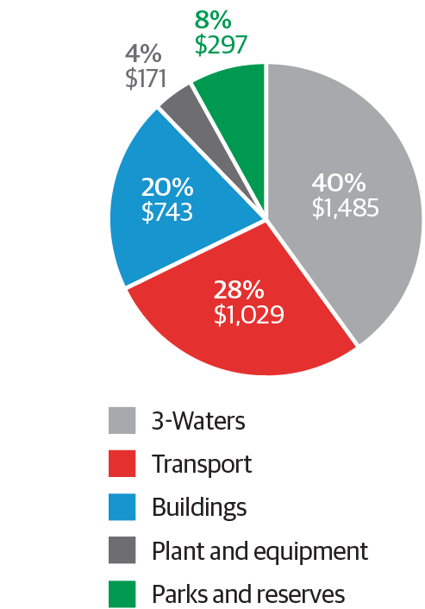
Our asset condition information shows our assets are well maintained and in reasonable condition. However, we have some challenges around accommodating the forecast growth and ensuring our assets are resilient to earthquakes and storms. The table below outlines a summary of our main asset classes and their condition.
 | Value $000s  ODRC | Condition | Performance
Transport | $1,029m | 3 -Maintenance required | 2 –Good  minor shortcomings
Water | $377m | 2- Minor defects only | 2- Good
Stormwater | $419m | 3- maintenance required | 3 Moderate
Wastewater | $689m | 4- Assets require renewal/ upgrade | 3 Moderate
Parks, Sport and Recreation | $187m | 2- Minor defects only | 2- Good
Waste Operations | $84m | 3 -Maintenance required | 2 - Good  minor shortcomings
City Housing* | $369m | 3 -Maintenance required | 3 Moderate
Corporate property** | $553m | 3 -Maintenance required | 2- Good
Community centres, halls & childcare facilities | $1m | 3 -Maintenance required | 3 Moderate
Libraries | $17m | 2 - Minor defects Only | 2 -Good  minor shortcomings
*This reflects average condition score for the social housing portfolio. Some housing units will require upgrading /renewing.
**Corporate property excludes the Civic Administration Building which was damaged in the November 2016 earthquake and is subject to a claim with insurers.

While our infrastructure strategy covers 30 years, the significant expenditure on capital upgrades to respond to growth and level of service demand that are planned, occur in the first 10 years. Years 11-30 are mainly concerned with capital expenditure on asset replacements (renewals) and their profile which is reflected in detail in section 8 of the ‘Financial and infrastructure strategy’ document.

Responding to growth
We expect population growth to continue strongly over the short-to-medium term. We forecast a population of 250,000 to 280,000 by 2043. Over 40 percent of this growth is expected to be accommodated in the central city. As the city’s population increases, the commercial sector will also expand. We expect an additional 28,000 people to work in the city by 2047.
Major ‘growth’ projects include
- Core infrastructure – $25 million for new water reservoirs in Horokiwi and Upper Stebbings, $10 million for waters infrastructure to support development in Shelly Bay, and public space development in Newlands
- City shaping / transport- $122 million for Let’s Get Wellington Moving and $23.3 million for new roads in the northern suburbs
Over the next 3 years a key priority for Council will be having discussions with our community about how and where the city will grow in the future. This will inform investment in core infrastructure for years 11 to 30. Our growth projections may also be influenced by regional infrastructure investment (such as the development of the Transmission Gully route) that may impact the distribution of growth in the region. More detail on this priority area is outlined in the sustainable growth priority area of this document.
We will cater for much of our inner city growth in conjunction with renewal and level of service upgrades and operationally through the review of our District Plan. As a result the expenditure categorised as ‘responding to growth’ primarily relates to the Lets Get Wellington Moving programme (which primarily responds to growth but also contributes to improved levels of service) and other growth areas – such as the greenfield development sites in the North of the city. The capital expenditure on asset growth for the proposed plan is $186 million over 10 years, of which $183 million is for core water and transport infrastructure. In the latter years (11-30) covered by this infrastructure strategy current planning assumes growth will occur within existing urban areas. We propose to cater for growth as we renew our assets.

Renewing our assets
Our asset management plans guide the renewal of our assets. Over the 10 years of this plan we propose to invest a similar amount each year in renewing our ‘three waters’ infrastructure (which appears in the ‘Resilience and environment’ section) and transport assets. These account for 25 percent and 29 percent of total renewals. Our capital expenditure renewal in the Social and Recreation Strategy is forecast to increase in the second half of our plan with stage two of our social housing renewal programme. Overall, we will spend $1.2 billion renewing our assets over the next 10 years, of which $574 million is for core transport and ‘three waters’ infrastructure. Over the 30 years covered by this infrastructure strategy we propose to spend a total of $3.3 billion renewing this core infrastructure. This renewal expenditure is spread across the various assets in similar proportions to their overall value.
Major renewal projects
- Social and Recreation – $19.2 million for aquatic facility renewals, $25.5 million for library collection renewals and $13.1 million for waterfront renewals
- Transport – $63.4 million for tunnel, wall and bridge renewals
- Housing – $38.1 million for renewals in addition to $147.5 million for the Housing Upgrade Project.

Responding to demands for improved service levels
The challenges facing the city also signal demand for investment to improve levels of service in a number of areas. We will invest $928 million over the next 10 years on improving levels of service in the city. Of this, $453 million is proposed to be invested in improving core transport and three waters infrastructure. We propose to invest a total of $798 million in improving this core infrastructure over the 30 years of our Infrastructure Strategy. Significant investment in improving levels of service is proposed in the areas in the table below.

Activity area | Investment | Level of service impacts
Environment | $118.5 million for upgrading water reservoirs over ten years | Improved level of service – once new and upgraded reservoirs are built, it is expected that the volume of water storage will be increase, including providing emergency water supply for 50 days.
 | $56.6 million for stormwater improvements | Improved level of service – stormwater infrastructure improvements in Miramar (years 5-7) Kilbirnie (year 1) and Tawa (in years 7-9) and a range of upgrades when we renew pipes across the city will reduce the frequency and severity of floods.
 | $34 million in years 9 and 10 for an initiative to deal with sewage sludge | Maintain level of service – with the predicted increase in population and the limitations of our current consent, our landfill will not be able to deal with the level of sewage sludge in 10 years. Alternative means of dealing with this sludge is required to maintain the level of service.
 | $343 million for upgrades to three waters infrastructure in years 11-30. This will be carried out in conjunction with asset renewals. | Increase level of service to improve resilience of the water, stormwater and wastewater pipe network, and increased capacity to respond to infill housing in the city.
Economic Development / Culture | $165 million for the Movie Museum and Convention Centre in years 2-5 (of the $165 million, $25 million of funding support has been requested from central government), and $85 million for an indoor arena in years 5-8. And a $10 million Wellington Museum building upgrade in years 3 and 4. | Improved service level to attract visitors to the city, boost economic growth and raise Wellington’s profile as an arts and culture capital.
Social & recreation | $17 million to complete the new Johnsonville library and community hub (Years 1 and 2) | Improved level of service – the new library and community hub will provide an enhanced community facility in Johnsonville. It will provide greater capacity and enhanced opportunities for education, community events, and knowledge sharing.
Urban Development | Wellington Town Hall ($88.7 million in years 1-3), St James Theatre ($11.5 million in year 1) | Improved level of service – Allowing public access to be reinstated, a music hub to be established in the Town Hall, and continued use of St. James theatre.
Transport | Let’s Get Wellington Moving programme (years 5 - 10).  Note: $122 million is incorporated within the Responding to Growth section of this plan. It is recognised that this initiative has both growth and improved service level outcomes. | Improved level of service – The new level of service will depend on which package of options is progressed; this will be confirmed later in 2018.  The programme is seeking to provide a transport system that:  - enhances liveability of the central city  - provides more efficient and reliable access  - reduced reliance on private vehicle travel  - improves safety for everyone  - is adaptable to disruptions and future uncertainty.
 | $73 million to improve the cycleway network ($32 million in year 1 and 2, and $5 million per year across years 3-10) | Improved level of service – The Council has developed a plan for active transport infrastructure which, at proposed levels of funding, will be completed in 20 years. The level of service for those using the active transport infrastructure will improve as the programme is progressed.  The improved level of service will see:  - safe connections between suburbs and the central city  - safe spaces for people on bikes, that are separated if the traffic speeds and volumes are high – in line with NZTA guidelines  - good signage to facilitate wayfinding for people on bikes  - good lighting to facilitate cycling at night  - safe clean and comfortable riding surfaces.
 | $36 million for bus priority improvements (across years 1- 10) | Improved level of service – Bus priority routes will facilitate the stated outcomes of the Let’s Get Wellington Moving programme and the routes for bus priority improvements will be confirmed later in 2018.
 | $36 million for retaining walls and structures to strengthen our roadways (across years 1- 10) | Maintained level of service – With the increase in frequency and severity of storms, additional funding is required to ensure we maintain the level of service provided by our retaining structures and roads.
 | $12 million allocated to improve the resilience of the Ngaio Gorge roadway (years 1 - 3) | Maintained level of service – With the increase in frequency and severity of storms, additional funding is required to ensure we maintain the level of service provided by our retaining structures and roads.

Overall capital expenditure
Over the period of Our 10-Year Plan, the Council proposes to invest a total of $2.31 billion of capital expenditure, including $1.2 billion for core transport and three waters infrastructure.
Approximately $1.2 billion of the total investment is proposed to be spent on renewing existing assets, $928 million on improving service levels and $186 million on responding to the growth needs of the city.
2018-2028 Projected Total Capital Expenditure
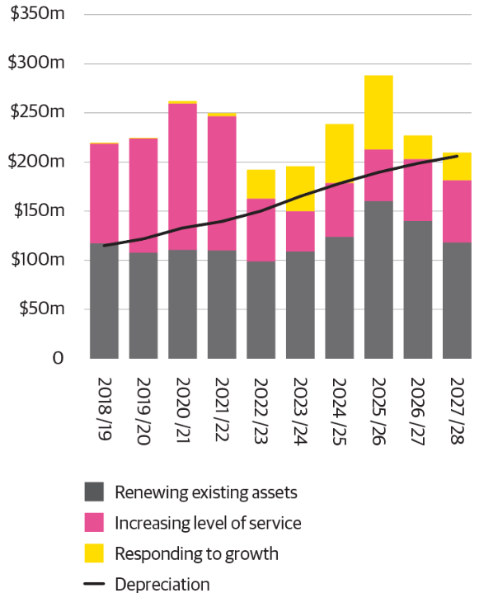
Over the 30 years covered by this strategy we plan to invest a total $4.3 billion on core transport and three waters infrastructure, incorporating $3.3 billion for renewing assets and $981 million on upgrading and improving and service levels.
2018 – 2048 Projected Core Infrastructure Capital Expenditure
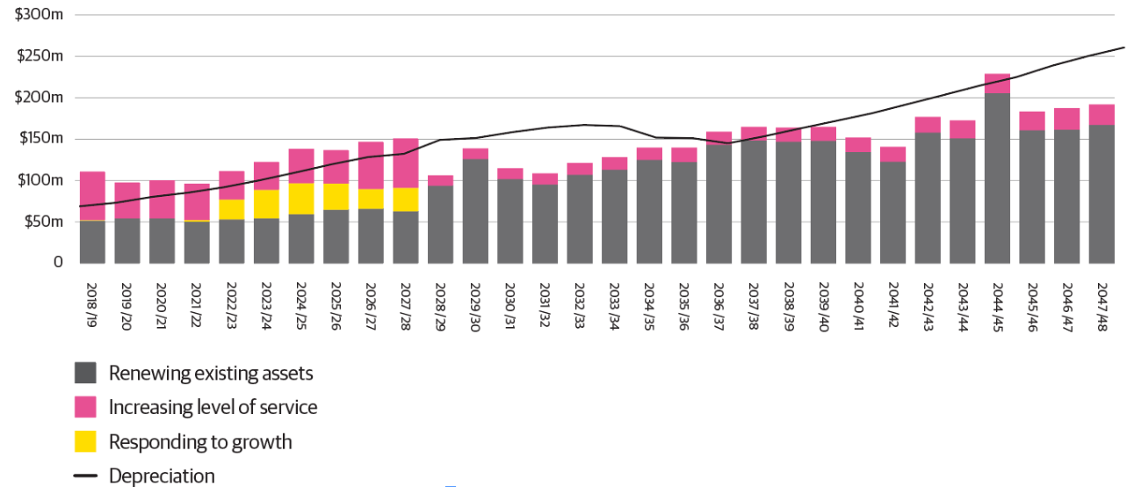

The graph illustrates the relationship between anticipated renewal and upgrade requirements and depreciation over the 30 years of our infrastructure strategy.
In years 11-30 there is increased expenditure on renewing three waters and transport infrastructure assets. This is because there is a high proportion of the existing infrastructure nearing the end of its useful life.

There are some annual spikes in capital expenditure renewals for three waters infrastructure across years 11-30 as specific network components are renewed , but overall capital expenditure is relatively in line with the cost of depreciation over years 11-30 for three waters assets, with both increasing gradually as the cost of replacement increases.

Depreciation costs for transport assets are increasing in years 11-15 as a result of increased capital investment in Let’s Get Wellington Moving (LGWM) and delivering the cycleways network across the city.

At this stage we do not know what specific type of assets the Council will invest in as part of the LGWM programme because a final option has not been prepared and this will be subject to negotiations with LGWM partners – the NZ Transport Authority and Greater Wellington Regional Council.

Because the nature of the assets that Council will invest in for LGWM is not yet known, we have assumed depreciation funding based on an average life of 10 years for the long-term plan. This is conservative, but appropriate considering the information available at this time.

As yet we do not know what the subsequent asset renewal requirements will be, we have assumed in the longer term forecasts that we will replace 50 percent of these assets after 10 years and a further 25 percent after 20 years, with 25 percent not renewed within the 30 years of our current strategy. This will be reviewed in the 2021/22 Infrastructure Strategy and in the Long-term Plan 2021-31 when the capital expenditure requirements of LGWM programme are confirmed.

In most years depreciation is above the level of renewals, because our long-life assets are expected to continue to meet service level requirements with modest renewal expenditure over the term covered by this strategy. We are not forecasting any major renewals expenditure on any individually significant asset. This provides some financial flexibility to invest in upgrades to level of service particularly in the first 10 years covered by this strategy. In years 11 to 20 depreciation funding exceeds renewals due to extra depreciation from new assets built in the first 10 years, including indicative investment in the Let’s Get Wellington Moving project. Assumptions made on both asset life and renewal requirements for this project will be reviewed once we have more certainty over the physical works the Council will be funding.

Our financial strategy

The proposed ambitious investment programme in this plan has increased levels of service in most of our priority areas. This investment programme and the supporting financial and infrastructure strategies are responding to the key challenges for the development of our city.
It is important that we carefully consider the appropriate levels of borrowing, income and expenditure that will allow us to invest wisely in our city. In planning the proposed investment programme we have considered both our ability to deliver the planned capital programme and meeting the on-going service level expectations of our residents and ratepayers. Our financial and infrastructure policies and strategies guide how we manage our budget for our proposed priorities and investment in our infrastructure assets. We will be revisiting our programme each year to ensure we are striking the right balance.
Our financial strategy aims to:
- achieve a balanced budget
- maintain prudent financial management by the Council
- ensure affordable rates
- manage net debt within borrowing limits
- continue to fund the depreciation cost of assets we build or buy.
- ensure we can fund infrastructure assets that allow the city to develop when needed
- ensure we have the financial capacity to fund priority programmes
The Council will maintain a balanced budget by raising sufficient income each year to fund the operating costs of providing services consumed by the city that year. No profit is budgeted or rated for. Note that our financial statements will show a surplus because revenue received for capital expenditure is required to be shown as income.
We will continue to fund depreciation to repay borrowings on assets that the Council will be responsible for renewing when they reach the end of their useful life. This is an important pillar of our financial strategy as it helps ensure we have sufficient financial capacity to pay for asset renewal in the future.
The Council uses a number of mechanisms to fund operational expenditure requirements. These include:
- general rates (mainly used to fund public goods)
- targeted rates (where an activity benefits an easily identifiable group of ratepayers such as the residential sector, for example water supply)
- fees and charges (user charges where an identifiable benefit exists for users for certain Council services such as swimming pools)
- borrowings (in general, the Council does not fund operating expenditure by borrowing. The exception is to fund the impacts on ratepayers’ intergenerational equity or to fund expenditure over the period during which benefits are received, such as weathertightness payments)
- other sources of funding (including income from interest and dividends from investments held by the Council, lease income and proceeds from asset sales, and prior year surpluses).
Capital expenditure is funded from rating for depreciation, development contributions, capital funding from third parties like the NZ Transport Agency, the sale of surplus assets, and restricted funds or through new or extended borrowings. Capital expenditure funding is further outlined below:
- If the capital expenditure relates to the replacement (renewal) of an existing asset, that expenditure will be initially funded by borrowings. These borrowings will be repaid by rating for depreciation over the life of the asset. Any surplus rate funded depreciation, after paying for the replacement of Council assets, will be used to repay borrowings.
- If the capital expenditure relates to the construction or purchase of a new asset or to the upgrade or increase in service potential of an existing asset, that expenditure will usually be funded from new or extended borrowings. Borrowing is the most cost-effective and equitable way to do this as it spreads the cost of the asset over all the generations who will benefit from it, making it affordable to ratepayers today.
- The Council has agreed that development contributions are to be used as the primary funding tool for capital expenditure resulting from population and employment growth for core infrastructure. Funds collected under either the Development Contributions Policy or the Financial Contributions Policy in the District Plan will result in a corresponding decrease in the amount to be funded from new borrowings.

Borrowing
Our debt position is conservative. We have far less debt (measured as debt to income) than most metropolitan local authorities. Our debt levels range from 121 percent to 162 percent of our annual income, which is below our limit of 175 percent. Our starting borrowing position of $507 million equates to $2,400 per person in Wellington. This borrowing position will move to $1.17 billion by year 10 and will equate to $5,100 per person in Wellington.
This draft plan includes increases in rates and a significant increase in borrowing over the first 10 years of our 30-year infrastructure strategy. The key cost drivers for our increased borrowing is the significant upgrade programme for transport, resilience and economic growth programmes. Key capital projects are outlined in the priority areas of this consultation document (pages 14 to 35).

Our strong financial position means we can afford the projects outlined in this plan. Our approach is to keep borrowing levels within the 175 percent debt-to-income limit set out in our Financial Strategy. We have achieved this by maintaining 13 percent capacity within our debt to income ratio threshold. Our forecast maximum ratio through the duration of the Long-term Plan 2018-28 is 162 percent and our limit is 175 percent. This equates to approximately $133 million of borrowing capacity in 2028.

This provides further capacity to borrow in the event of a natural disaster. This is in addition to the insurance cover we have on our assets and available government assistance. We also maintain bank standby facilities in excess of this amount to ensure the Council has sufficient liquidity if this situation were to arise. Based on current asset upgrade, renewal and depreciation funding assumptions for our core infrastructure, we will repay borrowing of approximately $340 million over the 30 years of this strategy. This will occur as the forecast revenue received from funding of depreciation is in excess of the capital expenditure (renewals and upgrades). We will therefore maintain sufficient capacity to remain within our 175 percent debt to income ratio limit.

Should demand for additional asset investment occur in subsequent plans, we expect the Council will have capacity to accommodate these within the limit. There is also sufficient balance sheet strength to amend the debt: income ratio limit to at least 200 percent without affecting the credit rating. This level is still well below the allowance of up to 250 percent specified in our covenant with the Local Government Funding Agency (LGFA).

2018-28 Forecast 10-year Borrowing ($bn)
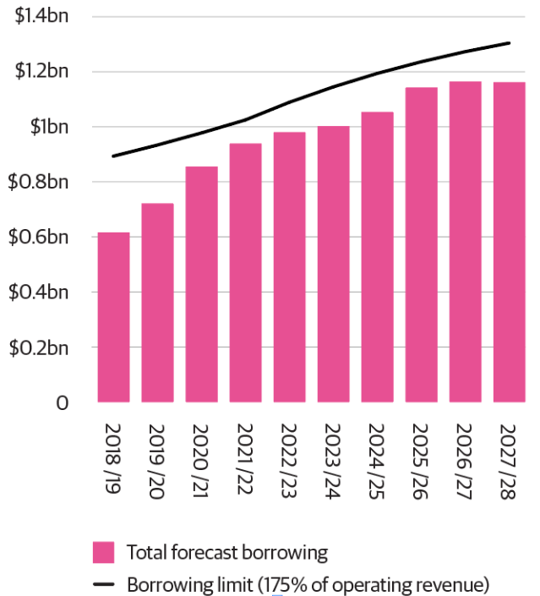

Spending in activity areas
We will invest $2.3 billion over the next 10 years in our assets. This investment is spread across a range of activities, with the major spending areas being environment, social and recreation, and transport. In total, we will plan to spend $6.3 billion of operational expenditure on delivering services and meeting the costs of depreciation and interest from our borrowings.
Capital Expenditure Long-term Plan 2018-28 by activity area | Operational Expenditure Long-term Plan 2018-28 by activity area
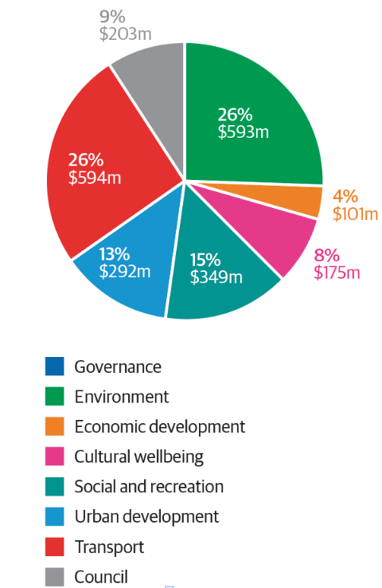 | 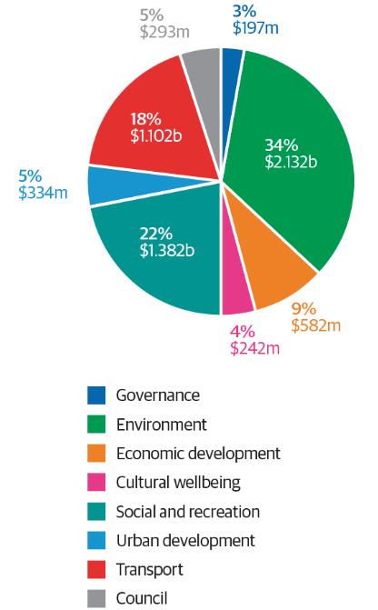

The following graphic illustrates the proposed 2018/19 rates funding for the service areas the Council provides per $100 of total rates.
Where do my rates Go?
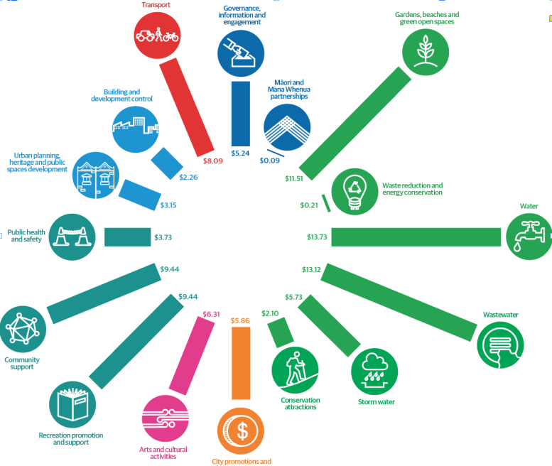

Paying for the proposed programme

Can we sustain this level of investment?
We have balanced deliverability, affordability and meeting service level expectations
The following graph shows the sources of income that we propose to use to finance the plan and Council services over the next 10 years.

Operating expenditure by funding sources ($m) 2018-28
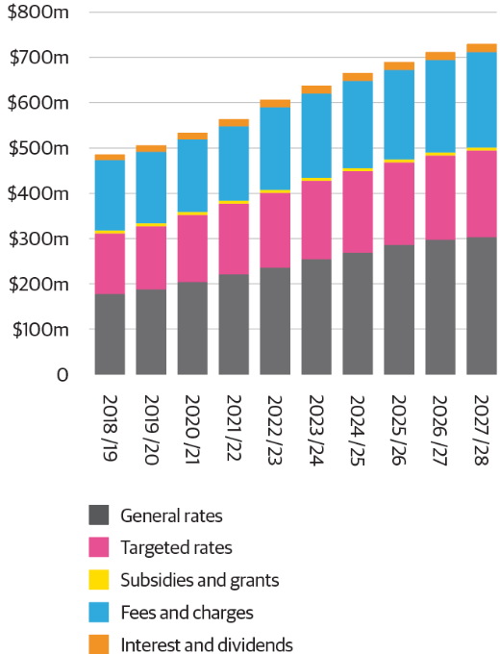

Fees and charges
Our Revenue and Financing Policy guides our decisions on how to fund Council services. We take into account who benefits from a service (for example individuals, parts of the community or the community as a whole) to help determine how the service should be funded. The policy also sets the targets for each Council activity indicating the proportion that should be funded from user charges, general rates, targets rates and other sources of income. As part of this plan we have reviewed our fees and charges and are proposing to increase some fees and charges for Council services. The key categories of services are:
- waste minimisation, disposal and recycling management
- sewage collection and disposal network
- sports fields
- marinas
- municipal Golf Course
- burials and cremations
- parking (see the ‘Transport’ section for further details).
Detailed information on the fees and charges for specific services can be found in our Revenue and Financing Policy document at wellington.govt.nz.

Rates limits
Our financial and infrastructure strategy provides limits to rates increases. These limits are:
- an annual limit of $350 million of rates funding for each of the first 3 years of the plan.
- an annual limit of $495 million of rates funding for years 4 to 10.
- The increase limit is to stay within the cap of $350 million for years 1-3, and $495 million for years 4-10. This can be calculated by taking the rates limit less the rates funding requirement from the prior financial year. Our forecast rates and rates increases are within these limits each year of the long-term plan.
Proposed year-on-year rates increase in value ($m)
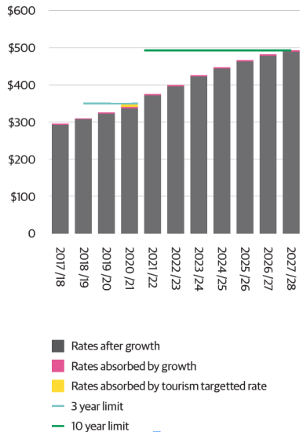
We have proposed the introduction of a targeted rate for the tourism sector from 2020/21. The details of the targeted rate for the tourism sector are yet to be worked through, however further consultation will occur on any specific proposal in the relevant annual plan year before implementation. If introduced, while the total amount of rates will be unchanged, the share of the rates paid by other (non-tourism sector) ratepayers will be lower by the equivalent of 2.8 percent of total rates.
Growth in the rating base reduces the impact of the overall rates increase on existing ratepayers. We have assumed an average growth in the ratepayer base or 0.9 percent per year over the 10 years of the plan. After accounting for growth and excluding the impact of the tourism targeted rate (which, if introduced, will be rated on the tourism sector) the annual rates increase limit is the equivalent of an average rates increase of 3.9 percent over the first 3 years of this plan and an average of 4.1 percent over 10 years.
The proposed rates increases presented in $ millions and percentage terms are summarised in the graph below. The specific impact of rates on properties is relative their capital value and their differential rating category. The indicative impact of this can be seen in the tables in the next section.
Proposed year-on-year rates increase in value ($m) and percentage
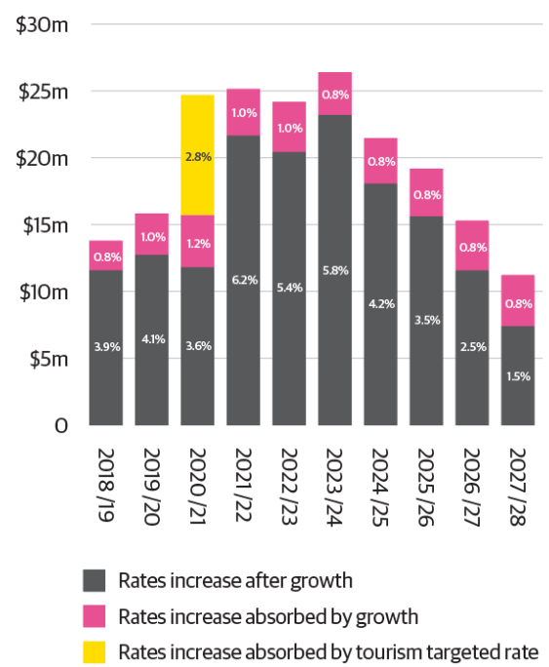

Note: The graph above shows the increase in the total year-on-year rates requirement in dollar terms. The percentage impact of the average rates increase (after growth) and the proposed tourism sector targeted rate in year 3 are included for information purposes.

How this plan will affect your rates
We are well placed to deliver core services as well as invest in the priority areas identified in this consultation document.
The following table illustrates the indicative residential and commercial property rates, inclusive of GST for a selection of billing categories for the 2018/19 plan.
Indicative residential property rates (for properties without a water meter) |  |  |  | Indicative suburban commercial property rates (for properties with a water meter)** |  |  |  | Indicative downtown commercial property rates (for properties with a water meter) **
Capital Values | 2018/19 Rates | Increase over 2017/18 |  | Capital Values | 2018/19 Rates | Increase over 2017/18 |  | Capital Values | 2018/19 Rates | Increase over 2017/18
$ | $ | %* |  | $ | $ | %* |  | $ | $ | %*
200,000 | 1,212 | 4.82% |  | 1,000,000 | 10,683 | 3.81% |  | 1,000,000 | 12,616 | 1.59%
300,000 | 1,664 | 4.83% |  | 1,250,000 | 13,316 | 3.80% |  | 1,250,000 | 15,732 | 1.57%
400,000 | 2,117 | 4.84% |  | 1,500,000 | 15,950 | 3.79% |  | 1,500,000 | 18,849 | 1.56%
500,000 | 2,569 | 4.85% |  | 1,750,000 | 18,583 | 3.78% |  | 1,750,000 | 21,965 | 1.56%
600,000 | 3,022 | 4.85% |  | 2,000,000 | 21,216 | 3.78% |  | 2,000,000 | 25,082 | 1.55%
700,000 | 3,474 | 4.85% |  | 2,250,000 | 23,850 | 3.78% |  | 2,250,000 | 28,198 | 1.55%
800,000 | 3,927 | 4.86% |  | 2,500,000 | 26,483 | 3.77% |  | 2,500,000 | 31,315 | 1.55%
900,000 | 4,379 | 4.86% |  | 2,750,000 | 29,116 | 3.77% |  | 2,750,000 | 34,431 | 1.54%
1,000,000 | 4,832 | 4.86% |  | 3,000,000 | 31,750 | 3.77% |  | 3,000,000 | 37,548 | 1.54%
1,100,000 | 5,284 | 4.86% |  | 3,250,000 | 34,383 | 3.77% |  | 3,250,000 | 40,664 | 1.54%
1,200,000 | 5,737 | 4.86% |  | 3,500,000 | 37,016 | 3.77% |  | 3,500,000 | 43,781 | 1.54%
1,300,000 | 6,189 | 4.86% |  | 3,750,000 | 39,650 | 3.77% |  | 3,750,000 | 46,897 | 1.54%
1,400,000 | 6,642 | 4.86% |  | 4,000,000 | 42,283 | 3.77% |  | 4,000,000 | 50,014 | 1.53%
1,500,000 | 7,094 | 4.86% |  | 4,250,000 | 44,916 | 3.77% |  | 4,250,000 | 53,130 | 1.53%
1,600,000 | 7,547 | 4.86% |  | 4,500,000 | 47,550 | 3.76% |  | 4,500,000 | 56,247 | 1.53%
1,700,000 | 7,999 | 4.87% |  | 4,750,000 | 50,183 | 3.76% |  | 4,750,000 | 59,363 | 1.53%
1,800,000 | 8,452 | 4.87% |  | 5,000,000 | 52,816 | 3.76% |  | 5,000,000 | 62,480 | 1.53%
*This is the indicative percentage rates increase, taking into account average increases in property valuations for the relevant billing category.
** Excludes water by consumption which is charged on actual usage.

The average forecast rates increase for existing ratepayers for the 2018/19 year is 3.9%. However, the forecast increase varies between each property rating category, dependant on factors such as whether a property is rated as commercial or residential, whether a commercial property is in the area where the Downtown targeted is payable, or whether a property pays for water via a meter or based on the property capital value. Within each rating category rates increases will also vary depending how much your property value has increased compared to other properties within your rating category – this will not impact on many properties in 2018/19 as we are mid-way through the 3 yearly revaluation cycle.

The indicative rates increase for Downtown Commercial properties is lower than the average mainly due the removal of the rates contribution these properties have previously made to pay for free weekend parking (it is proposed that this be paid for a user pays basis) and because the impact of increased water rates are not included in the indicative rates figures, as these properties pay for this based on the amount of water they use.

The indicative rates increase for Residential properties without a water meter is slightly higher than the average, mainly because the water rates increases are included, growth in the rating base is forecast to be slightly lower than for commercial properties and because there are slightly higher increases in the amount of rates funding required for activities that residential properties fund.

Your Mayor and Councillors
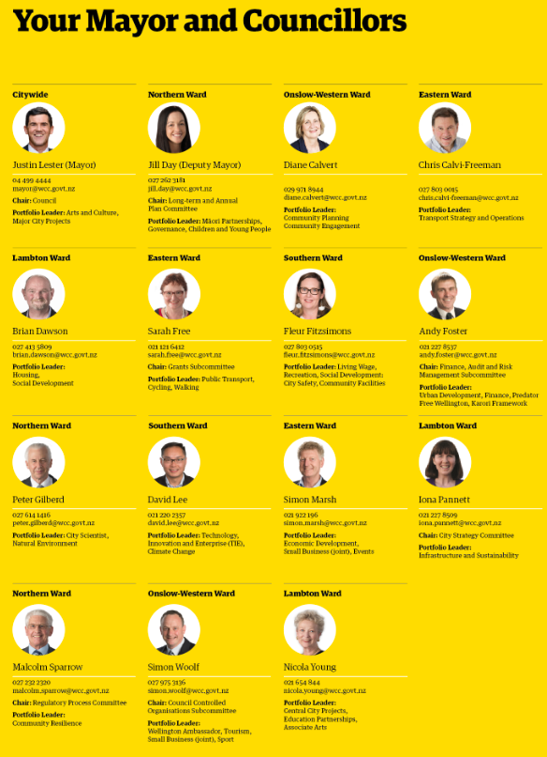

Auditor’s report
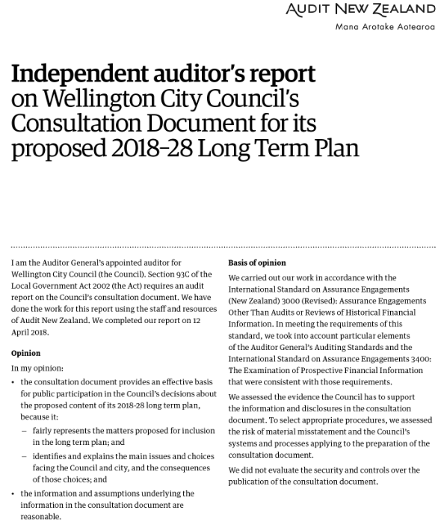
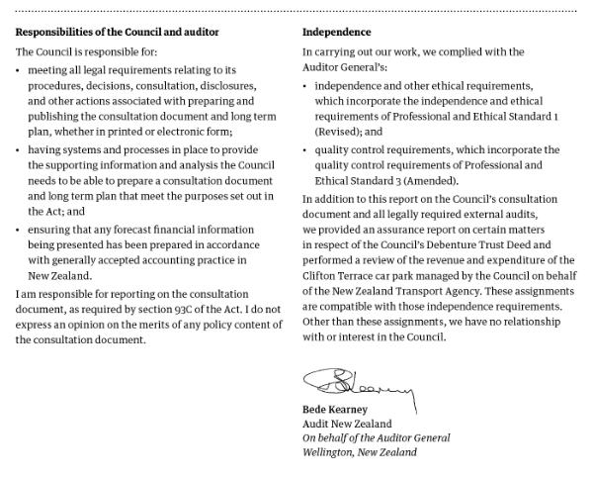

Have your say
There are four ways you can have a say:
- Online – make a submission or post your thoughts http://www.wellington.govt.nz.
- Email – email your submission form to buslongtermplan@wcc.govt.nz.
- Make a written submission ― write a letter or use the form in this document and post to Our 10-Year Plan, Wellington City Council, PO Box 2199, Wellington.
- Social media ― post your views on facebook.com/wellingtoncitycouncil, using the hashtag #WgtnPlan. You can also speak directly to Councillors in our Virtual Forum. Join the conversation on our Facebook page from 6pm on Tuesday 1 May.

You can make a submission from 15 April to 15 May 2018.

What happens next?
We appreciate the submissions we get, and we do take them seriously.
The Mayor and Councillors are given copies of all submissions. We also prepare reports on the submissions, so that Councillors know things like how many there are, and what issues are coming up often.

The final plan is scheduled to be adopted on 28 June2018.

To find out more:
Visit our website to find out more information, including our:
- Financial and Infrastructure Strategy
- Significance and Engagement Strategy
- Statements of Service Provision
- Housing Strategy
- Significant assumptions

