Contents
Introduction 3
Purpose and scope of the policy 3
Definition of play 3
Alignment with Council direction 4
Background and research 4
Information gathering 4
The future of Wellington 5
Play spaces 7
The importance of play 8
Nature play 8
What do people want from play spaces in Wellington? 9
Accessibility 10
Shade and fencing at formal play spaces (playgrounds) 10
Play opportunities for adults 10
Play opportunities for “youth” 11
Skate facilities, basketball courts and bike skills areas. 11
How are we planning for play as the city grows and changes? 13
The central city 13
Medium-density residential housing 13
Greenfield development areas 14
Community and school partnerships 16
What do we have now? 17
Dedicated play space 17
The playgrounds network 17
How we manage playgrounds 20
Skate facilities, basketball courts and bike skills areas 20
How we manage skate facilities, basketball courts and bike skills areas 20
Other dedicated play space 22
Community involvement and school partnerships 23
Incidental play space 24
Play Space Policy & Action Plan 25
Vision 25
Play space principles 30
Strategic Priority 1: Provide a network of play spaces across the city 25
Policy 1 - The play space network 25
Policy 2 - Dedicated play space (playgrounds) 25
Policy 3 – Skate and scooter facilities 29
Policy 4 - Outdoor informal court space 29
Policy 5 - Bike skills areas 29
Policy 6 – Nature play trails 29
Strategic Priority 2: Provide high-quality, fit-for-purpose play space 30
Policy 1 – Play space principles 30
Policy 2 – A guide to dedicated play space categories 32
Policy 3 – Standards for dedicated play space (playgrounds) 33
Policy 4 – Dedicated play space renewals and development 33
Policy 5 – Skate and scooter facilities management 33
Policy 6 – Outdoor informal court space management 33
Policy 7 - Bike skills areas management……………………………………………………………33
Policy 8 - Nature play trails management…………………………………………………………..33
Strategic Priority 3: Community and school partnerships 33
Partnerships Policy 33
Strategic Priority 4: The city as a play space 34
Strategic Priority 5: Programming and advocacy for outdoor play 34
Appendices 36
Appendix 1 - Play spaces theory and age appropriate activity guide 36
Age appropriate activity guide 36
Appendix 2 - Play spaces by category 38

Introduction

Purpose and scope of the policy
This policy provides strategic direction and guidelines for the provision and management of play spaces in Wellington City.
Planning for play will allow the Council to maximise any investment, add to it over time and ensure it is sustained.
The policy:
- defines what the Council means by play and a vision for play
- includes background information and research into best practice provision, quality, management and maintenance of play spaces and what that means in Wellington
- describes the value of and need for play and play space
- describes a set of play space principles
- outlines the planned network of play space opportunities
- outlines the types of play space, with a guide to the purpose and components of each
- guides design and management for high-quality renewals and upgrades
- guides community and school partnerships
- describes programming and advocacy for outdoor play.

Definition of play
Play is what children and young people do when they follow their own ideas and interests, in their own way, and for their own reasons.
The International Play Association (IPA) lists the key characteristics of play as fun, uncertainty, challenge, flexibility and non-productivity. These characteristics of play are relevant at all ages.
“Intent” is the key difference in the play of children (which adults have a role in fostering and providing for) and the play of older children and adults (who make a conscious decision to go somewhere and be somewhere, can get to that place and then engage in their version of “play”).

Alignment with Council direction

Wellington Towards 2040 Smart Capital
People-centred city, connected city,
eco-city, dynamic central city

Child & Youth Friendly Cities

Wellington Urban Growth Plan
Urban Development & Transport Strategy 2015

Central City Framework

Our Natural Capital
Wellington’s Biodiversity Strategy and Action Plan 2015
Our Capital Spaces
Open Spaces & Recreation Framework
2013

Reserve Management Plans
Play Spaces Policy
(and other Council plans and policies including the proposed Sports Strategy)
Citywide asset management plans

This policy has been produced to give effect to and align with Council plans, policies and initiatives as outlined in the diagram above.

Background and research

Information gathering
Wellingtonians care about play space as part of the open space network. We know this through preparation of Our Capital Spaces, Our Natural Capital, the Suburban Reserves Management Plan, the Mount Victoria Masterplan, informal feedback when we are renewing playgrounds and Long-term Plan benchmarking (Residents’ Monitoring Survey).
A review of literature around best practice for play space policy preparation and how children interact with their environment was used in preparing the Play Space Policy. A scan of play space policy around the region was also carried out to ensure there is a regionally consistent approach.
The following added further insight to the views of Wellingtonians to help inform this draft:
- a survey using the Council’s research panel
- a survey of all of the primary schools in Wellington
- an informal survey of passers-by at an event in Civic Square
- a series of workshops with youth
- a workshop with skate community advocates
- discussion with Council staff involved on a day-to-day basis with the provision, development, management and maintenance of play space.

The future of Wellington
The Wellington City population in 2013 was 197,500, living in about 71,000 households.
- In almost all of Wellington’s suburbs, family-with-children households (including sole parent families) make up less than 50 percent of all households. This reduces to 20 percent or less for the central city, Te Aro, and city-edge communities.
- Between 2013 and 2033, Wellington’s population is projected to increase by approximately 28,500 (14 percent) to 226,000. The total household count will increase by about 13,500 (18 percent).
- Family households with children will increase by about 2000 over the next 20 years.

We need to consider what play space requirements there will be as the city changes and grows:
- In 2013 there were 34,300 children (aged 0–14 years) in Wellington. By 2033 this is expected to rise by only 1650 children across the whole city (a 4.8 percent increase).
- Children made up 17 percent of the total population in 2013 and are projected to make up 16 percent of the total population in 2033.

This suggests that, to best meet the play needs of most children in the long term, it will be better to maintain and manage a network of play spaces spread relatively evenly around the whole city rather than plan for more playgrounds in established areas. Our priority will be to make sure that as the child population shifts around the city there will always be a quality play space nearby.

Map 1 is a broad-scale picture of the numbers of 0 to 14-year-olds as a portion of the total population and relative to other areas. The overlay of Council playgrounds shows the relatively even spread of playgrounds throughout the city, with good provision in areas where there are currently the highest numbers of children.
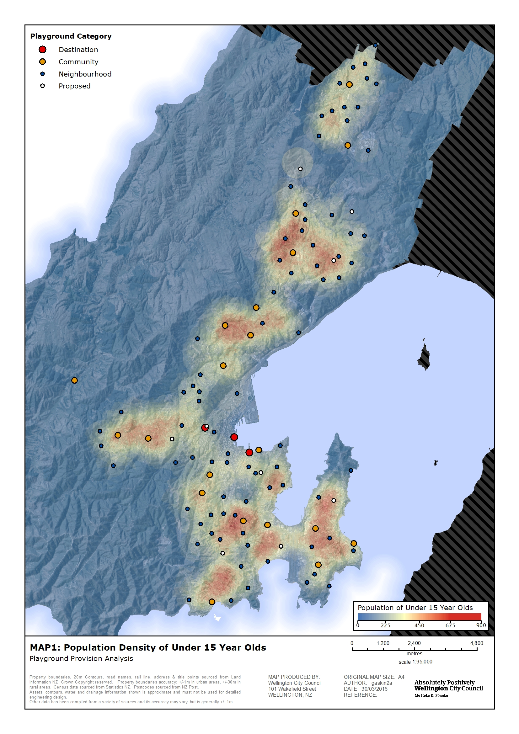

Play space
The diagram below shows the ideas in Our Capital Spaces around the value of multifunctional space and how “play spaces” fit within this plan. It illustrates the importance of providing for a range of play spaces – from formal, dedicated play areas through to incidental playable space within other multifunctional space (such as large parks or urban environments, for example). Provision of play is broader than formal playgrounds. This policy looks to broaden the scope of how the Council provides for play.
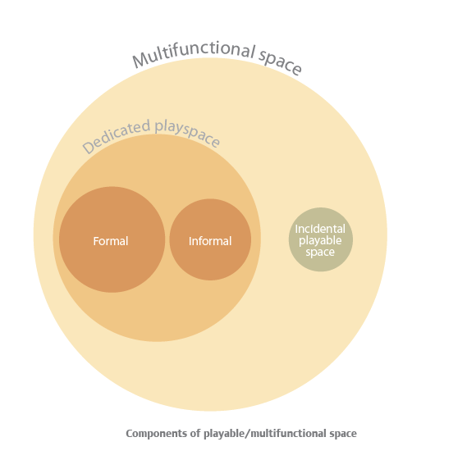
Incidental playable space can be anywhere. This might be a small slope in a park that could be rolled down, a tree that can be climbed or that drops leaves, sticks or flowers that can be collected, sorted or thrown in the stream. It could also be a non-natural environment – a low wall that could be walked along or a high wall to jump off. Backyards, house frontages and road verges can also function as local networks of incidental play space. High-quality public art and civic space is often playable. Walk anywhere with a 3-year-old and you will find incidental playable space. Wayfinding and place-making improve opportunities for adult and youth socialisation through incidental play, particularly in the urban environment.
Dedicated playspace is a space where play is identified as one of the main functions of the space. The Council plays a key role in provision of dedicated public play space. Schools and private property (in particular backyards) also offer important opportunities as places where children spend time each day. In Wellington, 93 percent of primary schools surveyed allow public access to their playgrounds outside of school hours. Shopping centres often have dedicated play space. City housing facilities have play space for their residents at sites where there are children and families.
The Council provides a network of dedicated, free outdoor play facilities across the city and has clear strategic direction to continue to do so, as shown in the relationship of this policy to other Council direction.

The importance of play
Playgrounds are currently valued and well used by Wellingtonians. Regionally, nationally and internationally, research has shown the importance of play for the development, health and wellbeing of children. It is also evident that there are wider benefits associated with play that have a very broad reach, including social and environmental.
Providing a place for children to play gives them different settings and environments to explore, exposure to different challenges, a social setting to play with other children and adults, and a place to discover what they can and cannot do.
Play theory defines types of play that can then be applied to different age groups. All play space design should be grounded in this theory as commonly accepted best practice. Play spaces provide for the physical, cognitive, social and imaginative development of children, with design and environmental setting key factors in maximising the potential benefit to the child.
For children, play is a human right. On 1 February 2013, the United Nations Committee on the Rights of the Child adopted a General Comment that clarifies for governments worldwide the meaning and importance of Article 31 of the Convention on the Right of the Child.

Nature play
There is a growing body of evidence to support the benefit of outdoor play and play in natural environments. A group based in the United Kingdom called the Wild Network is working to raise the profile of free play in the outdoors as not only a legitimate activity for children to engage in but a critical one that is becoming less and less of a part of children’s daily lives. They are looking at ways to “market nature” to children and their parents. They sum up the benefits to children of a “re-wilded free-range” childhood as:
- improving their ability to judge and understand risk
- increasing physical health through exercise
- enhancing and maintaining mental health and positive wellbeing through exposure to the natural world
- stimulating imagination and creativity through outdoor play and learning
- improving communication skills and the ability to build and maintain relationships.
The 2015 Wellington Residents’ Monitoring Survey found that 92 percent of respondents agree that a connection with nature improves residents’ quality of life. Outdoor play is an opportunity for children to make that connection.
“Nature play” covers a wide range of activities, from imaginative free play in a highly natural environment to play on natural elements in a formal playground setting (such as a garden to walk through under a slide). Current thinking about the importance of nature play suggests that children are not engaging in outdoor free play as much as they have in the past. Children are not able to roam as widely as they did, and now lead more structured and supervised lives with less emphasis on spending time “mucking about”.
The role of the playground as a place where children can have a broad play experience that includes free play in addition to physical and social development is more important as opportunities for outdoor free play are limited by modern lifestyles.
It is important for play spaces to offer opportunities for interaction with nature and promote the value of this for children. In Wellington, there is no shortage of places to engage in nature play at the “wild” end of the spectrum, but often there is a need for children and their families to get comfortable in a more structured or smaller scale natural environment first.
The panel survey indicated that people would choose a more natural “free play” type play space over a traditional “swings and slides” play space about 50 percent of the time. People also chose items such as “climbing/sliding on banks”, and “free play (piling up bark chips, digging, mucking about)” as things their children enjoy at playgrounds.

What do people want from play spaces in Wellington?
The panel survey recipients told us:
- children aged 5–10 years are the main users of playgrounds, with the 0–5 year age group second and 11–12 third.
- most people taking children to playgrounds are parents, with the remaining respondents primarily either grandparents or a relative
- the top five most enjoyed activities (from a list provided that included things like free play, trees and sliding on banks) are traditional playground equipment – swings, slides, flying fox, forts and structures, and climbing nets/frames
- 74 percent of people believe the number of playgrounds in Wellington is about right
- 56 percent of people believe that, in general, the playgrounds are excellent or above average quality, with 40 percent believing they are average
- the top five ideas for improvement (from a list provided) were more shade or shelter, different styles/designs of equipment, more toilets, a wider range of equipment and opportunities for free play/imaginative play
- when asked how the community might be involved in improving playgrounds, the top response in the general survey was through providing feedback to the Council on playground plans, followed by participation in working bees to help maintain the playground environment
- 41 percent of survey respondents go outside of Wellington City (eg to Porirua or Upper Hutt) to play every few months – just to go somewhere different or for another reason such as to visit family
- 58 percent of survey respondents said their neighbourhood playground (ie the one closest to where they lived) was the one they visited most often
- when asked which was most important to them, 21 percent of people said having a small basic playground near to where they lived, while 12 percent said having a large playground further away with more to offer – most people, however, believe both are equally important (66 percent)
- almost everyone (96 percent) visited playgrounds for 2 hours or less, with an almost even split between the “less than an hour” group and the “1–2 hours” group
- 45 percent of people drive to the playground, while 41 percent walk and 10 percent bike/skateboard/scooter
- 23 percent of respondents used skate/scooter areas, with Waitangi Park the most popular location – 90 percent of visitors are there for 1–2 hours or less.
The most frequently recorded general comments (after “no comment”) were:
- need more variety for the playgrounds with different kinds of design/equipment
- need more shade/shelter
- there is lots of choice
- they are well maintained.
Some of the more values-based quotes include:
For children living in a city environment, it is extremely important to have space and equipment for children to experiment, risk take and explore a range of different settings... free play, climbing, swinging, inventing games etc
Kids like the old school playgrounds not the plastic kit sets with super safe options. Life is about accepting a bit of risk and diversity. Kids like informal simple options like rope swings.
Neighbourhood playgrounds help kids socialise with their peers, and provide a meeting place for parents.
When playgrounds are renewed, requests for more than just the renewal of the equipment are always received. Most commonly this is for paths to and through the play space and for more seating.

Accessibility
The Wellington City Council Accessibility Advisory Group (AAG) stressed the importance of accessibility to play space around Wellington for both children and those caring for them.
In recent times, higher numbers of older grandparents are caring for children and need to be able to safely access play spaces and interact with the children in those spaces.
The Council has recently carried out an accessibility audit based on physical constraints to access to playgrounds. A series of recommendations were made to address identified shortcomings. These are currently proposed to be addressed at the time of renewal of each site.

Shade and fencing at formal play spaces (playgrounds)
Providing shade at playgrounds has been raised by survey respondents and others. Issues include:
- the risk to children of being exposed to the sun
- the benefits to children of being exposed to the sun
- the climate in Wellington
- the appropriateness of play equipment and surface material and how that performs in different weather (eg surfaces that get too hot)
- the amount of time children usually spend at the various play spaces
- the pros and cons of planting and maintaining trees
- the pros and cons of installing and maintaining shade structures.
It is not practical or desirable to shade entire play spaces. The ability to seek shade is important at each site. Shade structures are very expensive – approximately 12 times as expensive as planting one tree (planted at 2 metres in height) that would in time provide adequate shade. An important consideration is providing shade over the equipment and not just for caregivers.
More money could be spent on larger trees for more immediate effect. Trees will not only provide shade but also add a natural play element to the space, and have ecological and amenity value. They can also provide seasonal shade allowing sun in the winter months when playground users are often seeking the sun rather than trying to avoid it.
Fencing is another issue, generally at play spaces designed for younger children and when they are in close proximity to roads. Currently fencing is included in new play spaces where there is a safety risk.

Play opportunities for adults
Adult “play” can be interchangeable with the pursuit of leisure and even sport. The play of children is just that – play for the sake of play. There is no intent. They will learn (emotionally, physically, cognitively and socially) and form connections with their surroundings (natural or otherwise) through play.
Adults can and do play but it is not the same as the play of children and the Play Space Policy will focus on providing play opportunities for children and young people. Adults can choose for themselves when, where and how to play and make these conscious choices from a whole range of opportunities.
The International Play Association states that “Play is a right which all adults have a responsibility to uphold”. Children need to be given the time and space to play. This policy focusses on the Council’s role of providing some of that space and advocating the value and benefit of play for children and young people.

Play opportunities for “youth”
The current formal playground network is targeted at 0 to 15-year-old age range. Youth age range includes 13 to 24-year-olds. Often skate facilities and basketball half courts are considered “youth facilities”.
We know that youth are generally more concerned about finding places to meet and socialise over provision of specific equipment or facilities for “play”. Incidental play is appealing to this age group so the key is to design play spaces with places to congregate and equipment that can also be used in a more informal way by people who are physically bigger.
“We want to play on stuff in ways that it wasn’t made to play on” was a sentiment heard a number of times when talking to youth, which captures the challenge in designing spaces for them.
Mixed use spaces are well used by youth. For example, Waitangi Park and the waterfront were mentioned by every group as great places due to the range of activities all close by and the central, busy location. The large size of the area also means groups can meet without feeling like they are in someone else’s space or interfering with kids and families who they perceive might not want them there.
Grasslees Reserve in Tawa and Central Park play area were also mentioned as having specific equipment that was suitable for their age group to play on due to the size and fun and competitive nature of it.
This age group also use sportsfields and other flat areas for kick-about. Places to sit and meet and innovative technology (such as Wi-Fi access) were also drawcards.
We know that youth, along with other age groups, use skate facilities and half courts. Some youth, particularly females, do not use these facilities at all. This age group also has similar needs to adults, with one person stating I don’t go to playgrounds because I work. This highlights the very different needs of not only youth as compared to under-13 year olds but also the wide range within the youth age bracket.

Skate facilities, basketball courts and bike skills areas
These three facility types were considered as primarily catering for “youth”. It is apparent that bike skills areas are associated with biking ability rather than age group and would generally cater for younger children learning to ride or improving basic skills.
Outdoor basketball courts and half courts provide not only informal basketball space for youth age people but also due to the flat, hard surface of the space they also cater for other activities, including skating and scooters.
Scooter users are generally under 15 years of age or they are a small group of more highly skilled young people at skate facilities or commuters in older age groups. Some younger children on scooters will switch to skateboards as they get older.
The workshops with skate advocates and youth group discussions confirmed there are four main types of skateboarding: street/city skating, vert skating, plaza style skating and people using their board as a means of transport. There is also downhill skating, performance or trick skating, people just mucking about and pro skating.
Each type of skating can be provided at different facilities, with skate parks being the best place for overlap between the different styles. For example, a skate park can provide for round wall style vert skating, street and plaza style skating.
Waitangi Park is by far the most popular skate facility in Wellington, as it has all the factors that make for a good skate space – a range of activities in the skate area but also the activities and facilities around it and a central, high-profile, busy location. Due to the popularity of the space there are also periods of crowding and conflict between users with a wide range of abilities.

The key issues raised by skaters at the workshop are:
- planning for “minor” improvements of the existing network through an upgrades programme
- catering for a range of abilities at each space
- the ongoing maintenance of the existing facilities
- the opportunities for development of a network of skateable “spots” around central Wellington (either stand-alone projects or as part of other urban renewal work)
- the need for and feasibility of an indoor skate facility (pay-to-skate)
- the need for and funding of significant skate projects such as an extension to the Island Bay/Berhampore skate park or a new vert ramp at Ian Galloway Park
- promotion of skating as an activity that benefits participants and the city.

How are we planning for play as the city grows and changes?
There are three key areas for growth and change; the central city, suburban housing density change and city growth outside the existing residential areas.

The central city
Residential occupation in the central city is growing and some of this growth will include families. Part of the drawcard for living in the central city is the proximity to large areas of open space for engaging in recreation activities and play. The central city is contained within a 2.1 square kilometre area. It is surrounded on all sides by either the waterfront or Wellington Town Belt, which are easy to access and offer a range of informal play space and opportunities for interaction with the natural environment. The waterfront has a series of large, well-equipped, formal playgrounds (Frank Kitts Park, Waitangi Park and Freyberg Beach).
The Central City Framework notes:
“Unlike most central cities, Wellington is small enough that it’s easy to walk from one end to the other. This compactness, and the relationship between the city and the natural features that surround it, contribute to Wellington’s unique character – making it an urban village with a wild edge.”
“This framework aims to introduce more green spaces – places to reflect, relax, kick a ball, play with the kids. These spaces include small parks, green roofs and green links. These will be introduced when we upgrade streets, when areas are revitalised, and when developers and building owners recognise that tenants value such spaces.”
The proposed network of smaller spaces offers opportunity for informal and incidental play space to complement the existing formal playgrounds and wider natural environment. Great examples include the recent laneways projects where people play on the dots on Bond Street and kick balls at the end of Leeds Street. Cobblestone Park includes play equipment, a basketball hoop and half court and opportunities to play amongst the vegetation. Pukeahu National War Memorial Park is a large, flat open space where people of all ages can run around and explore.
There will be opportunities to create more play space through ongoing central city greening initiatives and streetscape upgrades. Future parks and public open spaces in the city will be developed with opportunities for play in mind.
Another key area for provision of play in the city is at or near Council community housing where children and young people are tenants, often in some of the highest density accommodation in the city (ie apartment blocks). Each site that accommodates children has its own play space specifically for tenants. Given the limited private outdoor space some of these children have direct access to, it is important that the families know about the range of places they can go to play outside and that they are able to easily get there.

Medium-density residential housing
Across Wellington, there are two existing medium-density residential housing areas (MDRA) and five additional suburbs being investigated for the introduction of MDRA zones. The intention of these is to enable a broader range of housing choice around a selection of suburban centres with good connection to public transport and community services/amenities.
The proposed MDRA are expected to cater for people to “age in place” and provide alternative housing choice for small/childless households. However, there is no guarantee about who exactly will ultimately reside in these homes – some couples may elect to live there with a small child, given the proximity to service and transport amenities. It is also possible that if the medium-density areas attract ageing baby boomers, then the larger family homes that this group currently occupy in the local area will be bought by families and accommodate more children in the future. This project will not specifically create a large growth in the number of children residing in these areas, but there may be some small increase as larger family homes are effectively “freed up”. Any change in the number of children in each suburb is unlikely to require new formal playgrounds when considered in the context of the citywide projections for child population across the whole city over the next 20 years.
Each of the existing and potential MDRA areas under investigation have been mapped to identify the existing formal playgrounds in the respective neighbourhoods (refer to Map 2). Each is slightly different. Tawa is well serviced for formal play, with seven playgrounds within the area and a number around the edge. Newlands has a skate facility and funding in place for construction of a new community playground in 2018/19. Johnsonville has three playgrounds within the MDRA. The new library development area and further development at Alex Moore Park may result in the need to review half court provision. Khandallah has one small play space in the village centre, however, Khandallah Park and Nairnville Park will service a large portion of any potential new MDRA. The potential need for play space on the eastern edge of this area has been identified in the Suburban Reserves Management Plan (SRMP). The Karori area is lacking at the city end and Island Bay at the northern end. Both of these have been identified as an issue in the SRMP. There is a new playground planned (and funded) for Island Bay/Berhampore (at Wakefield Park) in 2016/17.
In addition to formal play space, each suburb has access to neighbourhood parks, large natural parks and other open spaces where children, young people and adults can play and enjoy recreation activities. The artificial turf in Johnsonville for example provides for year-round outdoor play space.
In summary, there is no additional formal play space required (other than that already planned) to meet the needs of the community as a result of existing and future MDRA. The change to the make-up of these communities is not expected to result in significant numbers of extra children. While some new homes in the MDRA zones may have smaller backyards, all of the areas are, or will be, appropriately served by formal and informal public play space with access to natural environments.

Greenfield development areas
There are two main areas for growth in the northern suburbs: at Churton Park (Stebbings Valley) and between Woodridge and Grenada North (Woodridge, Lincolnshire Farms and Hunters Hill). As development is planned and constructed, the reserves network will extend into those areas, including the provision of formal play space.
A new community playground is planned for Lincolnshire as identified in the District Plan Structure Plan. The playground will be funded by development contributions. A new neighbourhood playground is planned for Stebbings Valley as part of a Reserves Agreement between the land owner and the Council. Development beyond these areas or changes in anticipated development style (from rural to residential for example) may result in the need for further play space.

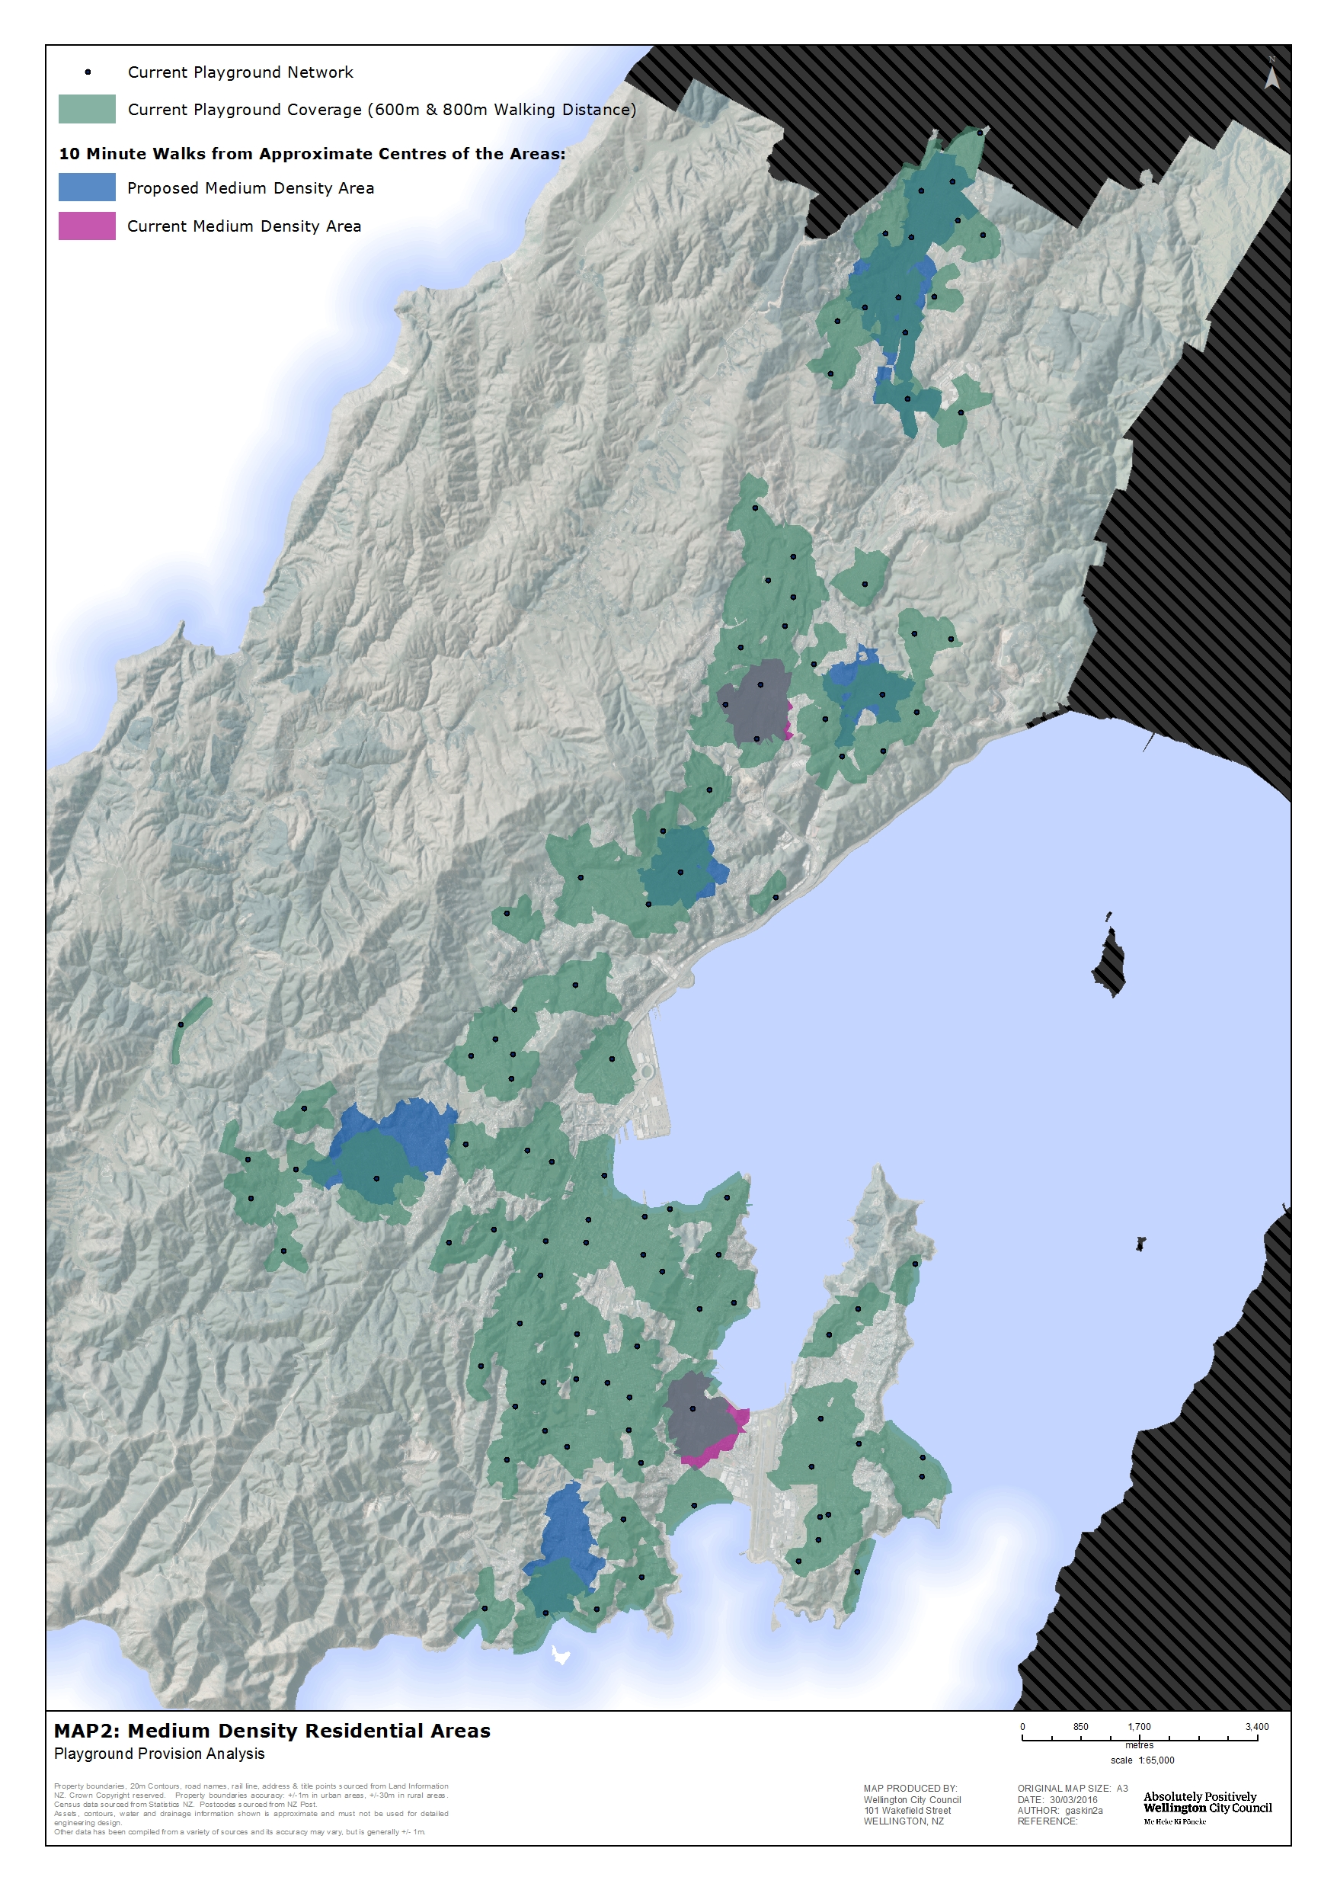

Community and school partnerships
A survey sent to all of the primary schools across Wellington in early 2016 found:
- 93 percent of schools allow public access to their playgrounds outside school hours
- during school hours, the majority of respondents (75 percent) said their children never or only on special occasions use public playgrounds – the reasons why students visited public playgrounds were varied, with most answering “they are just somewhere different” or “they are close to our school”
- 63 percent of respondents have upgraded their playground in the last 3 years or were planning to do so – of those, 50 percent considered having different equipment to other playgrounds in the area and 25 percent didn’t consider other playgrounds at all
- the most important consideration for schools in planning a new playground was age appropriateness of equipment, followed closely by the equipment’s level of challenge and student or community input.
There were also some really helpful comments that provided more detail. Like the Council, a key issue for schools is funding playgrounds – both the initial build and also the maintenance and inspections.

The survey of schools and the panel survey both indicate that many people can and do use playgrounds in schools. The Ministry of Education fund schools but do not directly influence the provision of outdoor play (type, quantity or quality). Individual schools make this decision in consultation with their community and subject to prioritisation of the general funding.

Sport New Zealand is developing a framework to enable them to take a “lead agency” role at a central government level to advocate for the importance of play.

The Council has a health and safety responsibility around managing and maintaining formal playground equipment, which will limit involvement in this aspect of playground management. The survey panel told us that providing feedback on playground plans was their preferred way to be involved but some were willing to participate in working bees to help maintain the playground environment. A comment at a more informal survey in Civic Square included support for community involvement as “teaching respect for the park if kids have more say” and “so they feel the park is part of their community”.

The general public want to be involved in providing for play in public space. There are existing community groups already actively engaged in the care and custodianship of different reserves, including ones with playgrounds in them. For example, the Friends of Central Park help beautify and maintain the playground environment at Central Park.
The Council currently provides Push Play trailers and free sports equipment from the Push Play library for use in parks. This is intended to facilitate easy and free opportunities for outdoor play.

What do we have now?

Dedicated play space

The playgrounds network
In 2016 the play spaces network includes 107 public formal playgrounds. The majority of play areas fit the category of local or local basic (82 percent). Map 3 shows the spread and category of the current formal playground network.
A nature play trail is proposed at Mount Victoria. The idea is to integrate play trails into the open spaces and tracks to encourage play and broaden children’s interest in landscapes and Mount Victoria/Matairangi. Natural landscape play elements might include balancing, climbing, living huts, and tunnels.
66 percent of all residents are located within a 600-metre or 10-minute walk of a neighbourhood playground or 800 metres of a community playground (refer to Map 4). In addition to this there is a network of school playgrounds that the general community use outside of school hours. City housing residents also have playgrounds for their use.
Wellington City compares well regionally with the number of playgrounds per head of population (at approximately 1/1800 residents or 3.2/1000 children) and the walking distance “ideals” that represent an equitable distribution across the city.
There is limited public support for retirement of formal playspace, even where there would be a citywide benefit in helping provide a more even distribution of playgrounds around the city. The community believes that the current network of 107 is “about right”.
Formal playground space is the “favourite place to play”. This is followed by pools, other water places (beaches, rivers, lakes, ocean), the non-playground area of parks and around our house/flat or outside at a friend’s house.
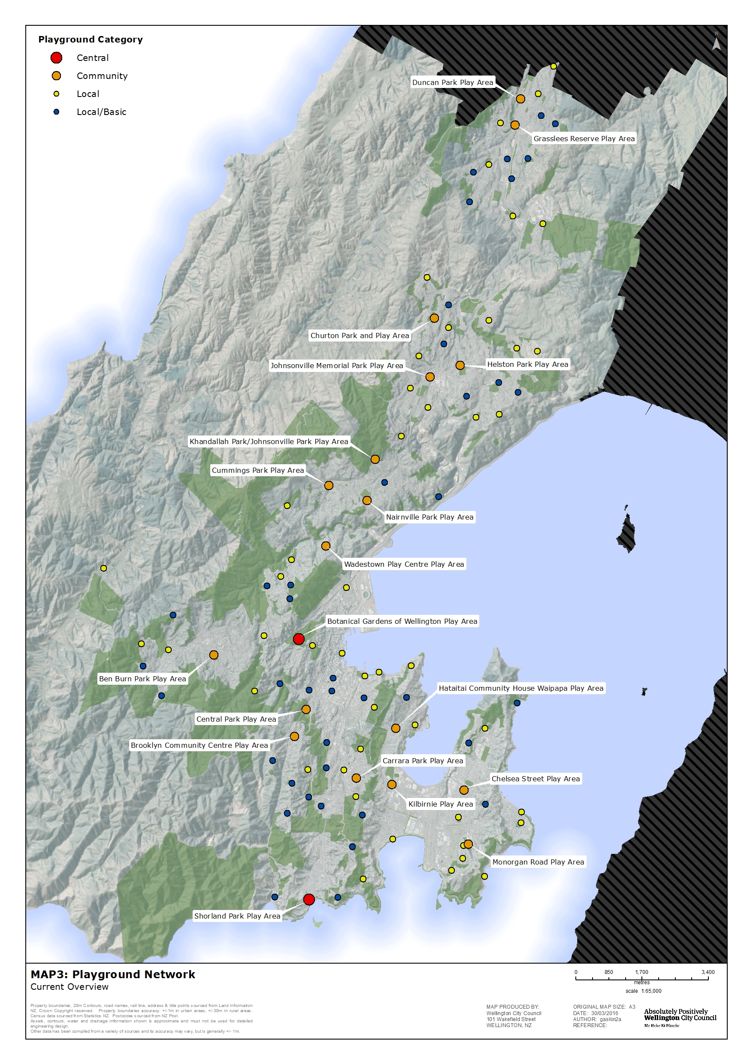

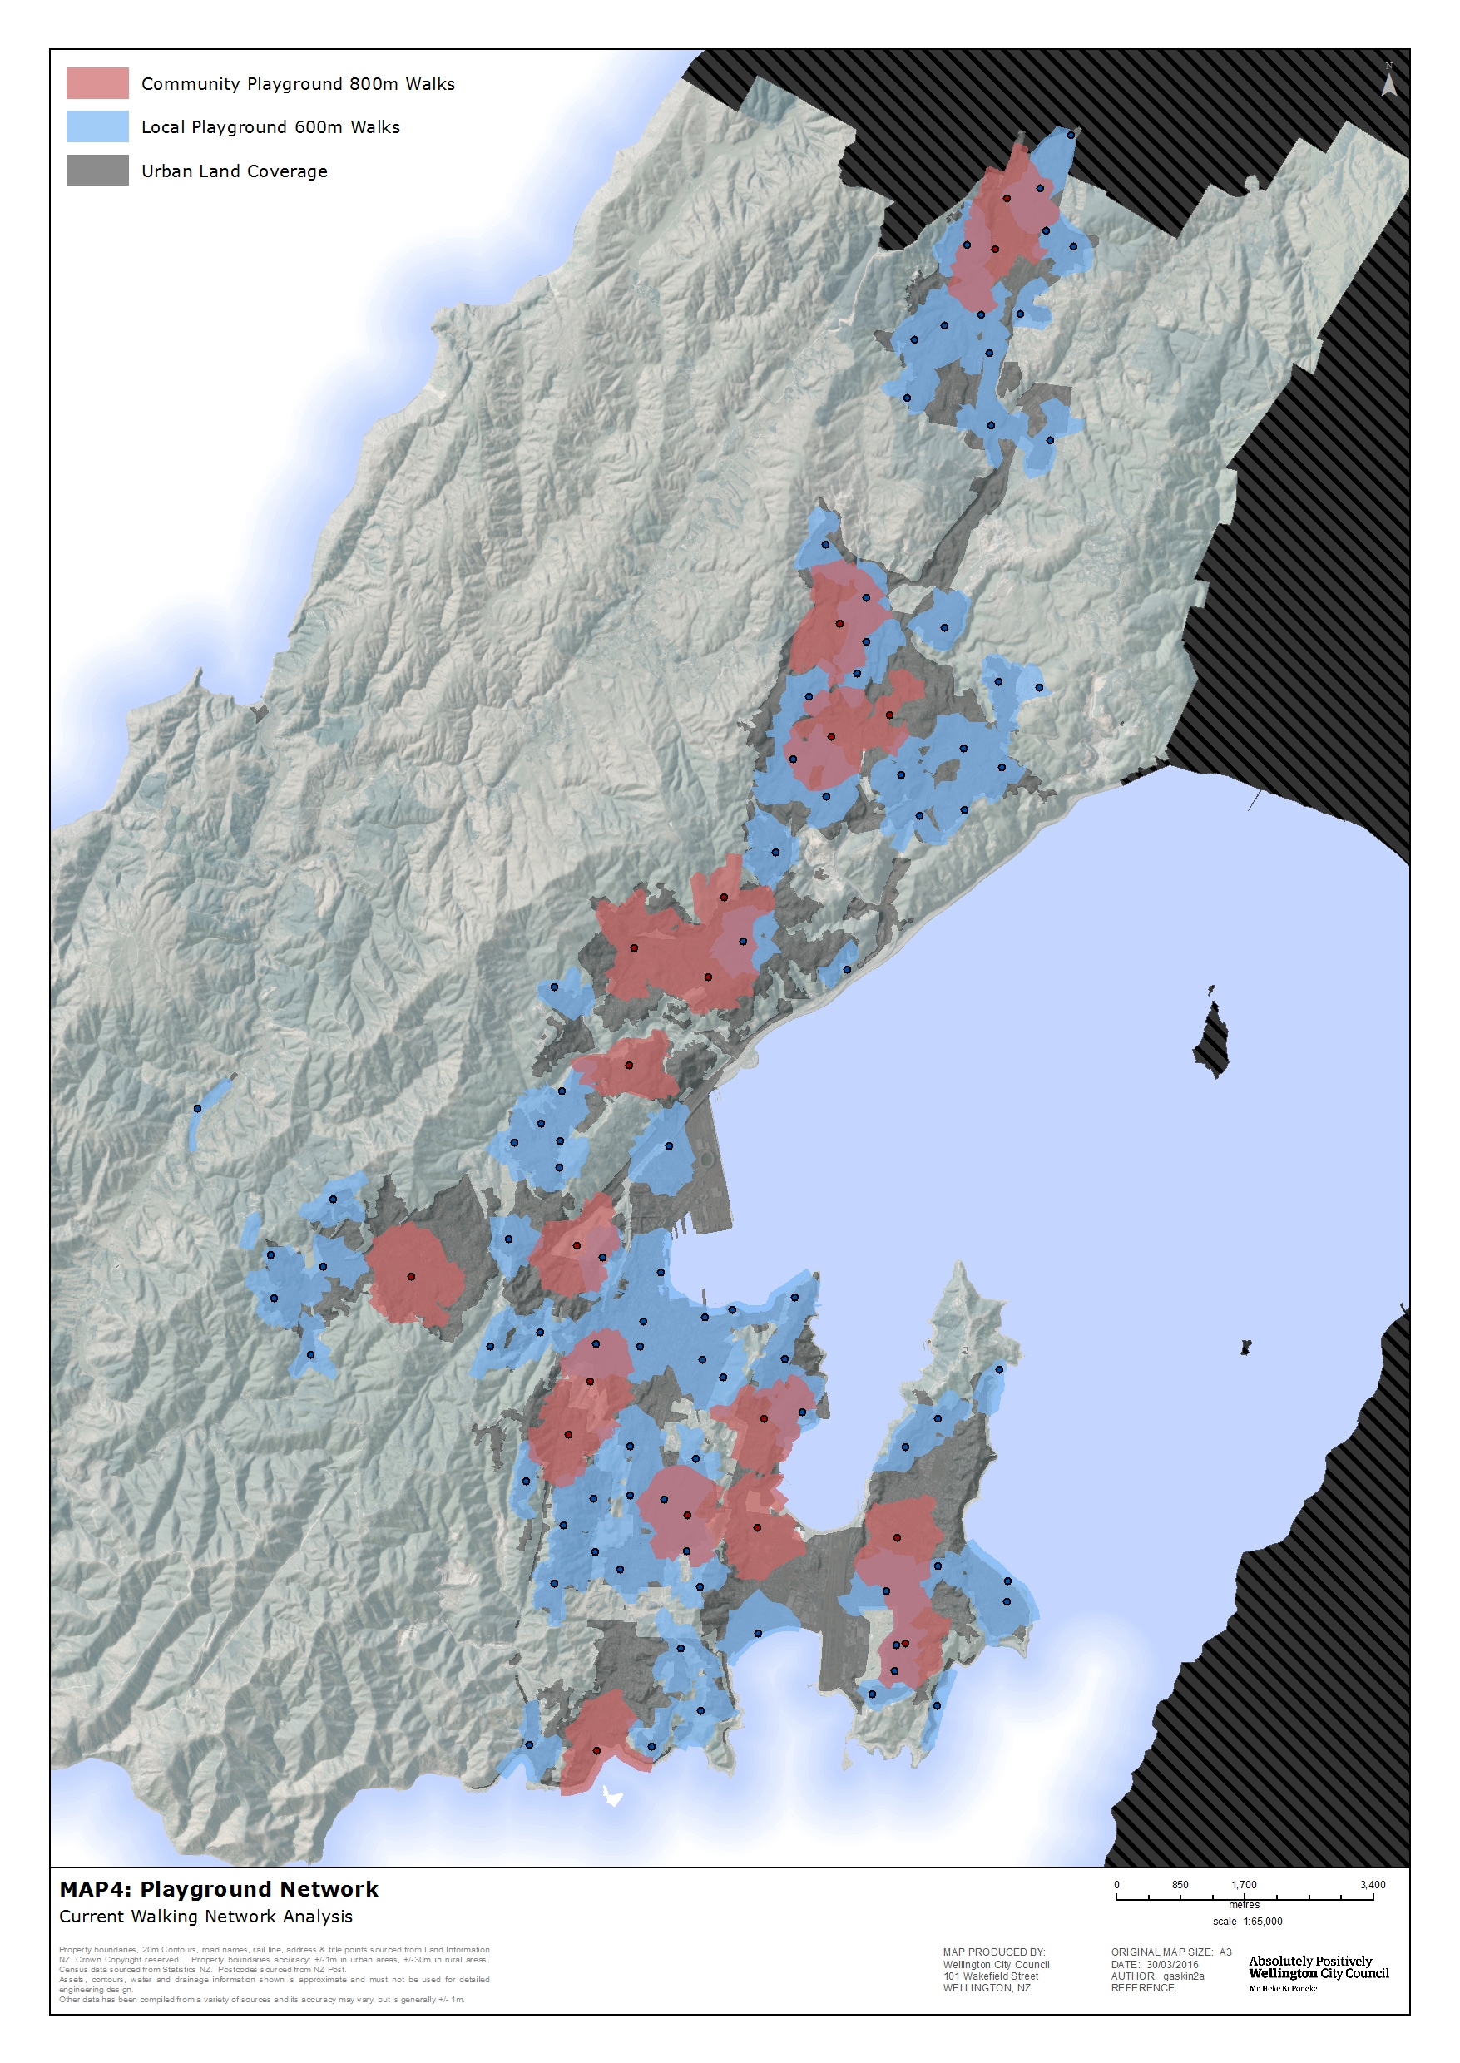

How we manage playgrounds
The existing budget for the “renewal” of playgrounds allows for approximately four renewals per year. This equates to a replacement of play equipment and safety surfaces at each playground every 25 years. Regular inspections and maintenance is carried out, which helps inform renewals prioritisation.
The category of playground currently determines what play equipment could be expected and the age of child the playground will primarily cater for. This can at times limit opportunities to achieve the best outcome for each particular space and community in terms of the renewal allowing the creation of a more multi-functional play space. The opportunity to consider drainage work or earthworks or other general park improvements to create a better space at the same time as the play equipment renewal would have a better long-term result in terms of the quality of the space and its range of use.
Community expectation has changed to anticipate more than just replacement of old and/or failing equipment (which is what the budget provides). Consistently, there are requests for associated improvements to the park such as paths, tree and amenity planting, shade and fencing.
A key issue is the implication of including amenity planting as part of the playground renewal. This is an important part of the concept of play spaces and familiarising children with nature play opportunities. This is something the community support, and research shows it will deepen the value of the space as a place to play. This work is not currently funded through the LTP. A tree, for example, could provide shade, be a place to play and beautify the area but there is currently no funding to provide the tree, a tree cage and to plant and maintain it for the first 5 years. Amenity planting often needs high maintenance, particularly if it is designed to be played in and amongst.
There is an identified need to address the accessibility of many of the Council’s playgrounds. As a result of the accessibility audit, opportunities to improve access are considered at the time of the playground renewal. This includes, for example, widening gate clearance to 1.2 metres, removing vehicle barriers that restrict pedestrian access, improving seating opportunities for carers, and improving paths and play equipment accessibility.
We know that people want different equipment in each playground so that they can go to a different area in the city and the playground will look and feel different.

Skate facilities, basketball courts and bike skills areas
There are seven skate facilities, six bike skills areas (including three in schools developed in partnership with the Council and the Bike On Charitable Trust) and 22 outdoor basketball courts (17 half and five full sized) available for public use. Map 5 shows these areas with a good spread across the city. There is no outdoor court provision in Karori.

How we manage skate facilities, basketball courts and bike skills areas
Maintenance is carried out on a reactive basis. Unlike playgrounds, however, these facilities don’t have a predicted “lifespan” in the same way as play equipment does. Changes are made in response to changing use over time (led by popularity and/or evolution of different sports) or repair of general wear and tear.

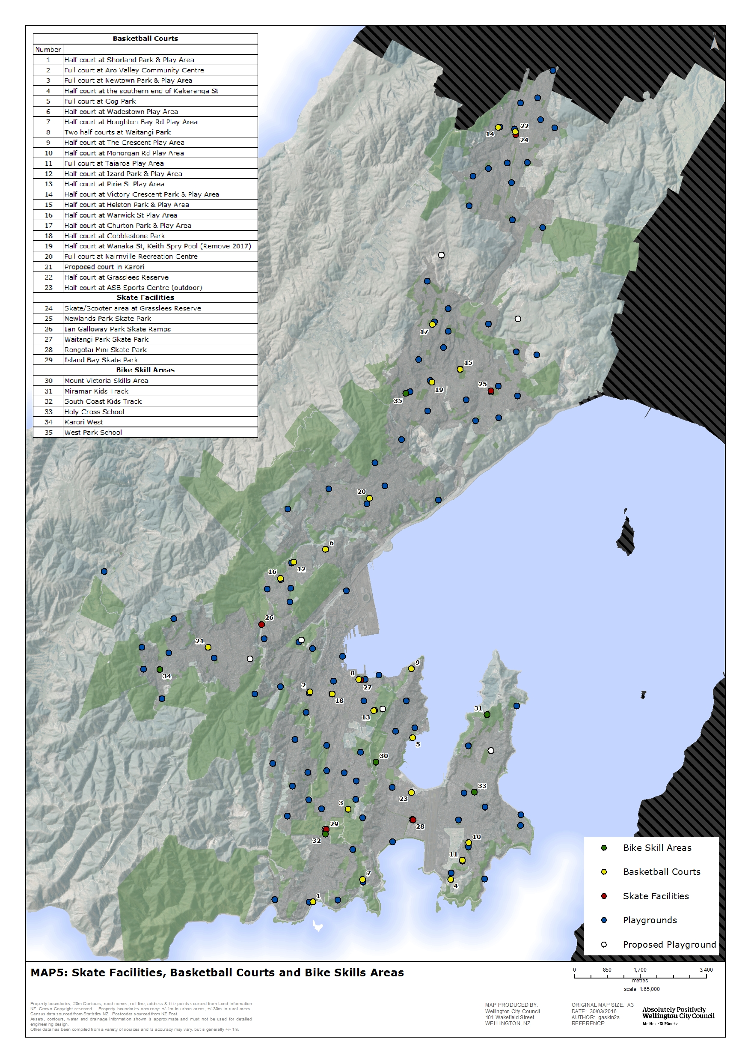

Other dedicated play space
There is a range of other dedicated play spaces around the city that are not part of the Council public playgrounds network, including:
- school playgrounds
- city housing playgrounds
- private facilities (shopping centres, retail stores, commercial play experience)
- private backyards.
Public accessibility to these varies but they all form part of the complete picture of play available to children and young people living in Wellington. Map 6 shows the range of “other” play spaces alongside the publically accessible Council network. Schools and backyards are particularly important as places where children spend large parts of their time each day.
The Children’s Garden is a new development at the Wellington Botanic Garden. It will demonstrate our dependence on plants and ecosystems and the services they provide. It will provide a unique opportunity to get children involved and encourage environmental and botanical awareness in future generations. It will provide an opportunity for interaction with nature that will help children feel more comfortable in their natural environment and will have a focus on learning through play.
There are regional opportunities for play, both free and at a cost, such as the regional parks and destination playgrounds. The recent Wellington Zoo developments provide a focus on play and nature connection and Zealandia also provides opportunity for play. Te Papa is a popular indoor play space.

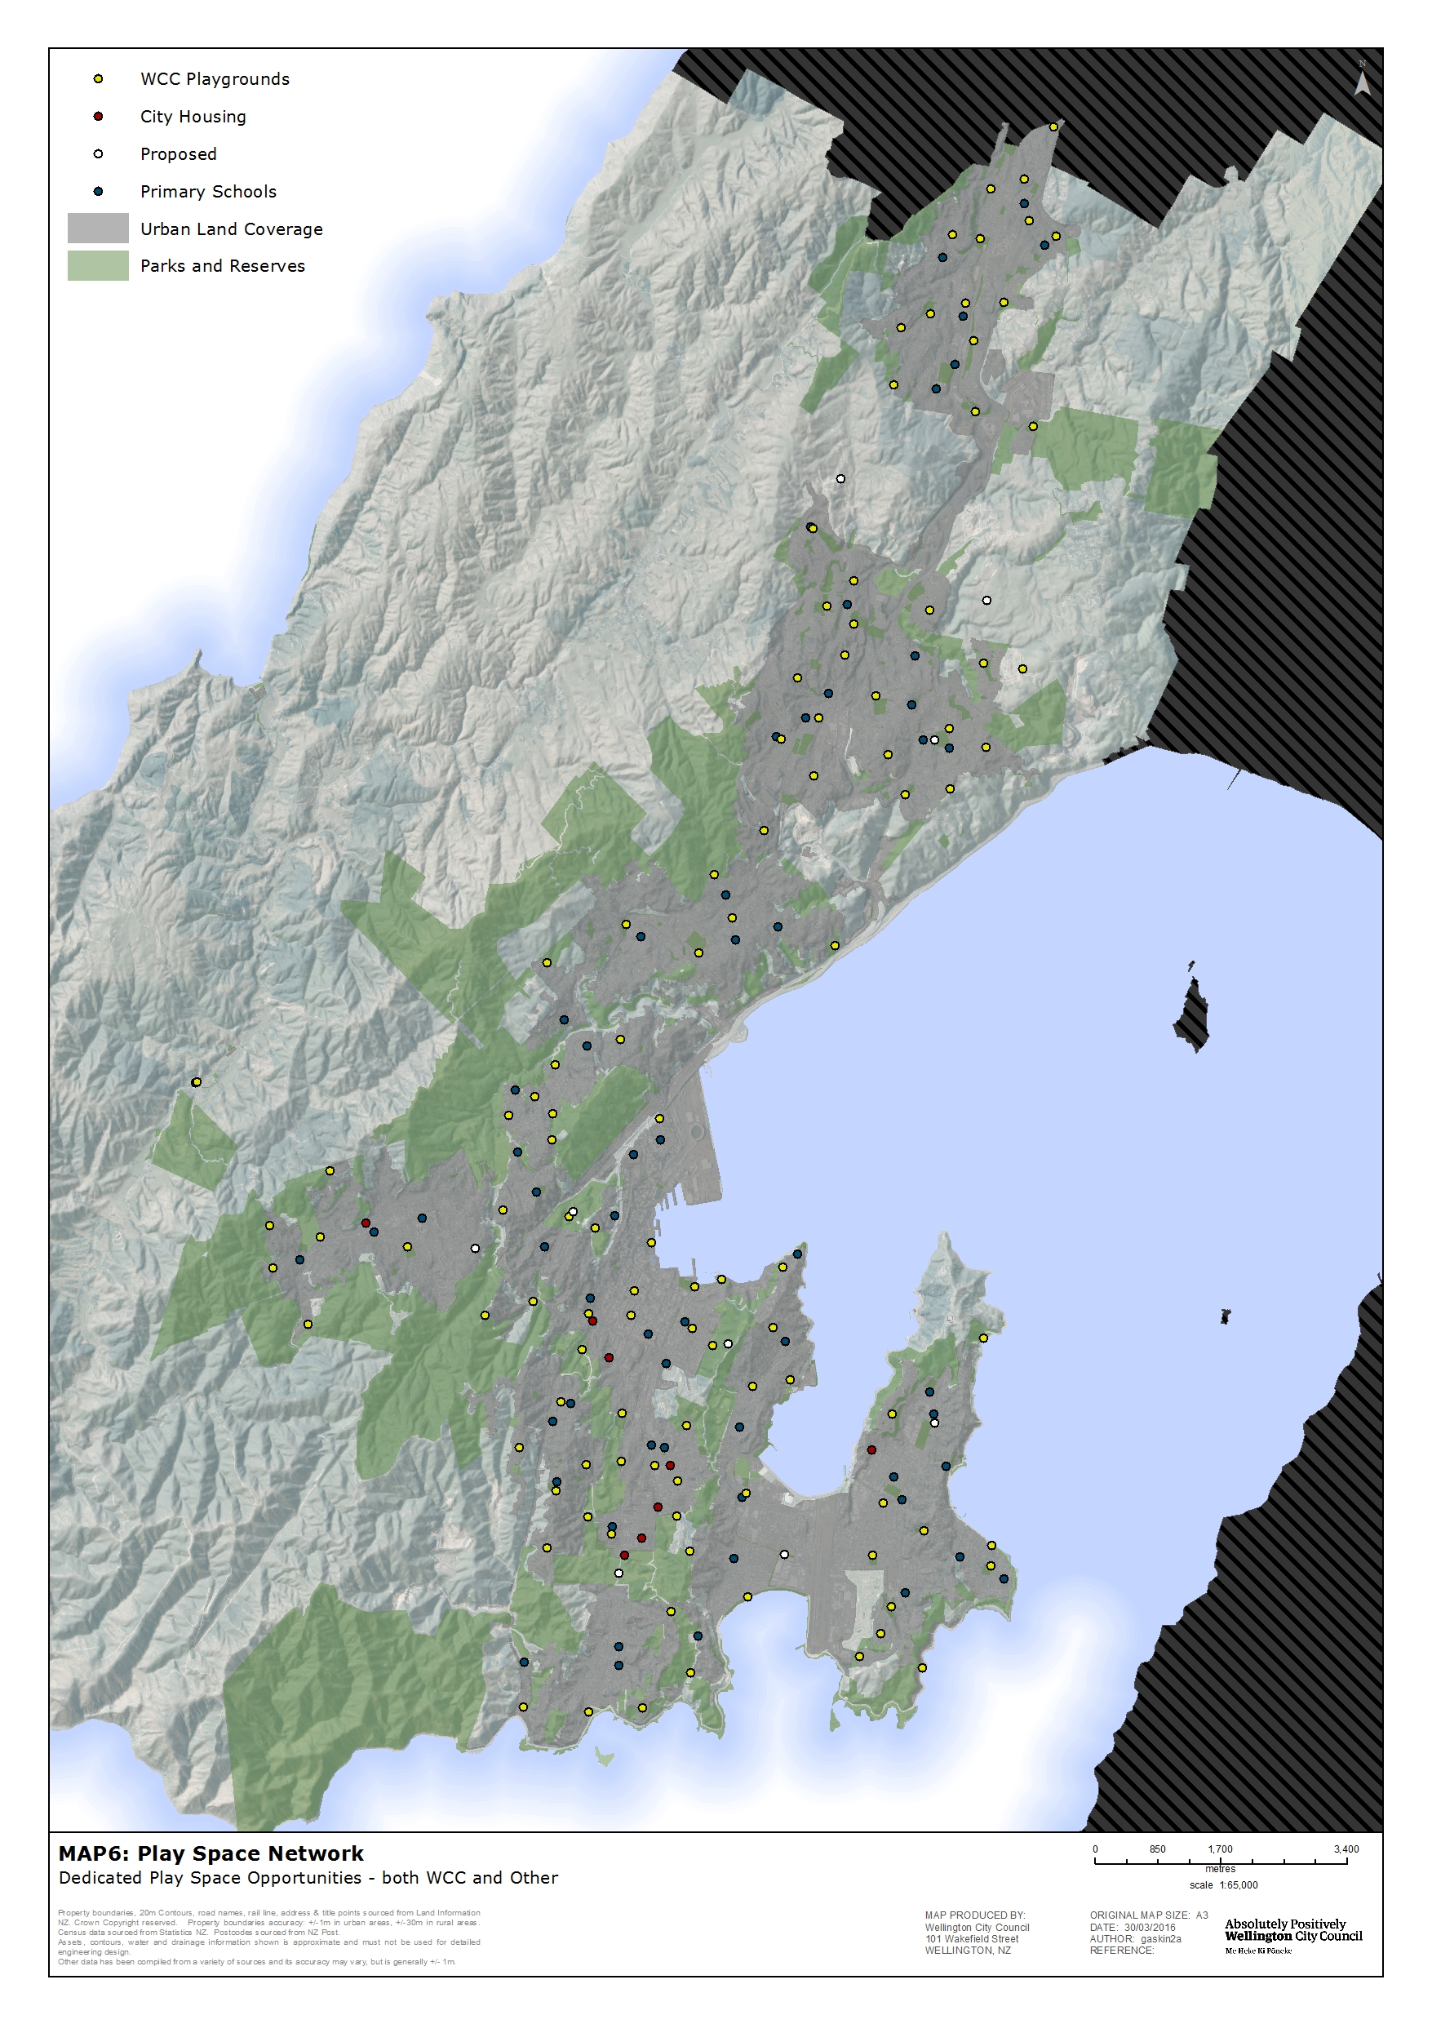Community involvement and school partnerships
Included in the 107 formal play spaces are three school playground partnerships. Each partnership was developed specifically for the situation and is therefore different. They provide for playgrounds on school and/or Council-owned land that are managed and maintained by the Council with renewal through joint funding. Makara School is open to the general public outside of school hours, while Amesbury Drive School and the Kipling Street play area are open to the public at all times, as the location of those allows use without disruption to the rest of the school.
The Council provides funding for bike skills areas in schools through the Bikes in Schools programme, which was piloted in 2015/2016. To date, West Park School, Karori West Normal School, and Holy Cross School have developed a fleet of new bikes and bike helmets, purpose-built riding tracks and bike storage facilities. The schools came up with ideas to make the track design and use safe, fun and unique to each school. They are open for community use outside school hours. The Council has allocated funding until June 2018 for 3 to 4 more schools to develop bike skills areas per year, in partnership with the Bike On Charitable Trust.
Community involvement in the development of plans varies depending on the scale of the playground development. A neighbourhood playground renewal, for example, will have plans posted on site and users can comment. The new playground development at Frank Kitts Park included in-depth and wide-reaching public engagement and consultation.
While survey results suggest the community wants to be more involved in maintenance and management of playgrounds, to date this has not occurred in any formal way and will be limited somewhat by strict health and safety requirements around play equipment and fall surfaces.

Incidental play space
Wellington City has endless opportunities for free play in the natural environment, with over 4207 hectares of open space, including Wellington Town Belt, the Outer Green Belt, coastal reserves, 250 neighbourhood park spaces, 43 sport and recreation parks, Wellington Botanic Garden, Otari-Wilton’s Bush and 330 kilometres of tracks. This abundance of natural environments all close to the central city and residential areas is part of what makes Wellington unique.
“Just take your children outside, give them time, and let them play.” – Karl Nolan, Botanic Garden Collection Curator.
Suburban areas and the central city also provide incidental play space. The Council has a responsibility in ensuring opportunities for play spaces are improved where possible in the public realm. The Bond Street activation project is a good example of “playful” design that encourages a range of people to use a street space in a whole new way, while the artificial turf in Civic Square has seen informal play become a major use of this space for all ages.

Play Spaces Policy & Action Plan

Vision

Wellington City’s Play Spaces are a network of sometimes wild, always fun, diverse, safe and accessible places that foster growth and development of children and contribute towards building a healthy, active, connected city.

Strategic Priority 1: Provide a network of play spaces across the city

Policy 1 – The play space network
The Council will provide:
- 111 dedicated formal play spaces (playgrounds) – destination, community, neighbourhood, school partnerships (at 2015 there are 107)
- the Mount Victoria/Matairangi nature play trail
- the Children’s Garden
- six formal skate/scooter facilities
- 22 outdoor basketball courts (16 half court, six full)
- six bike skills parks (both in parks and at schools)
- playgrounds at City Housing sites where children are living
- incidental play space across the city, both in parks and other public spaces.

Policy 2 – Dedicated play space (playgrounds)
The Council will provide a network of dedicated play space based on best practice provision analysis, nationwide comparison, census data that suggests there will not be a significant increase in the number of children in Wellington in the next 20 years, and the knowledge that Wellingtonians believe the number of playgrounds in Wellington is “about right”. Areas of higher density living, both existing and planned, have also been considered. Map 7 shows the proposed network of playgrounds by category.
The focus on an evenly spread network of a variety of high-quality, well-maintained spaces means that after accounting for the actions described below, there will be no more new formal playgrounds. This allows for approximately 74 percent of all Wellingtonians to be located within 600 metres of a neighbourhood playground, or 800 metres of a community or destination playground. Map 8 shows this distribution and walking catchment.
A relatively even spread of a mix of formal play opportunities across the city provides the best outcome for the most children, and young people now and into the future. This will be complemented by a play trail, skate/scooter facilities, outdoor half courts, bike skills areas, spaces provided by others (at schools, for example) and informal and incidental play opportunities that exist and will be improved throughout the city.
Actions:
- The following new playgrounds will be constructed to complete the network of dedicated playspace:
- a community play space near or at Wakefield Park (Island Bay/Berhampore)
- a community play space at Newlands Park
- a neighbourhood play space at the city end of Karori
- a neighbourhood play space at Kilbirnie.
- The following new playgrounds will be constructed and funded by development contributions as part of future greenfield growth in the northern suburbs:
- a community play space at Lincolnshire Farms and potential for a further neighbourhood play space between Lincolnshire Farms and Grenada North (at Hunters Hill)
- a neighbourhood play space at Churton Park (Stebbings Valley).
- The Miramar North and Kenmore Street neighbourhood play spaces will be retired at the time of development of a new community play space at Miramar Park and Newlands Park respectively.
- Play equipment in the Nuku Street reserve and Burbank Crescent reserve will not be replaced when it reaches the end of its lifespan, as outlined in the Suburban Reserves Management Plan and Northern Reserves Management Plan respectively. In both cases, the land will remain reserve.
- No other dedicated play space (playgrounds) will be closed unless there is a proposed partnership for a new playground (with a school, for example) or there is a proposal for a new playground nearby. The result is no reduction in the number of playgrounds in the network over time.
- Opportunities for school partnerships will be investigated alongside proposals for new or replacement playgrounds.
- Other than described above, no new playgrounds are proposed with a completed network of 111 in total. There may be a need to consider new play space in the longer term as greenfield development areas in the north of the city are planned and developed.

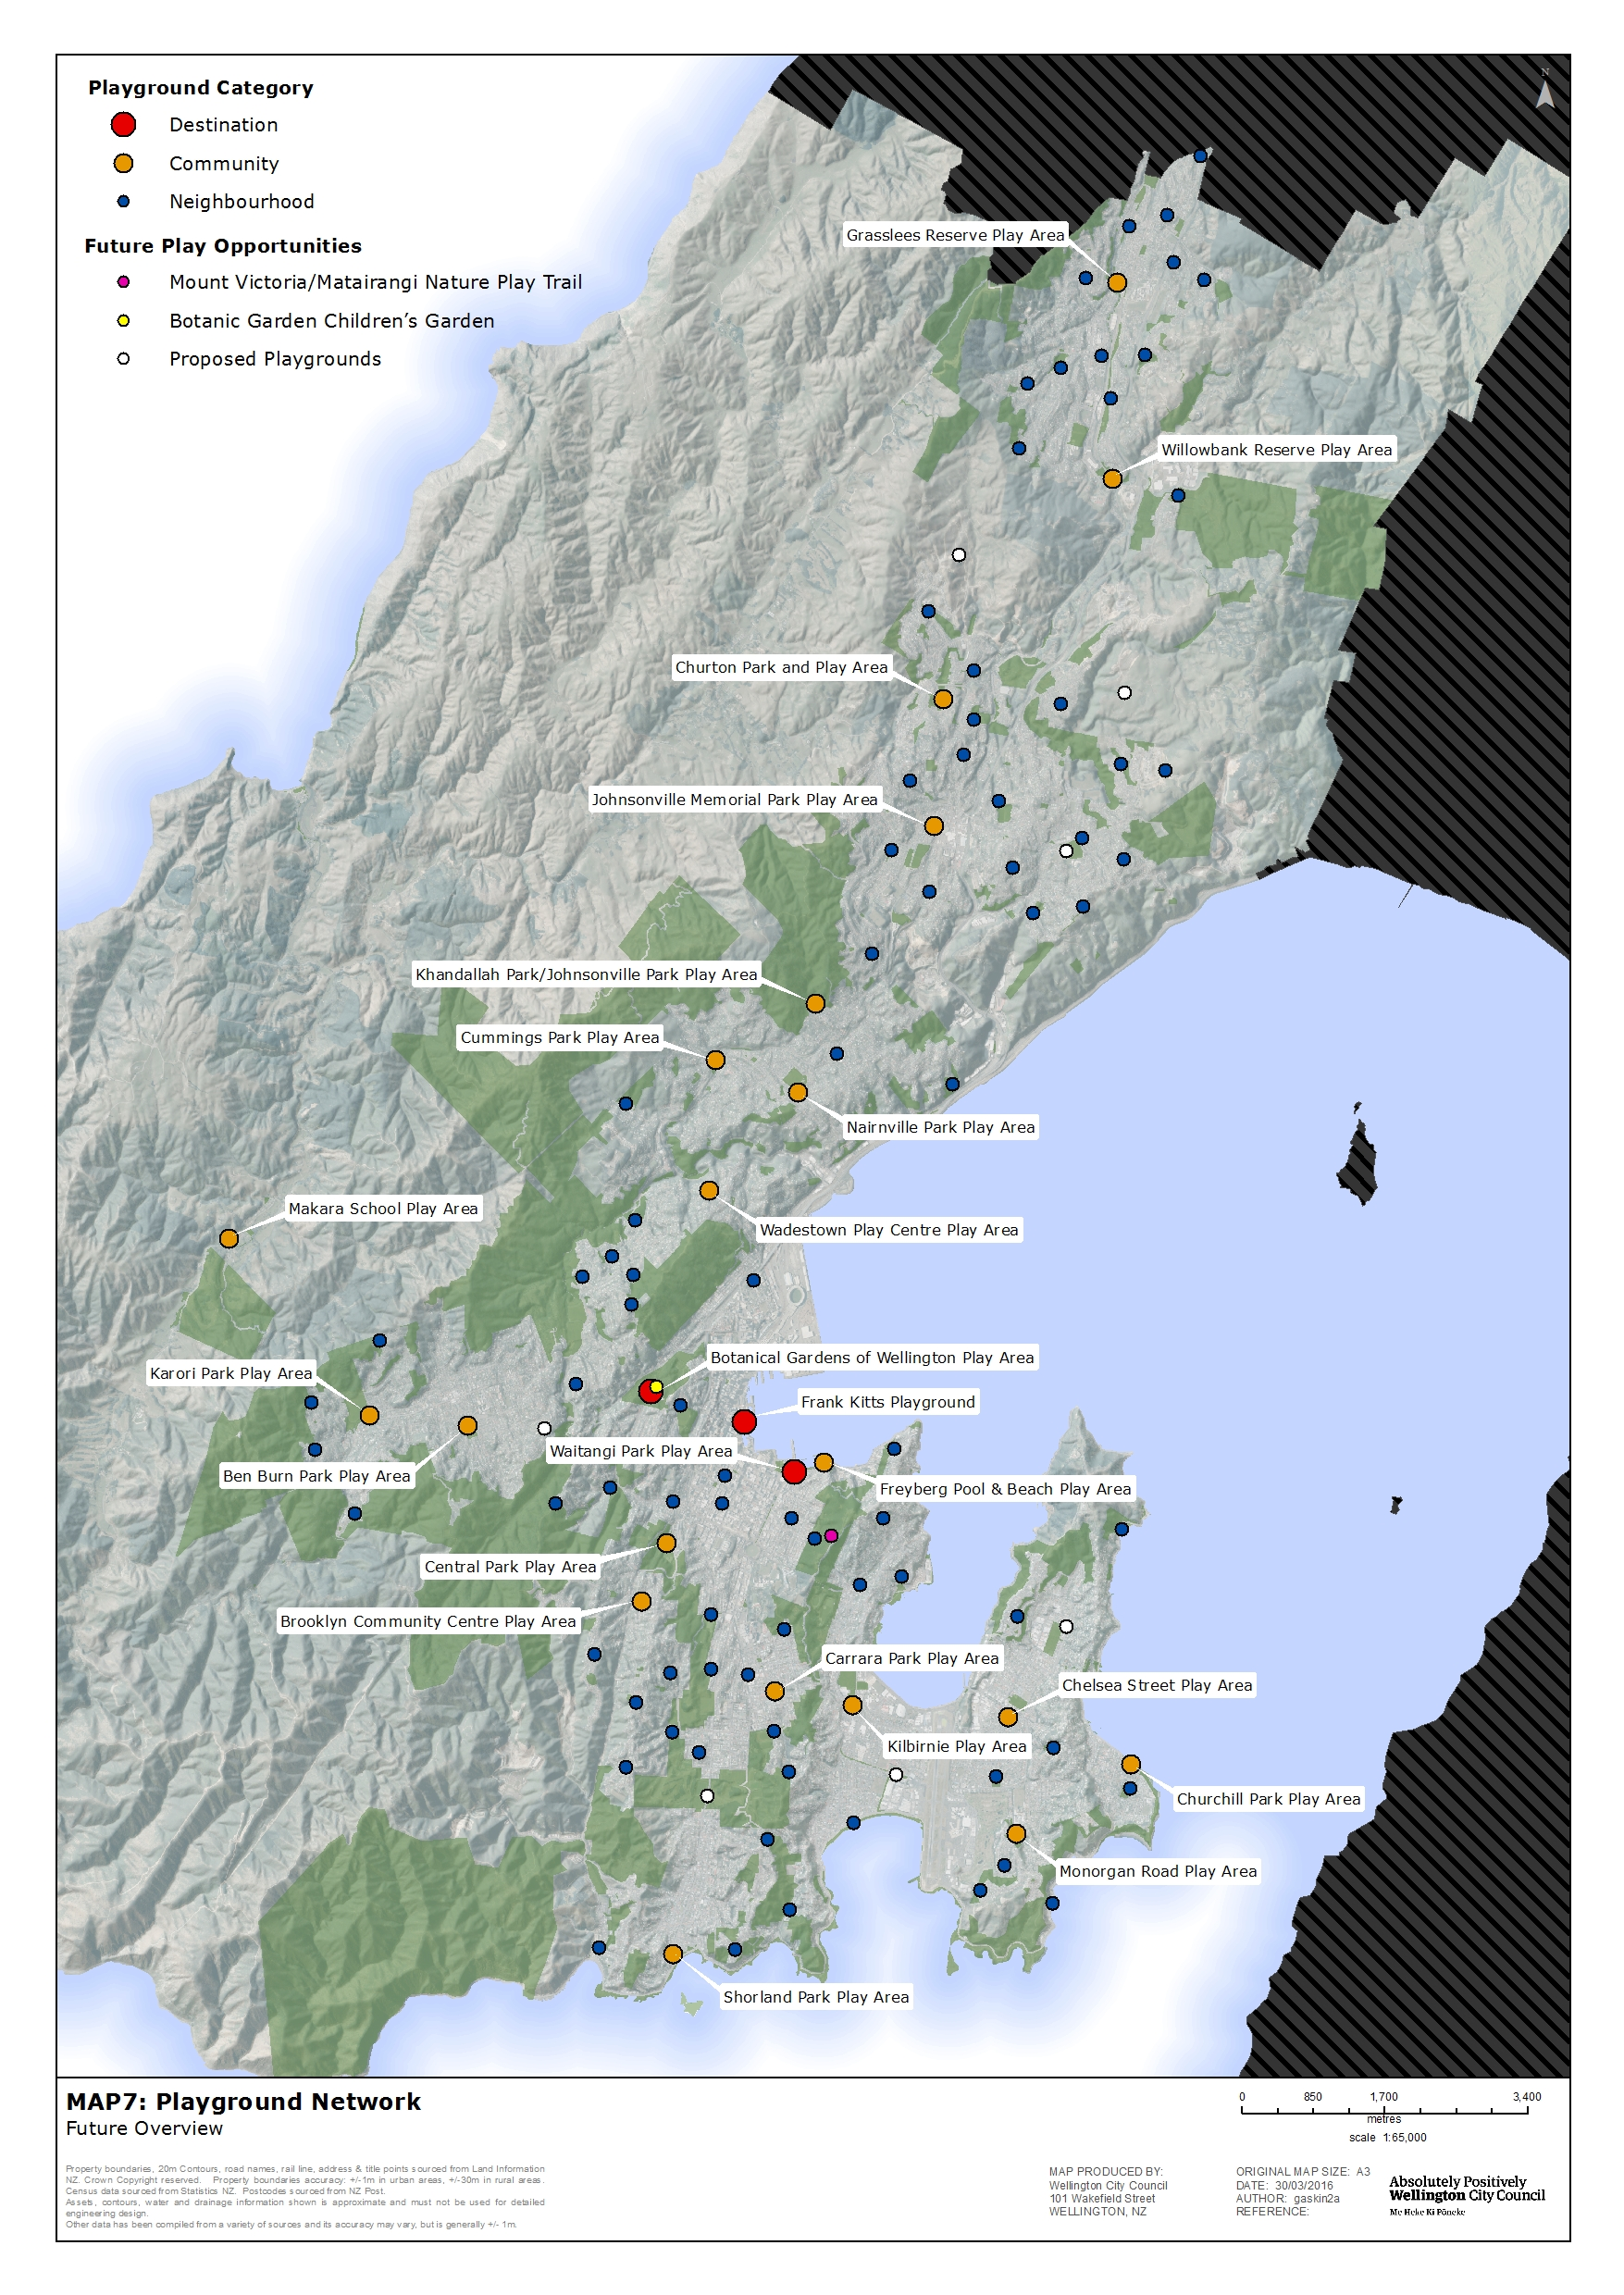

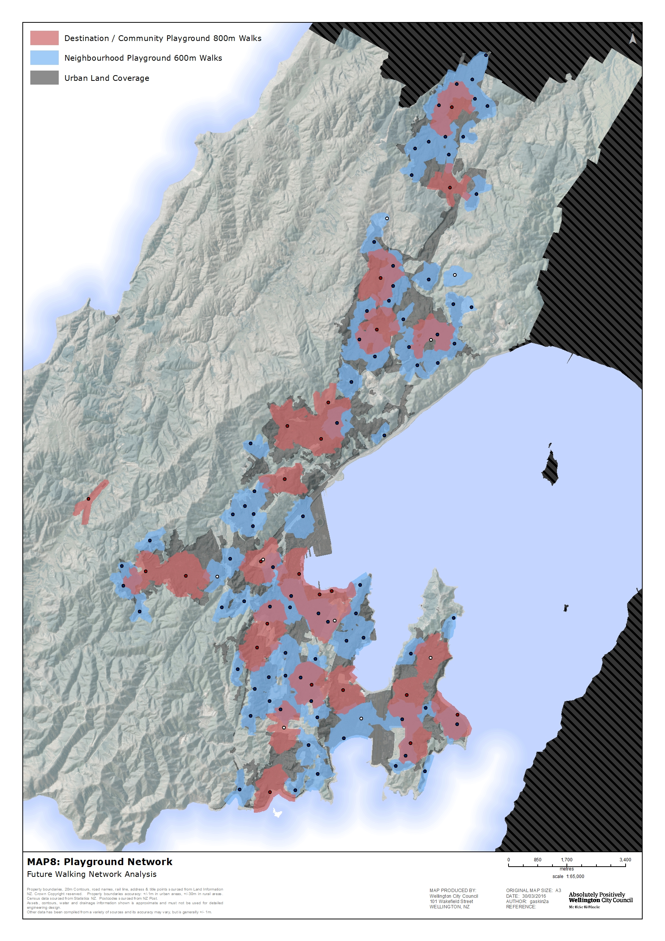

Policy 3 – Skate and scooter facilities
A network of six formal skate and/or scooter facilities will provide a spread across the city, ideally located within or near to community reserves where there are other recreation opportunities available (see Map 5). They are further spread apart as they serve a smaller user group than playgrounds and users can and do travel to a quality facility. The network will provide a good range of skate opportunities for different types of skating and different skill levels at each site.
Actions:
- Skate facility provision in the eastern suburbs will be assessed to consider the need for, type and location of, a new skate facility or improvements to existing facilities.
- The old skate ramp at Nairnville Park will be removed when it reaches the end of its serviceable life (within the next 3–5 years) as it is not well located.

Policy 4 – Outdoor informal court space
The outdoor court network for informal play is also well spread around the city, providing a range of court spaces set in a variety of environments from suburban to inner city (see Map 5). As with skate/scooter facilities, there are fewer of them in total but they are well maintained and located within spaces that have other facilities for play and/or informal recreation.
Opportunities for an alternative location for the half court at Johnsonville will need to be explored when the existing one is removed as part of the proposed library development plans. There is no outdoor facility in Karori. The need and feasibility of a new one will also be considered. In both cases school partnerships will be considered.
Actions:
- A new half court will be provided in Karori (potentially through community or school partnership).
- Consider the need for an alternative outdoor court space when the Johnsonville Wanaka Street site is closed.
- The fenced court space at Nairnville Park will be resurfaced and basketball hoops installed to broaden use of that space for informal play, particularly for youth.

Policy 5 – Bike skills areas
The bike skills areas provide for learn to ride spaces and are located as shown on Map 5. Any new projects will be led by community initiatives or the Bikes in Schools Programme. The Open Space Access Plan outlines new initiatives for easy mountain bike tracks.
Actions:
- The Council will continue with the Bikes in Schools programme partnerships, subject to securing ongoing funding.
- A new skills area is already proposed at Karori Park (close to the Mud Cycles shop) to support other track developments at Karori Park and Makara Peak.

Policy 6 – Nature play trails
The Mount Victoria/Matairangi nature play trail will be a different experience to the traditional playground and will foster and encourage nature connection through play for a range of age groups.
Actions:
- Construction of the Mount Victoria/Matairangi nature play trail will begin in 2016/2017.

Strategic Priority 2: Provide high-quality, fit-for-purpose play space

Policy 1 - Play space principles
Wellingtons outdoor play spaces are:
- expertly designed and firmly grounded by play theory to inform age appropriate equipment and space
- designed to reflect the site context expressing iwi/cultural, environmental or other community stories and values – contribute to “sense of place”
- accessible and inclusive
- multifunctional space whenever possible and may not incorporate a formal playground or play equipment
- high quality, well built and well maintained
- fun, varied and interesting with opportunity for age appropriate risk
- designed and built to encourage nature connection whenever possible
- found in a range of settings, from remote, natural parks to neighbourhood parks and suburban streets to the inner city streets and urban spaces
- evenly spread around the whole city
- well promoted and easy to find
- adequately funded.

The Council will promote nature connection in play spaces, recognising the continuum of opportunity and making the most of opportunity whenever possible to deepen the benefits of the play experience.

Natural reserves and “wild” environments
Free play in a natural setting.
Play trails and nature play at playgrounds
Natural/more informal environment still with some instruction or cue to “play”.
Botanic Gardens teaching garden and schools
Safe, highly supervised environment. Demonstrates/facilitates how to interact with nature in a safe setting.

Formal playground
Place to play but might mimic nature with natural looking equipment and areas of garden to play in.

Policy 2 - A guide to dedicated play space categories
The Council will provide three categories of dedicated play space (playground) spread throughout the city, as illustrated on Map 7. Appendix 2 lists the playgrounds by category. The following table provides a guide to the considerations for each type that will inform development of the play space.

 | Play equipment | Types of informal play opportunities | Types of visitor and caregiver amenities | Catchment areas
Destination play space  A premium playground that attracts residents, visitors and tourists. Users may stay for 2 hours or more | Play opportunities for multiple age groups  Regionally unique and a celebration of place | Kick-about area  Spaces to gather and meet  Informal court space (eg basketball half court)  Natural landscape features  May have art installations or hard landscape features that offer opportunities for play  Located in spaces where there are opportunities for informal and incidental play and interaction with the natural environment | Picnic tables and seats  Drinking water  Lighting  Rubbish bins  Central city location  Shelter/shade over some of the play equipment and other areas of the play space provided by structures and/or trees  Car parking  Toilets | The whole city and Wellington Region  Centrally located and easy to get to with connections to public transport routes, and linked to pedestrian pathways and cycle ways where possible
Community play space  Enough activities to keep children and/or youth aged people entertained for at least an hour | Play opportunities for a range of age groups  Unique or with a point of difference to other community playgrounds around the city | Kick-about area  May have informal court space (eg basketball half court)  Spaces to gather and meet and to engage in different types of play (eg both active play and relaxation/quiet contemplative play)  Natural landscape features  Where possible, designed to encourage exploration of the natural environment such as steps to a stream or a path to the bush or the beach  Amenity planting and planted areas that are designed and located to be played in or on  Include opportunities for nature play | Picnic tables and seats  May have a barbecue  Drinking water at park or nearby  Security lighting where appropriate  Rubbish bins  Shade/shelter over some of the play equipment and other areas of the play space provided by structures and/or trees  Car parking  Toilets at park or nearby (may have limited open hours)  Paths to connect to the wider neighbourhood and provide access to the play equipment area | Service the immediate neighbourhood and local community within approximately 800-metre walking distance  Ideally located in community parks or near neighbourhood centres.
Neighbourhood play space  Handy place for a quick play | Play opportunities for at least one age group (ideally junior children as a minimum). Size of site may constrain the amount of equipment  Nature play and kick-about space will be considered to broaden play experience alongside swings/ slides for example | Natural landscape features and opportunities for nature play  Amenity planting and/or semi-natural areas that are designed and/or managed for play  Spaces to play in groups, as individuals or for a common purpose. May have kick about area | May have shade provided by trees  Seats  Paths to play equipment where possible | Service local neighbourhood within approx. 600-metre walking distance  Likely to be located in neighbourhood parks

Policy 3 – Standards for all dedicated play space (playgrounds)
The following standards will apply to all Wellington playgrounds to ensure they are high quality and fit for purpose:
- NZS 5828: 2015, Playground Surfacing and Equipment is adhered to
- CPTED principles are incorporated in design and location decision making and upgrade project briefs
- dogs are not allowed
- smoking is not permitted within 10 metres of playgrounds or as determined by the Smokefree Environment Policy
- whenever practicable they are inclusive, enabling children and young people of different abilities and with different types of impairment to play with and alongside other children
- new playgrounds and upgrades aim to reduce and eliminate social and physical barriers to access for children and their caregivers, considering people with disabilities as well as parents with children in prams and older people with an age-related decrease in mobility or sensory abilities
- they are creatively and professionally designed and built with a point of difference that makes them unique
- they are well managed and maintained.

Policy 4 – Dedicated play space renewal and new development (playgrounds)
There are four issues to consider when planning for renewals: how often each space is renewed, growth in the network (eg an increase from 107 to 111 over the next 10–20 years), how much each renewal will cost, and order of renewal.
The Council will renew playgrounds based on an average lifespan of equipment of approximately 25 years. While this is longer than the regional comparison of 15 years, a focus on spending more at each renewal rather than shortening renewal times will enable each site to be developed as a high-quality play space. A 25-year renewal cycle for 111 playgrounds will deliver approximately 4–5 renewals per year.
Critical to getting the most from the newly improved play spaces is establishing the appropriate maintenance regime, in particular for amenity planting and nature play areas.
Actions:
- The playgrounds network will be renewed based on a 25 year lifespan at approximately 4–5 per year. Renewals order will be determined by regular inspection as it is anticipated that some may last longer than 25 years and others will be shorter depending on design, use and environmental conditions.
- Each renewal will include play equipment as well as other necessary improvements (for example, drainage, fencing, paths, earthworks, kick-about area, hard and soft landscaping and nature play areas) to broaden the play experience at each site and as described by the playground category guide.
- The need for public toilets at or near Monorgan Road play space as part of the Strathmore facilities review in 2017/18 will be investigated, in light of this being in the community play space category.
- Order of renewal will be determined by the regular inspections regime as it is anticipated that some play space may last longer than 25 years and others less (in a coastal environment or high use space for example).

Policy 5 – Skate and scooter facilities management
The number and mix of type of skate facilities across the city is currently suitable to cater for the needs of the skate community. Diversifying the use and improving the quality of the network over time will maximise use of these facilities.
Actions:
- A programme for “minor improvements” to each of the six facilities will be developed to diversify use (catering for different skill levels) and make them fit for purpose. Opportunities to separate skate and scooter use will be considered at each site.
- Community and/or club partnerships to develop new facilities or for significant upgrades will be considered on a case-by-case basis. Decision making will be based on needs assessment and effects of the proposal on the site and on other users and on the wider park values.

Policy 6 – Outdoor informal court space management
The range and number of court facilities (including planned improvement to the network discussed above) is considered appropriate for the needs of Wellingtonians. The existing network of outdoor court space for informal use will be good quality and fit for purpose.

Policy 7 – Bike skills management
The Bikes in Schools programme includes ongoing management and maintenance by the schools. The Council’s bike skills areas are managed and maintained as part of the public tracks network.

Policy 8 – Nature play trails management
The Mount Victoria/Matairangi nature play trail is a new initiative and one that has not been provided by the Council before as part of the network of play spaces throughout the city.
Action:
- The success of the new play experience will be monitored. Any future nature play trails will be subject to consideration during future long-term plan or annual plan process.

Strategic Priority 3: Community and school partnerships
Schools play a key role in the provision of additional dedicated formal and informal play space but are not a substitute for fully publicly accessible playgrounds.
Schools do not have a mandate to provide their grounds or their play equipment to the general public (although most currently do and encourage after hours use). The potential for closure or limits to public access to schools is also a risk in relying on schools as providers of open space.
The Council has entered into three partnerships with schools to build new playgrounds that benefit the school and the wider community.

Partnerships Policy
The network of existing and planned playgrounds is now at a point where there is a good spread across the city. Any new partnerships with schools will be where there is an existing school and Council playground close by and there is an advantage in combining the playground either on the reserve or at the school. Partnerships will not be considered that result in additional playgrounds.
School partnerships will also be considered where there is opportunity for shared outdoor court space for informal play, particularly for youth. Any partnership will again be where there is an existing Council reserve nearby or adjacent.
There is the potential for other community groups to play an ongoing role in the care of play space and wider park environments, as some already do. Health and safety requirements for play equipment installation and maintenance will limit community involvement in the actual play space equipment.
The community can and will continue to contribute to development plans for new playgrounds and renewal plans.

Strategic Priority 4: The city as a play space
Opportunities to encourage incidental play throughout the city are considered in planning, design, construction, upgrade and management of all public space. This includes:
- park space
- road corridors
- inner city public places, such as Civic Square and laneways
- the waterfront.
All upgrades to public space should consider opportunities for incidental play space and celebrate the notion of the city as a play space. The nature of incidental play is that it occurs in places not specifically dedicated for play and is engaged in by all ages. Often a playful design theme or subtle cue is all that is needed to encourage play.
Suburban areas also have opportunities for incidental play space including along the road reserve network – particularly on routes where children walk to school. Generous road corridor width with a high proportion of road reserve space as compared to formed road surface can sometimes provide an opportunity for safe use of this space. Road corridors also offer opportunities for street planting that provides seasonal interest or sensory stimulus (touch/smell/sound).
Action:
- Opportunities for development of a network of five skateable “spots” around central Wellington (either standalone projects and/or as part of other urban renewal work) will be explored through an assessment of potential spaces and through inclusion of skate opportunity in the design brief for all new public space upgrades.

Strategic Priority 5: Programming and advocacy for outdoor play
Delivery of programmes (by the Council and in partnership with other agencies) and advocacy that promotes the value and importance of outdoor play will help get more children and young people outdoors, active and healthy and using the range of play spaces the city has to offer. Programming and advocacy will help deliver on broadening the opportunities for play in Wellington making the city more child and youth friendly.
Providing children and young people with the space and time to play outdoors is a key message.
Actions:
- The Council will explore the following initiatives to promote the value of play and what Wellington has to offer as a play space:
- supporting community groups in development of initiatives (eg play streets, nature play groups, community sensory/edible gardens, wayfinding for new users)
- temporary interventions (eg pop-up streets, engagement events, tactical urbanism, nature play networks)
- promotion of skating and parkour as activity that benefits participants and the city
- providing City Housing and apartment residents with information about their local play spaces, eg a local play spaces map in their tenancy pack
- making playable space a consideration in the design of every new project (eg civic spaces, neighbourhood parks, streetscapes) to help make Wellington a child and youth friendly city
- providing good quality easy to access, digital, print and on-site information about play spaces across the city
- explore emerging play experience opportunities, such as digital playgrounds for example, where it provides high quality play experience and can sustains high levels of public engagement
- supporting schools and parents of new entrants – could emphasise the value of free and outdoor play and where they can do it in their neighbourhood and wider Wellington
- supporting schools through knowledge sharing around playground best practice design and management and to improve the play opportunities network across Wellington.
- Work with Sport New Zealand to assist them in their role to advocate at central government level on the value of play and associated cross sector benefits – health, education, social for example.

Appendices

Appendix 1 - Play spaces theory and age appropriate activity guide
Play types | Description
Cognitive play | Include activities that challenge the intellect; games of strategy exploration and observation, and games that use and develop language.
Creative play | Creative play includes sand play, play in dirt, play with loose and found objects, play with art materials, making music, cubby building and construction activities.
Social/dramatic play | Social play includes role-play, imaginative play, small and large group activities, “hanging around” and talking, and traditional games.
Physical active play | Active play includes running, hanging, climbing, experiencing height, agility/gymnastics activities, sliding, jumping, balancing, swinging, crawling, bouncing, spinning, rocking, ball games, skipping and perceptual motor activity. Age appropriate opportunities for risk taking.

Age appropriate activity guide
Age group | Play space activity
Toddlers  (approx. 0–3yrs) | - Play centres around the carer  - Crawling  - Running and rolling down gentle slopes  - Climbing on very low level changes  - Gentle rocking  - Manipulation of tactile materials such as sand  - Interaction with natural elements and wildlife (eg birds)
Junior children  (approx. 3–7yrs) | - Play is more child directed mainly with adults in attendance  - Climbing  - Running  - Agility skills  - Skipping and ball play  - Settings for dramatic play and/or imaginative use of loose materials, eg sand , water, vegetation  - Collecting things  - Small-scale areas for riding bicycles and skateboards and mastering other skills
Older children  (approx. 8–12yrs) | - Highly varied play, potentially unsupervised  - Desire for physical challenges  - Spaces for riding bicycles and skateboards and mastering other skills  - Social gathering spaces and places for games with made up rules  - More complicated manipulation of the natural environment
Youth  (approx. 13–24) | - Great desire to master new skills and games  - Testing physical challenge  - Competition  - Thrill seeking  - Parading and socialising  - Mucking around  - “Play” on equipment not designed for play or use of play equipment in ways it was not designed for

Appendix 2 - Play spaces by category
Destination play space | - Wellington Botanic Garden  - Frank Kitts Park  - Waitangi Park
Community play space | - Grasslees Reserve  - Willowbank Park  - Churton Park and Play Area  - Newlands Park (proposed)  - Johnsonville Memorial Park  - Khandallah Park/Johnsonville Park Play Area  - Cummings Park  - Nairnville Park  - Wadestown Play Centre Play Area  - Makara School Play Area  - Karori Park  - Ben Burn Park  - Freyberg Pool & Beach Play Area  - Central Park  - Brooklyn Community Centre Play Area  - Carrara Park  - Wakefield Park (proposed)  - Shorland Park  - Kilbirnie Park  - Monorgan Road Play Area  - Churchill Park  - Chelsea Street Play Area  - Miramar Park (proposed)
Neighbourhood play space | - All others

Play England – Why Play is Important. http://www.playengland.org.uk/about-us/why-play-is-important/
A group of approximately 2000 Wellington residents who have indicated they are willing to be surveyed by Council. Only those who visted or used playgrounds or skate/scooter areas in the last 12 months were asked to respond resulting in 418 reponses.
Shaping Neighbourhoods: Play and Informal Recreation,published by the Greater London Authority, Sept 2012.
Our Capital Spaces: An Open Spaces and Recreation Framework for Wellington 2013-2023.
Refer to appendix 1 for Play Theory and age appropriate activity guides
Also supported by the content of Natural Neighbourhoods for City Children (2015). A report on research findings by C. Freeman, Y van Heezik, A Stein and K Hand. Published by the Department of Geology, University of Otago, Dunedin 2015.
The 2015 WCC Residents Monitoring Survey found 84% of people using playgrounds were either ‘very’ or ‘quite’ satisfied with the playground or skatepark they most recently visited.
Based on 2013 census data and national receration benchmarking (Yardstick) and including city housing playgrounds
Research panel results
From a national benchmarking database (Yardstick) – the number of playgrounds per 1000 children.
This does not equate to number of pieces of play equipment but the quality of the playspace as a whole.
Up 8% from 66% with the inclusion of proposed new play spaces.
At the time of writing the Draft Play Spaces Policy the current standard is NZS 5828:2004 however on 9/12/2016 NZS 5828: 2015 will supercede the 2004 version.
‘Impairments’ include physical, sensory, neurological, psychiatric, intellectual & any other impairment & encompass people with permanent, intermittent, temporary and perceived impairments (excerpt from WCC Accessible Wellington Action Plan 2012–2015.
Wellington City Council is a signatory to the Child & Youth Friendly Cities initiative.
Play Category information taken from ‘Palmerston City Council Playground Strategy’ September 2010, SLI consulting group – based on The Playgrounds and Recreation Association of Victoria (PRAV) “Play Area Development Policy for Local Govenment in Victoria” (June 2011).
Adapted from ‘The Royal Parks Play Strategy 2015-2020’.

