2023/24
Mahere ā-Tau

Annual Plan

Contents
Welcome from Mayor and Chief Executive 5
Part A: Introduction 6
Community feedback on the Annual Plan 2023/24 7
Operating environment: Key changes and influences 10
What has changed since the 2021-31 Long-term Plan? 10
What’s influencing this Annual Plan 10
Our Vision 12
Your money at work 12
What is the plan for rates? 14
Options for paying rates 14
Operating budget 15
Fees and User Charges 15
Capital budget 16
Part B: Our work for the year 18
Our seven strategic areas 19
Pārongo ā-tāone | Governance 19
Te Taiao me te Hanganga | Environment & Infrastructure 20
Whanaketanga ōhanga | Economic development 20
Oranga ahurea | Cultural wellbeing 23
Pāpori me te hākinakina | Social and recreation 23
Tāone tupu ora | Urban developmenth 24
Ngā waka haere | Transport 24
Key investment projects and programmes 26
Projects that start this year 26
Projects that continue throughout the year 27
Projects that finish this year 31

About this document
  - Nau mai, haere mai – Welcome
This Annual Plan is our plan and budget for 1 July 2023 to 30 June 2024 – essentially what we will do, when and how we will pay for it.
We first outlined the projects for this year in our Long-term Plan (LTP) for 2021-31. The 2023/24 Annual Plan represents year three of the LTP. The LTP was consulted on extensively with Wellingtonians in April and May 2021 and received strong community support.
However, we know times change. Therefore, we produce an Annual Plan so we can highlight any changes to the programme for that year because of changed circumstances. These could be budget revisions, new priorities that arise, the rescheduling of projects underway or new work to address issues facing the wellbeing of the city.
The changes to year three of the LTP in this year’s Annual Plan are minimal. Despite the cost of living pressures, we have been able to manage our costs to keep budgets as similar as possible to what we first outlined in 2021.
We engaged our community on this Annual Plan in April 2023. The outcome of this engagement is summarised on page 6.
More details on the 2021-31 LTP are available at: wellington.govt.nz/annual-plan
We acknowledge mana whenua
Through the signing of Tākai Here, we as a council have forged stronger partnerships with our Mana Whenua here in Te Whanganui ā Tara. This partnerships agreement allows for a stronger governance relationship and sets out the principals, values, and priorities for the way in which we work together. The signing of the document took place 182 years to the day that Te Tiriti was signed here in Te Whanganui a Tara, acknowledging the creation of a new partnership.
Through Tākai Here, we work in partnership with:
- Taranaki Whānui Ki Te Upoko o Te Ika (Port Nicholson Block Settlement Trust)
- Te Rūnanga o Toa Rangatira
- Te Rūnanganui o Te Āti Awa Ki Te Upoko o Te Ika a Māui
We also have relationships with the Te Aro Pā Trust and the Wellington Tenths Trust. We acknowledge Te Tiriti o Waitangi.
We recognise that Te Tiriti o Waitangi forms the underlying foundation of the Council and mana whenua relationship, and that the Council acts in accordance with Te Tiriti o Waitangi.

Welcome from Mayor and Chief Executive
  - Thank you for taking the time to read this document and for your interest in Wellington City Council’s 2023/24 Annual Plan.
We are in an important period in which our city is undergoing a significant transformation programme – replacing aging infrastructure, preparing for population growth, earthquake-strengthening our buildings, and responding to the climate crisis. At the same time, the Council is facing major financial pressures, including increased inflation, borrowing and insurance costs.
This year’s Annual Plan is about striking a difficult balance.
We understand the cost of living is going up for everyone, and our communities and local businesses are still recovering from the impact of COVID-19. We have managed our costs to stay within the budget in our 2021-31 Long-term Plan, while delivering the service and infrastructure upgrades Wellingtonians have told us they wanted.
The budget for the Annual Plan includes a rates increase of 12.3% after growth (the increase in the number of ratepayers) – an average of about $8.00 per household per week.
We took steps to reduce costs, including deferring decisions about some new additional funding, delaying debt repayments for COVID-related borrowing costs, using some surplus funds from previous years, and increasing some user fees and charges. A further $14.6 million in organisational savings have been incorporated as part of this budget, on top of $30 million saved over the past three years.
The 2023/24 Annual Plan is the last one based on our current Long-term Plan. The Council’s Long-term Plan is revised every three years and sets our direction for the next 10 years, outlining what it will be investing in, how much it may cost and how this will be funded.
Initial community engagement on the 2024-34 Long-term Plan started in April and will help us set the future priorities for our city.
In the current environment it can be challenging to strike that balance between affordability and the investment that will enable us to keep moving towards an improved, more resilient and vibrant city.
Thank you again to those who took the time to make a submission on the plan and to understand these challenges.

Tory Whanau Barbara McKerrow
Mayor of Wellington Wellington City Council
Chief Executive

Part A: Introduction

This section includes an overview of our engagement on the 2023/24 Annual Plan, key changes to the programme since it was outlined in the 2021-31 LTP, an update on our climate change response and mana whenua partnerships, our LTP vision and priorities, and summaries of our capital and operational budgets.

Community feedback on the Annual Plan 2023/24
Engagement activities were carried out from 27 March to 30 April 2023 on our Annual Plan Community Engagement Document. It was centred on an engagement website which outlined what was proposed and encouraged submitters to fill out the submission form online.

The Numbers
3.4k  pageviews on Annual Plan website by 2,429 people | 351  Annual Plan submissions
236
via website
36
oral hearing requests
1.9k
downloads of Annual Plan information
85
via Councillor-initiated forms
30
via hard copy or email

What people said
We asked the community the following questions to gain information about the public’s views on the plan, the increase in the amount granted under the Rates remission and Rates postponement policies and the changes to the fees – including new fees being introduced for new services or material changes to current fees.
NOTE: Categories for the analysis of submission data is as follows:
- Support – comment/submitter was in favour of the plan as proposed. Positive in tone.
- Mixed – where the comment is supportive of the plan but with caveats.
- Neutral – this is often where a general comment was made about the category but it wasn’t possible to determine support for the plan or not.
- Don’t support – comment/submitter did not support the plan at all. Negative in tone
Question | Support | Mixed | Neutral | Do not support
Do you have any overall feedback on our 2023/24 Annual Plan? | 39 | 51 | 9 | 91
Do you support these Rates remission and Rates postponement policies policy changes? | 138 | N/A | 49 | 44
Do you have any feedback on the proposed material fee increases? | 24 | 19 | 9 | 29
Do you have any feedback on the proposed new fees? | 32 | 24 | 6 | 27
Do you have any additional feedback on the proposed fee changes? | 17 | 26 | 10 | 55

The feedback was split between support/mixed (47%) and those opposed to the plan (48%). However, the negative views were more direct, with those supporting the plan often having a caveat attached. For example:
- “I support rates increases if it is for good infrastructure development.”
- “I support it but there should be greater action on climate change.”
Themes of the overall feedback ranged from high cost of living and reducing services and costs, to increasing climate change and infrastructure investment and maintaining access to services.
There also mixed feedback on proposed fees changes. Feedback received ranged from not increasing fees above inflation to increasing commercial fees (consents, parking) but not community ones (swimming lessons, sportsfields/centres).
There was support on the Rates remission and Rates postponement policies policy changes.
The full analysis of the Annual Plan submissions is available on the Council website: https://wellington.govt.nz/your-council/meetings/committees/long-term-plan-finance-and-performance-committee/2023/05/31
During the community engagement period, we received a number of significant funding request to be considered for the 2023/24, including Ian Galloway Park masterplan, public toilets at BMX track and Huetepara Park construction.

Impact of the engagement
The Annual Plan engagement received four specific funding requests through submissions.
- Ian Galloway Park master plan and public toilets: a request for $150k to install temporary toilets at the southern end of Ian Galloway Park to service the BMX track, skate and dog park users until the outcome of the masterplan is known and a permanent location is implemented.
  - This was agreed to and funded through the reprioritisation of the existing capital programme.

- Huetepara Park: wanted a signal of continued support of the project in this financial year through the funding of the ramp and viewing platform for Huetepara Park at the site at Lyall Bay. Submitter costed out at $1.3m.
  - Council costed out this project at $4.03m. The Council agreed to increase the $1.2m in the Annual Plan by an additional $1.2m so that stage 1 of the project can be completed.

- Cancer Society: a request for increased shade in play areas around the city.
  - The Council noted that shade would be installed in community playgrounds as appropriate and it would directly engage with the Cancer Society on this.

- South coast cycleway safety changes: a request to bring forward work on cycling improvements from Lyall Bay to Houghton Bay on the south coast. Also for there to be a speed limit reduction to 30km/r.
  - Part of the route has been reduced to 30km/hr in Lyall Bay. However, the cycleway on the south coast is part of the bike network with areas being completed according to priority. The route is a low priority for completion being prioritised as 13 out of the 14 areas.
  - However, when work such as resealing of roads or footpath improvements are scheduled, opportunities to ‘build back better’ and improve outcomes for cyclists will be considered and actioned where justified.

There were also a variety of questions on the plan that will be answered in the report back to the submitters and on the Council website. These questions ranged from feedback on disability access and community services funding to how Council’s building upgrade programme worked and engagement with the business community.

Operating environment: Key changes and influences
While we plan to continue to deliver on the programme of work set out in the 2021-31 Long-Term Plan, there are areas where some changes have been made.
There are also several external and internal factors we need to consider when setting this plan. For example, inflation, climate change and our organisation’s key strategies.

What has changed since the 2021-31 Long-term Plan?

Capital programme
We have had to reschedule parts of our ten-year capital programme in response to market and supplier constraints. This has involved shifting the timing of some projects back to give time for delivery capacity to be increased. For example, the timeline for some parts of the bike network have been extended such the Evans Bay cycleway and Kilbirnie Corridor.
We have also delayed some facilities-related projects such as the demolition of the Municipal Office Building and Civic Administration Building at Te Ngākau Civic Square.
The capital budget includes $126.2 million for the detailed costs relating to the Sludge Minimisation project. Because of its inclusion in the budget along with associated revenue from the matching Infrastructure Funding and Finance Act capital funding, the annual plan shows an accounting surplus of $64.8 million.
As was consulted on as part of the draft budget, the Council is expecting an operating loss of more than $60 million.

Operational budget
Since 2021, the Council has provided additional funding (above the 2021-31 LTP budget) to support Wellington Water Ltd (WWL) to respond to market pressures, supply chain constraints, and to repair more leaks. The 2023/24 Annual Plan also includes an additional $4.6m operating expenditure in the 2023/24 budget, including $2.3m for leak repairs only.
The following additional cost pressures and adjustments have also been incorporated into the 2023/24 Annual Plan budget as they are adjustments to existing items or items that are required for the Council to operate:
- LED Street lamps urgent repair: $3m
- Employee costs (increase to living wage): $5m
- Greater Wellington Regional Council bulk water purchase: $5m
- Insurance premium increase: $5m
- Other operating costs (WWL, software licenses etc): $1m
- Climate Emergency Response Fund Revenue – Climate Change Response: $(0.4m)
- Climate Emergency Response Fund Revenue – Cycleways Programme: $(5m)
- Other adjustments: $(5m)

What’s influencing this Annual Plan

Operating environment
While the Council’s operating environment for this Annual Plan has settled following the high level of disruption experienced during Covid-19, there continues to be financial challenges.
Inflation and interest rates are significantly higher than expected when our 2021-31 Long-term Plan was prepared. This is increasing the cost of Council services and we are having to manage these pressures while maintaining levels of service, delivering city development projects and producing an annual budget.
There are also construction market pressure and constraints impacting our ability to deliver our capital programme. This has caused us to re-phase work as outlined above.

Climate Change Response
In June 2019 the Council declared a climate and ecological emergency, and adopted the climate change strategy Te Atakura – First to Zero.
In the context of the flooding events in Auckland, and the devasting impact of Cyclone Gabrielle, our work this year on the 2021-31 Long-Term Plan priority of “An accelerating zero-carbon and waste-free transition” is key to ensuring our city is fit for the future.
This priority area is delivered through many of the projects and workstreams highlighted in this Annual Plan. For example:
- start implementation of the Climate Adaptation Community Engagement Roadmap, funded this year through the DIA’s Better Off Fund.
- public engagement on adaptation planning for high-risk communities will begin in 2024, once we have better understand of the policy from central government.
- ongoing investments in stormwater systems and maintenance of seawalls.
- significantly increase public transport capacity and improve active transport infrastructure through programmes like Let’s Get Wellington Moving and Paneke Pōneke Cycleways.
- continue the EV chargers project – the Charged Up Capital.
- ongoing support to shift to zero-carbon lifestyles and business models, through education and practical support, enhanced this year with funding from the DIA’s Better Off Fund and through Let’s Get Wellington Moving.
- we have already achieved a significant reduction in emissions from the landfill. This has reduced Council emissions by about a third. This year we plan to put in place a new Council Emissions Reduction Plan based on our recently revamped greenhouse gas inventory, which includes our project to electrify our vehicle fleet, and reduce emissions from our buildings and suppliers.

Partnership with mana whenua
In 2021, a priority of the Long-Term Plan was to strengthen mana whenua and Māori relationships, this provided $29 million over the next 10 years for Māori Strategic Outcomes. Council then created Mataaho Aronui, a Strategic Māori Outcomes unit to drive the new strategic direction focusing on:
- Māori Partnerships
- Māori Strategy
- Māori Success
Tūpiki Ora Māori Strategy
To ensure mana whenua and Māori would lead the direction of the change, we co-facilitated hui with mana whenua to ask for their aspirations for the future.
These aspirations shaped the development of Tūpiki Ora Māori Strategy (Tūpiki Ora). We are now focused on developing the action plan for Tūpiki Ora, to create activities and initiatives across the Council and Council-controlled Originations that will deliver on achieving the vision and priorities of mana whenua and Māori.
Tākai Here Partnership Agreement
In April we embarked on a new partnership journey with Te Rangapū Ahikāroa, a new body of mana whenua partners representing Te Āti Awa, Taranaki Whānui and Ngāti Toa Rangatira. The signing of this new partnership agreement sets a new direction for our partnership with mana whenua. This agreement speaks to the accountability of each partner ensuring that they meet their responsibilities, uphold the shared values, and keep the partnership strong and moving forward, together.

Our Vision
Our vision for Wellington 2040 is: An inclusive, sustainable and creative capital for people to live, work and play.
The following outcomes and priorities were consulted and agreed as part of the 2021-31 LTP process.
Community Outcomes - environmental, social, cultural and economic
A sustainable, natural Eco city  (Environmental wellbeing)  A city where the natural environment is being preserved, biodiversity improved, natural resources are used sustainably, and the city is adapting to climate change – for now and future generations | A people friendly, compact, safe and accessible capital city  (Social wellbeing)  An inclusive, liveable and resilient city where people and communities can learn, are connected, well housed, safe and healthy | An innovative, inclusive and creative city  (Cultural wellbeing)  Wellington is a vibrant, creative city with the energy and opportunity to connect, collaborate, explore identities and openly express, preserve and enjoy arts, culture and heritage. | A dynamic and sustainable economy  (Economic wellbeing)  The city is attracting and developing creative talent to enterprises across the city, creating jobs through innovation and growth while working towards a sustainable future.

Alongside these we have six priorities, where we are focusing our work and investment.
Priority Objectives
A functioning, resilient and reliable three waters infrastructure - with improving harbour and waterway quality and, reducing water usage and waste
Wellington is an affordable, resilient and safe place to live - with an accessible, connected, and compact city
The city’s core transport infrastructure is a safe, resilient, reliable network - that supports active transport choices, and an efficient, productive and sustainable economy
The city has resilient and fit-for-purpose community, creative and cultural spaces – including libraries, museums and community halls, where people connect, develop and express their arts, culture and heritage
An accelerating zero-carbon and waste-free transition - with communities and the city economy adapting to climate change, development of low carbon infrastructure and buildings, and increased waste minimisation.
Strong partnerships with mana whenua - weaving Te Reo and Te Ao Māori into the social, environmental and economic development of our city and, restore the city’s connection with Papatūānuku

Your money at work
This section explains our budget, how it works and outlines the impact on your rates and the Council’s debt for the year.

Where does the Council’s money come from?
The Council has two budgets – operating and capital – that together support our services and the delivery of development projects to improve the city.
The money for operating expenses comes mainly from rates, fees and charges from the users of a service, or revenue from investment income (for example, ground lease income and any Wellington International Airport dividend). Rates are made up of general rates, which everyone pays, and targeted rates, which are paid by those who use a specific service. This year rates are expected to fund 58.7% of our operating budget.
Debt funds most of our capital projects and expenses – our development projects and renewing and upgrading our assets and infrastructure. We borrow for these expenses as they are often quite large. It also means we can spread the cost of paying for the projects over time through the repayment of the debt and ensure the community assets remain fit for purpose through funding depreciation.
Waka Kotahi NZ Transport Agency also provides funding for parts the transport network, such as cycleways.
For the Sludge Minimisation project, we have accessed Infrastructure Funding and Finance funding, which in 2023/24 is budgeted at $126.2m.
For some projects, for example a new housing development, the Council will provide roading or water pipes as a contribution to the development. We recover some of these costs by requiring the developer to reimburse the Council. These are development contributions.
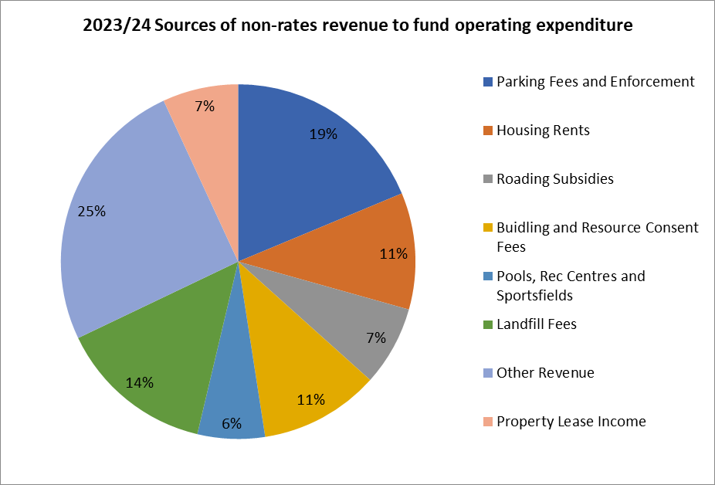

What this plan means for me

What are rates for, and why are they important?
In the same way, our national taxes contribute to the running of the country, Council rates are important to ensure Wellington continues to function.
We set our rates based on the needs of the community, demand for services and affordability in rates. Your money helps us deliver more than 400 day-to-day services and pay for the borrowings used to fund big capital projects across Wellington.
Some of the services and facilities that Wellingtonians receive through their rates include:
198 sqm  open space per Wellingtonian | 101,999  native plants planted with the community | 181,216  calls answered by our Contact Centre staff
820km  stormwater pipes | 18,659  streetlights operated | 968.5km  footpaths
1,080km  wastewater pipes | 407km  walking and biking tracks | 767,257  items available at our 14 libraries
389  litres of drinkable water supplied per resident per day | 760,017  resources in City Archives | $4.9m  funding to community projects and organisations
108  play areas | 25  free public events | 7  new public murals

What is the plan for rates?
This year, the rates increase is 12.3 percent after growth in the ratepayer base is considered. This is equal to the after-growth increase budgeted for in previous plans for this year. In total, the council proposes to collect $479.8m (GST exclusive) of rates during 2023/24.
This increase is driven by investment in the city’s infrastructure and services signalled in the Long-term plan, and the impact of increased inflation, borrowing costs, and depreciation.
Council has used alternative funding mechanisms to absorb some inflationary impacts, and keep rates increases to levels previously signalled. This has resulted in a decision to pause some debt repayments and to fund some initiatives through accumulated surpluses.

Johnsonville Business Improvement District (BID)
A BID is a mutual partnership between Council and a local business community to improve the projects and services that will benefit the economy of a specific local area.
This year, we are introducing a new Business Improvement District in Johnsonville, which includes a new targeted rate for participating.
More information, including a map of the proposed district is on page 16 of Part C and Part D document.
212,174  Wellington city residents | 81,252  Total properties that pay rates | 57:43  collection % of the general rate from base and commercial ratepayers

Options for paying rates
There are several ways to help people manage their rates payments, such as spreading your payments into regular affordable amounts across the year.
Along with Central Government, we have a rates rebate scheme that provides a reduction in rates to those that meet set low-income criteria.
- if you are on a low income, you can apply for a Government rates rebate at: www.govt.nz/browse/housing-and-property/getting-help-with-housing/getting-a-rates-rebate
- for those who are eligible for the Government rates rebate, Council can provide an additional reduction of your rates and we are proposing changes in this area.
If you are worried about paying your rates invoice, please get in touch with us as soon as possible at rates@wcc.govt.nz or call 04 499 4444.
There are also multiple ways to pay your rates: online, by direct debit, internet/telephone banking and in person at the Arapaki Service Centre on Manners Street or at any NZ Post shop.

Policy Changes
The Council has made changes to the Rates remission and Rates postponement policies to enable better support to ratepayers facing financial hardship.
The key changes are:
- Increase low-income remission amount from $500 to $700
- Engage with DIA to include the Council remission in their rates rebate form
- Eliminate the financial hardship postponement application fee for ratepayers that also qualify for the Central Government rates rebate

Operating budget
The cost of delivering and running Council services in 2023/24 is budgeted to be $817.6m or $10.56 per resident per day. This is an $91.4m increase from the 2022/23 Annual Plan, which primarily relates to increased depreciation costs, increased interest expenses, and increased contracts, services and materials cost.
The proposed split for our budget across our eight activity areas is as follows:
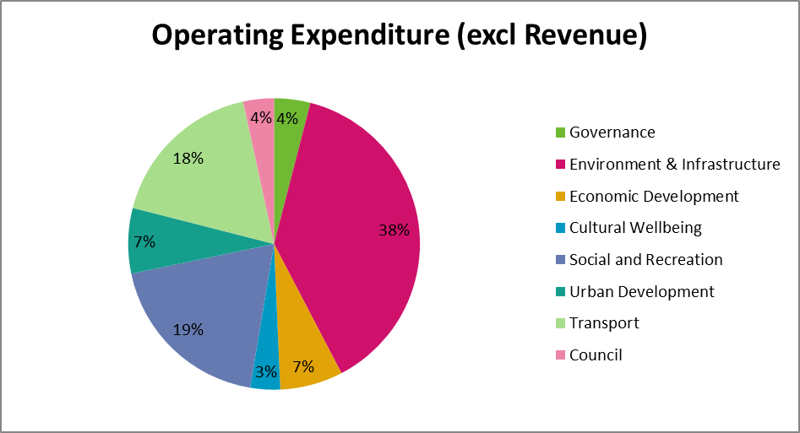

Fees and User Charges
Our Revenue and Financing policy guides our decisions on how to fund council services. We consider who benefits from a service (for example, individuals, parts of the community or the community as a whole) to help determine how the service should be funded.
The policy also sets the targets for each council activity, stating what proportion should be funded from user charges, general rates, targets rates and other sources of income.
The following areas have material increases this year because of changes to existing Council policies or implementation of new policies.
- Town Belts & Reserves – implementation of the Trading and Events in Public Places Policy
- Public health regulation – application fee for Responsible dog owners, which has not been adjusted for several years
These two material fee increases are related to the rising costs to Council to offer the services in these two areas:
- Waste minimisation services – increased ETS costs and Waste Minimisation Act levy
- Building control and facilitation – alignment of some existing fees to new fee structure
We are also introducing new fees in the following areas to streamline some Council booking processes or to offer new services:
- Waterfront Public Spaces - multiple new fees relating to taking over management from Centreport
- Swimming pools – multiple new fees relating to pool party offerings
- Botanical gardens – including new picnic kits and hire rates for Bolton Cottage
- Sports fields – including a new sandcourt hire fee and hire rates for the Newton Park function room
- Recreation Centre – multiple new fees for booking Ākau Tangi Sport Centre sessions
- Marinas – fees for new services for boat pump-out and service outside license agreement
- Burials and Cremation – Ash Plots Makara extensions
- Public Health regulations – Parklet permissions
- Building Control & facilitation – New minor works fee, New LIM fast track option
We also have standard inflation increases proposed for the following areas:
- Botanical gardens
- Waterfront public spaces
- Swimming pools
- Recreation centres
- Marinas
- Burials and cremations
- Public health regulations
- Building control and facilitation
- Development control and facilitation
More detail on the proposed fees can be found on our website: wellington.govt.nz/annual-plan

Capital budget
Capital expenditure is used to renew or upgrade existing assets or to build new assets to provide a higher level of service or account for growth. Our assets include buildings, roads and footpaths, water, stormwater and wastewater pipes, libraries, swimming pools, and sportsfields.
We have a significant capital expenditure programme in place, with $566.1m planned for 2023/24. This year, our programme includes significant investment in our water, stormwater, wastewater and transport networks, the sludge minimisation project, and the development of Te Ngākau Civic Square precinct, including continuing the construction of the city’s new Te Matapihi Central Library.
The total is an increase in what was included in the 10-Year Plan ($356m). The variance primarily relates to the refinement of project costs, the inclusion of sludge minimisation project costs, inflationary pressures, and timings on major building and water projects.
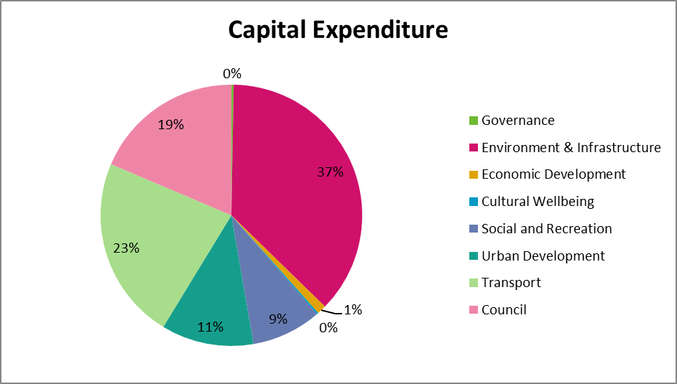

Explaining our borrowing
We borrow to fund upgrades to our assets or to invest in new infrastructure. This allows us to spread the cost of funding this expenditure over the multiple generations that will benefit from the investment.
For 2023/24, net borrowings are forecast to be $1.55 billion at the end of the year, equating to 211 percent (including insurance headroom) of our operating income compared to the Council imposed cap of 225 percent. Council’s imposed cap is lower than the LGFA covenant level of 290 percent for 2023/24 (noting this reduces over coming years). The reason the Council has set a lower rate than the LGFA covenant is to ensure it has sufficient debt headroom for asset renewals and any shocks in the future.

Part B: Our work for the year

In this section we outline each of our seven strategic area, highlight what’s changing since we released Our 10-Year Plan, other key projects, performance information and what it costs.

The Annual Plan 2023/24 focuses on changes to year three of Our 10-Year Plan, with some updates on other key projects.

For full details of our Council services, see Our 10-Year Plan 2021-31 on our website, wellington.govt.nz/ltp.

Our seven strategic areas
Our work is grouped into seven strategic areas:
- Pārongo ā-tāone | Governance
- Te Taiao me te Hanganga | Environment & Infrastructure
- Whanaketanga ōhanga | Economic development
- Oranga ahurea | Cultural wellbeing
- Pāpori me te hākinakina | Social and recreation
- Tāone tupu ora | Urban development
- Ngā waka haere | Transport
We use these areas to showcase our plans, group together relevant services, facilities and projects and monitor our performance.
To achieve our objectives for Wellington, we have also established several companies and trusts. These were set up to independently manage Council facilities, or to deliver significant services and undertake development on behalf of the Wellington community.
Where necessary, we provide funding to support their operations and capital investment requirements.
The organisations are:
- Wellington Museums Trust (Experience Wellington)
- Wellington Regional Economic Development Agency Ltd (WellingtonNZ)
- Wellington Zoo Trust
- Basin Reserve Trust
- Karori Sanctuary Trust (ZEALANDIA)
- Wellington Cable Car Limited
- Wellington Water Limited
- Wellington Regional Stadium Trust (Sky Stadium)

For more details on the organisations, their objectives, structure, and how their performance is measured, please refer to Our 10-Year Plan wellington.govt.nz/ltp.
This section provides an overview of the seven areas.

Pārongo ā-tāone | Governance
We aim to build trust and confidence by being open, transparent and accountable.

What we do – an overview
This strategic area includes activities which enable democratic decision making.
We encourage public input and involvement to ensure all points of view and relevant information are considered when we make decisions on behalf of Wellington. This includes: running local elections; operating, recording and communicating Council and Committee meetings and decisions, and creating and reviewing policies, bylaws and strategies.
This area also includes the operation of our City Archives, Contact Centre and Arapaki Service Centre and communicating with the public on climate impacts.
Our partnerships with mana whenua recognise their special place in the city’s history and their relationship with its land, waterways and other parts of its environment.
There are two groups of activities in this area:
  - 1.1 Governance, information and engagement.
  - 1.2 Māori and mana whenua partnerships.

What it costs
$32.8m  Operating expenditure | $1.6m  Capital expenditure

Te Taiao me te Hanganga | Environment & Infrastructure
We aim to protect and enhance Wellington’s natural environment.

What we do – an overview
The Council’s environment portfolio is large and diverse, encompassing beaches and green spaces, waste reduction and energy conservation, as well as the three waters services (drinking and tap water, wastewater and stormwater) and support for our Wellington Zoo and Zealandia.
Through this areas we maintain and care for our walking and biking tracks, Wellington Gardens, our open green spaces and work to enhance the city’s biodiversity.
We work to make Council facilities and services more energy efficient, work to reduce the Council’s overall greenhouse gas emissions, encourage waste minimisation and actively divert more than 15,000 tonnes of waste from the Southern Landfill and operate the Tip Shop and Recycling Centre.
There are six groups of activities in this area:

- 2.1 Gardens, beaches and green open spaces
- 2.2 Waste reduction and energy conservation
- 2.3 Drinking Water
- 2.4 Wastewater
- 2.5 Stormwater
- 2.6 Conservation attraction

What it costs
$313.4m  Operating expenditure | $209.6m  Capital expenditure

Whanaketanga ōhanga | Economic development
We aim to support economic growth to enhance quality of life.

What we do – an overview
We support Wellington’s economic growth in collaboration with WellingtonNZ and others by supporting high-quality events such as concerts festivals and sports matches, promoting tourism, attracting and supporting business and conference activity, and delivering major economic development initiatives.
These activities make Wellington a more vibrant place to live. They improve residents’ quality of life, prosperity, identity and the opportunities available to them.
We also support large and small scale economic growth programmes through grant funding, deliver programmes that support businesses to reduce their carbon emissions, and support innovators to develop new climate reduction business opportunities
There is one activity group in this area: 3.1 City promotions and business support.

What it costs
$56.9m  Operating expenditure | $6.4m  Capital expenditure

Oranga ahurea | Cultural wellbeing
We aim to strengthen and promote Wellington’s unique cultural identity.

What we do – an overview
We provide opportunities to develop the city’s cultural landscape to build engaged and curious communities. We provide the key theatrical infrastructure for the performing arts, as well as directly funding several community arts and cultural events, and arts partnerships. Through Experience Wellington, we operate six venues: Wellington Museum, Capital E, Cable Car Museum, Nairn St Cottage, Space Place and City Gallery. We also operate the Toi Pōneke Art Centre and maintain the City Art collection.
We develop and deliver an extensive programme of events throughout the year in collaboration with the sector, including signature events Matariki ki Pōneke and our Summer, Christmas, New Year and Waitangi events
We’re investing in the creative sector to maintain our position nationally and internationally as a connected and vibrant, capital.
There is one activity group in this area: 4.1 Arts and cultural activities.

What it costs
$27.1m  Operating expenditure | $1.2m  Capital expenditure

Pāpori me te hākinakina | Social and recreation
We aim for strong, healthy communities.

What we do – an overview
Our focus in this area is on recreation provision, social initiatives and community support, and public health and safety.
We deliver programmes that reduce harm and improve perceptions of safety, including graffiti management, and work to ensure we are a welcoming and inclusive, tolerant and healthy city with a strong social infrastructure supporting its residents
People are at the heart of everything we do, from working with the community to provide shelter to end street homelessness and supporting our most vulnerable residents to investing in infrastructure such as libraries, community centres, swimming pools and recreation centres, playgrounds, and sportsfields.
We also regulate alcohol licencing, food safety, and dog registration, provide community funding for social organisations, and support community climate action through education and funding.
We try to make sure people have access to services and activities that contribute to opportunities for them to live healthy lifestyles, realise their potential, and enjoy their city.
There are three groups of activities in this area:
- 5.1 Recreation promotion and support
- 5.2 Community support
- 5.3 Public health and safety

What it costs
$156.1m  Operating expenditure | $48.8m  Capital expenditure

Tāone tupu ora | Urban development
We aim for a compact, resilient and attractive city.

What we do – an overview
Our work in this area includes enhancing central city public space, making improvements to the waterfront, laneways and suburban centres and planning for the future growth of the city through the District Plan and Spatial Plan. Through this area we work to make Wellington more accessible.
We also look after heritage in the city, and fulfil regulatory functions including assessing and issuing building and resource consents, ensure earthquake-prone buildings are strengthened.
These activities matter to the lives of individual Wellingtonians and to the community. They enable the city to grow while retaining its unique sense of place and liveability. They also provide the opportunity for people to live, work and play in an urban environment that is attractive and sustainable.
There are two groups of activities in this section:
  - 6.1 Urban planning, heritage and public services development (including waterfront development)
  - 6.2 Building and development control

What it costs
$59.4m  Operating expenditure | $64.7m  Capital expenditure

Ngā waka haere | Transport
Connecting people and places.

What we do – an overview
A good transport system should do more than just move people and goods efficiently. It should benefit people’s overall quality of life, be accessible and child friendly, support growth and economic productivity, help create healthy urban neighbourhoods that are people focused, and reduce the city’s carbon emissions.
Practically, we maintain streets, footpaths, cycleways, bridges and retaining walls; upgrade and build new seawalls; operate, maintain and upgrade street lighting; build and maintain bus lanes, bus stops, and bus shelters; and plan and build minor safety projects such as safe crossing points and intersection improvements. We operate and maintain traffic signals and a network of CCTV cameras, own and operate Kiwi Point Quarry, and operate the Cable Car through a Council-controlled organisation.
We’re investing in transport options to maintain easy access in and around our city, in low or zero carbon ways, managing congestion and acting as a catalyst for urban renewal and sustainable growth. Wrovide electric vehicle charging infrastructure on Council-owned land and support car sharing services with dedicated car parking spots and resident parking permits.
There are two groups of activities in this section:
  - 7.1 Transport
  - 7.2 Parking

What it costs
$144.0m  Operating expenditure | $128.5m  Capital expenditure

Key investment projects and programmes
We have a full year of programme and projects planned across all areas of our city. Many are already underway, have been consulted on, decided on by Council or were included as part of the 2021-31 Long-term Plan.
Visit our website to see which projects are in your area: wellington.govt.nz/annual-plan

Projects that start this year

Tūpiki Ora Māori Strategy
Begin implementing some of the short-term actions from the Tūpiki Ora Māori Strategy, including:
- Support and develop resources that encourage learning more about the region, Mana Whenua and Māori histories, identities, landmarks and narratives.
- Support existing cultural initiatives and develop new community-based events.

Ian Galloway Park Planning and public toilets
We will commence scoping and early engagement with stakeholders on a plan for the park, this work will include considering the future options for nearby Wilton Park following a significant slip in 2022. Plans for Ian Galloway will include provision of a public toilet at the southern end of the park.

Kilbirnie Park Master Plan and Rec Centre
We are continuing our work to create a master plan for the Kilbirnie Park area. This will include commencing the design of Kilbirnie’s destination Skate Park. We will also begin planning the earthquake strengthening and renewal of Kilbirnie Recreation Centre, including reconfiguring toilets to gender neutral.

Grenada North Park Master planning
The planning and design for improvements to Grenada North Park will commence in 2024, and will involve engagement with park users and the community. The project will consider the future passive and active recreation needs at the park to support growth in the north of the city,. This is a multiyear project with work expected to start in 2024/25 after planning and design has been completed. .

Shed 5
The strengthening and reroofing of Shed 5 is scheduled to commence in early 2024. The building will be closed while the work is completed. It will take about nine months, with completion expected in late 2024.

Karori Pool
In 2024, we will close the pool for its six yearly maintenance. This will renew the operating plant, replace sealant joints and broken tiles in the pool and renew customer facilities. More details on how long the pool will be closed for will be shared closer to the date.

Parking management plans
We will begin consultation on parking management plans in Newtown in mid-2023 and Wadestown in late 2023. These are local plans developed for particular areas to either address local distribution of parking from projects changing the layouts of our streets or to address ongoing localised parking issues.

Speed management plan
The work will start on creating a plan for safer speeds in the city. Implementation of the plan will begin in January 2024 once NZTA certifies the plan.

Paneke Pōneke - Bike network plan
We will start the planning and design phase for Johnsonville to Ngaio, Khandallah Connections, Ngaio to Karori and Kelburn transitional projects.
We will start planning for projects in the central city including Tasman/Tory and Courtney to Waterfront and projects in the North, including Grenada North and Broderick Road.

Water programme
Alongside an extensive three waters programme across the city, we will also be starting:
Watermain Renewal Programme: Newlands and Johnsonville
The first portion of the Watermain Renewal Programme will begin construction. The first to be renewed include three in Newlands. Also be progressing design and procurement for the second phase, which will begin construction next year and includes three watermains in Johnsonville.
Wastewater Network Renewals – Newtown
The first portion of the programme to renew wastewater assets in Newtown will begin in 2023/24. Renewing them will reduce environmental risks, and occurrences of surface water contamination leading to public exposure to untreated wastewater discharging onto land and waterways.

Projects that continue throughout the year

Begonia House Precinct
We will continue to develop the design for a major refresh of the building, its infrastructure, and the plant displays. We’ll freshen up the café, improve accessibility, plan for the return of the Botanic Garden Shop, and upgrade the toilets. The construction is planned to commence in mid-2024, and take about two years.

Khandallah Swimming Pool
We have completed the technical reports for the site and will be engaging further with the community on options for the pool and park entrance before reporting back to Council.

Frank Kitts Park redevelopment and Fale Malae
We will develop the design of the park further in support of a resource consent application to be lodged by early 2024. Council will submit consents in relation to the demolition of the car park, Chinese Garden of Beneficence and surrounding park green spaces and play areas. The Council will be required to decide on funding for this project through the 2024-34 Long-term Plan. The Fale Trust will submit a separate yet aligned Resource Consent for the Fale building.

Southern Landfill
This year, we will finalise the design of the landfill extension, continue the resource consent application process and undertake preliminary works in advance of construction commencing in 2024. The landfill extension is due to be complete and in operation by June 2026.

City Housing
- Upgrade Phase 2: Planning for the second half of the housing portfolio upgrade is underway, comprising of about 1,000 units across 32 sites. By mid-2023, multi-site criteria analysis will be completed and a detailed business case for the programme submitted. Tenders for the first tranche of work will start to go to market in late 2023, pending Council approval of the business case.
- Healthy Homes: We will be continuing the work to bring all our social housing units up to the new Healthy Homes standards. We have finished the investigations into what is needed at all our units and are on track to have all upgrades completed by the July 2024 deadline.

Te Ngākau Civic Square
- Council buildings: Consent for Civic Administration Building has been submitted for demolition. Consent for the demolition on the Municipal Office Building will be submitted in 2023 however the actual demolition will be delayed until 2024-25 year.
- Town Hall: We are continuing the earthquake strengthening work at the Town Hall. This project is due for completion in 2024/25. More information about the stage of this project and the work underway is available on the Council website.
- Te Matapihi Central Library: Construction continues with work due to be completed in early 2026. The rebuild work started in December 2022 and the work in 2023/24 will include the continuation of the re-piling and installing new concrete foundations with base isolators.

Council Emissions Reduction Plan
We will be continuing the conversion of the Council fleet to electric vehicles and working on developing and implementing an action plan for the Council’s energy decarbonisation plan.

Climate Change Adaptation
We are creating a Wellington Regional Climate Change Impact Assessment, which will inform the Regional Adaptation Plan that is due December 2024. We will also be engaging with the community on climate risks and impacts (the Climate Adaptation Community Engagement Roadmap), and furthering the development of the Bloomberg-funded digital twin engagement tool.

Climate action support
We will continue to run the Home Energy Saver Programme and start the new business energy saver programme (renamed “Let’s Talk Shop), as well as Zero Together (community workshops), the Climate and Sustainability Fund and the Environmental and Accessibility Performance Fund.

Sludge minimisation project
Construction has been approved for the new Sludge Minimisation Facility. Work at the site at the southern end of Stewart Duff Dr is expected to be underway in mid-2023 and completed by 2026. The Council has been approved for funding for the project through the Infrastructure Funding and Finance Act 2020, which in 2023/24 amounts to $126.2m.

Waste minimisation
The proposals for the Regional Waste Management and Minimisation Plan, Resource recovery network expansion, and the Organic processing facility and redesign collection (kerbside) will be out for public consultation in July 2023. Council will make final decision on preferred options and approve for funding through the 2024-34 Long-term Plan.

District Plan
By November 2023, the parts of the plan at relate to intensification become operational through a streamlined process outlined in legislation. The rest of the plan will go through an appeals process before becoming operational in 2025.

Te Kāinga programme
Continue to deliver Te Kāinga rentals. The Council has committed to providing 1,000 apartments over five years. This will be year 3 of the programme and is expected to deliver 78 additional apartments.

Huetepara Park
We will start the development of the public space in Lyall Bay, with toilets and improved visitor experience.

Pōneke Promise
We will continue to investment in improving safety and vibrancy, and reducing harm, in the central city. We will be starting on work on the new Te Aro Precinct public toilets on Inglewood Place, upgrading public spaces in the Te Aro Park area, providing inner-city community spaces, improving vibrancy and sexual violence prevention.

Former Workingmen's Bowling Club Newtown
We have completed our engagement with the community on the future options for the site this work will help inform the design for the site, the next stage with be to advance a plan for area followed by the development of the site.

Three Waters transition
Continue to work on the transition of Three Waters responsibility to new water service entity, with the change-over date to be confirmed.

Central city water upgrades
Alongside an extensive three waters programme across the city, we will also be continuing:
Wastewater pump station and watermain programme: A new watermain up Taranaki Street is the latter part of the first phase of the major CBD Wastewater Renewals Project to renew and upgrade the central city’s wastewater network. Wakefield St and Victoria Street works are forecast to continue into 2023/24.

Paneke Pōneke - Bike network plan
We will complete the transitional installation of 15.3km of the network including: Kilbirnie Connections; Aro Connections; Thorndon Connections; and Ngaio Connections. Following a period of review and community feedback, work will begin to plan for the permanent installation of the cycleways across future years.
We will complete the business cases and consultation for Wadestown to Thorndon, Botanic to Karori, and Berhampore to Newtown Transitional cycleways. Some physical works will then take place on these projects throughout the year.
We will continue with physical works on Evans Bay Stage 1 and complete the detailed planning and start physical works on Evans Bay stage 2 and Brooklyn to City.
We will start and complete the business case for Tawa to Johnsonville.

Charged-Up Capital
Continuing the installation of EV chargers across the city, with another 15 chargers installed this year, building on the 11 chargers installed in the last financial year.

44 Frederick Street Urban Park
This year we will begin the planning and design phases for the park. The concept design will be done with key stakeholders, with public engagement to commence once the land purchase negotiations are finalised. Construction is expected to be completed in 2025/26.

Cuba Street playground
The upgrade of the Cuba Street Playground will be completed by June 2024. The design of the playground will be developed together with mana whenua, rangatahi and tamariki. The new playground will provide great play opportunities for young children, while encouraging other members of the community to benefit from it. The design will include play elements weaving in storytelling, reflecting the site's proximity to Waimapihi Stream and Te Aro Pā.

Let’s Get Wellington Moving
- Transformational programme: Development of detailed business case for mass rapid transit, basin reserve, and second Mt Victoria tunnel.
- Golden Mile: Finalise the design and begin construction in late 2023. The Golden Mile project aims to improve bus reliability and provide opportunities for walking, cycling, and more open spaces. This means better lighting, wider footpaths, more public seating, outdoor dining opportunities and more.
- People Friendly City Streets: Aimed to create better walking, cycling, and public transport provision to have safer and more convenient connections between Wellington City and suburban centres. Any improvements will be consulted on, with phase one construction due to begin in 2023.
- Thorndon Quay and Hutt Road: Finalise the design and construction begins on walking, cycling, bus priority and safety improvements including new Aotea Quay roundabout.

Projects that finish this year

Omāroro Reservoir Area
The back-filling of the area surrounding the reservoir is underway. Playing field restoration and landscaping is due to be completed in 2023, followed by a five-year period for landscaping defect correction at the site.

Taranaki Street New Pump Station
Alongside an extensive three waters programme across the city, we will also be finishing the installation of a new pump station in Inglewood Place off Taranaki Street. This, alongside construction of a new rising main up Taranaki St, is the first phase of the major CBD Wastewater Renewals.

Te Whaea/Tawhiri Project
Upgrade and renewal works in the Tawhiri space include a replacement roof, upgraded patron toilets and performer changing spaces, along with increased building floor structure for tiered seating and a stage area. Works are scheduled to allow the space to be used for the 2024 Festival of the Arts in early 2024.

Karori Community Hall
The Karori Community Hall has been gifted to Council by the Karori Event Centre Trust. The Council has agreed to complete the internal fit out of the building alongside any work required to achieve compliance. This will create a hall that can be used by the community. It is intended that this work will be completed by the end of 2024. An estimate of the costs to complete the fit out of the building will be provided by August 2023 allowing the project to move into the design phase.

Granville Flats
Currently underway on working towards handing back of the Granville apartments site to Wellington Tenths Trust by May 2024. Involves re-housing 107 properties, demolition of buildings and clearing the site. All tenants will be rehoused in alternative Council homes by December 2023.

Frank Kitts Park Playground
The project has been paused as we are unable to proceed with the current design after it became clear it could not be delivered within budget, given the increasing costs resulting from the original contractor going into liquidation and wider construction market inflation. An update on this project and any decision on work in the 2023/24 year is expected by the end of September.

Town Centre and street upgrades
Island Bay Town Centre: The public space upgrade has been designed in collaboration with a local working group. The project includes better places for people to gather, public seating, resurfacing, lighting upgrades, murals, planting and more space for local businesses to extend out into the public space. It will also integrate with the proposed cycleway and safety upgrade work. Detailed design will be completed in June 2023, with construction beginning August 2023 and expected to end early 2024.
Berhampore Town Centre: The public space upgrade to the Berhampore Town Centre has been developed with a public working group. The project is now moving into the detailed design phase. It will include tactical upgrades and minimal earthworks by creating better spaces for the community to gather, street art new planting and seating. Construction will be coordinated with the Paneke Pōneke Bike Network Plan project beginning in mid 2023 and complete in late 2023 (as phase 1 of the wider Newtown-Berhampore transitional cycleway and parking management implementation).

Not all is used in a resident’s home. Other users include industry, businesses, schools, hospitals, the fire service and councils.

